Application of Web-Based GIS
in Coastal Margin Observatories

Aaron Paul Racicot
B.S., University of Washington, 1996

A thesis presented to the faculty of the
OGI School of Science & Engineering
at Oregon Health & Science University
in partial fulfillment of the requirements
for the degree
Master of Science
in
Environmental Science and Engineering

April 2005
The thesis “Application of Web-Based GIS in Coastal Margin Observatories” by Aaron Paul Racicot has been examined and approved by the following Examination Committee:

_____________________________________________
António M. Baptista, Ph.D., Thesis Advisor
Professor
OGI School of Science & Engineering, OHSU

_____________________________________________
Nirupama Bulusu, Ph.D.
Assistant Professor
Portland State University

_____________________________________________
David Maier, Ph.D.
Professor
Portland State University

DEDICATION

To my parents Mark and Linda Racicot,
my wife Heather and my daughter Madeline.

ACKNOWLEDGMENTS

I would like to thank António Baptista for his support and encouragement throughout this process. The CORIE project has proven to be a great place for me to do research as well as make some great friends.
I would also like to acknowledge and thank my thesis committee for taking time out of their busy schedules to critically review this work.
Direction for the July 2004 cruises was based at the Center for Coastal and Land Margin Research at OGI School of Science and Engineering. Scientific oversight was directed by António Baptista. Operational direction for the July 2004 cruises was directed by Mike Wilkin. The research vessel was staffed with captains Gene Bock and Dennis Degner, both Clatsop Community College Maritime instructors. Deckhand Brian Marshall, Associate of Science student at Clatsop Community College also provided assistance. I truly appreciate all of the help received from the crew of the MV Forerunner and the cooperation of Clatsop Community College while testing this project in the field.
Paul Turner provided much of the direction on interfacing with the CORIE modeling infrastructure and use of the ACE toolkit. Charles Seaton has been invaluable in helping with the interface between this project and the CORIE modeling and observation data.
The National Science Foundation (ACI-0121475, OCE-0239072), Bonneville Power Administration (00019126) and National Oceanic and Atmospheric Administration (AB133F-04-SE-0304, AB133F-03-SE-1227, AB133F-04-RP-0033, NA17FE1026) provided financial support for this research.
Lastly, I would like to thank all the developers and users of University of Minnesota Mapserver that have provided assistance and encouragement during the development of this project. Without the help of the very active UMN Mapserver community this project would not have been possible.
TABLE OF CONTENTS

Dedication iii
Acknowledgments iv
Table of Contents v
List of Tables vii
List of Figures viii
Abstract ix

CHAPTER 1. Introduction 1
1.1 Context 1
1.2 Background and Recent Tools 2
1.3 Objectives, Methodology and Structure 3
1.4 References 3

CHAPTER 2. Developing a Web-Based GIS Interface for Coastal Margin
Observatories 4
2.1 Abstract 4
2.2 Introduction 5
2.3 Underlying Hardware and Software Technology 7
2.3.1 System Software Layer 8
2.3.2 Data Processing Layer 8
2.3.3 Data Server Layer 11
2.3.4 User Interface Layer 13
2.3.5 Hardware 13
2.4 System Implementation 13
2.4.1 Problems Addressed in CORIE 13
2.4.2 Capabilities of the CORIE-Mapserver Tool 15
2.4.3 CORIE-Mapserver Performance 17
2.5 Results and Future Direction 18
2.6 References 19

CHAPTER 3. Real-Time Cruise Planning Using Web-Based Open Source GIS 37
3.1 Abstract 37
3.2 Introduction 38
3.3 System Application – Cruise Planning, July 2004 Cruises 39
3.3.1 Scientific Objective 39
3.3.2 Methods 41
3.3.3 Contextual Data 42
3.3.4 Cruise 1 – Plume Gradient Structure 43
3.3.5 Cruise 2 – Plume Size and Shape 44
3.3.6 Cruise 3a – Estuary – South Channel Salt Wedge Propagation 44
3.3.7 Cruise 3b – Plume Dissipation 45
3.3.8 Cruise 4 – Estuary – North Channel Salt Wedge Propagation 45
3.4 Results and Future Direction 46
3.5 References 48

CHAPTER 4. Final Considerations 61
4.1 Synthesis and Conclusions 61
4.2 Contributions 62
4.3 Implications 62
4.4 Acknowledgments 63
4.5 References 63

APPENDIX A 66
APPENDIX B 70
APPENDIX C 73
Biographical Sketch 83

LIST OF TABLES

Table 1. Particle tracking database table definition 32
Table 2. Fixed station database table definition 33
Table 3. Stationary transect database table definition 34
Table 4. Vessel transect database table definition 35
Table 5. Buoy database table definition 36

LIST OF FIGURES

Figure 1. System data flow diagram. 22
Figure 2. How CORIE-Mapserver fits into the existing CMO infrastructure. 23
Figure 3. CORIE-Mapserver software diagram. 24
Figure 4. CORIE-Mapserver user interface 25
Figure 5. Particle tracking utility example. 26
Figure 6. Stationary transect image generation 27
Figure 7. Example stationary transect output image. 28
Figure 8. Vessel transect image generation. 29
Figure 9. Example vessel transect output image. 30
Figure 10. CORIE-Mapserver performance statistics. 31
Figure 11. Geographical area of interest for July 2004 cruises: 49
Figure 12. Graphs of system forcing during the July 2004 cruises. 50
Figure 13. Cruise 1 – Plume gradient transect overlaying forecast model data 51
Figure 14. Cruise 1 – Model-Data comparison. 52
Figure 15. Cruise 2 – Transect path looking at plume length and width. 53
Figure 16. Cruise 2 – Model-Data comparison. 54
Figure 17. Cruise 3a – Fixed location indicated by a star 55
Figure 18. Cruise 3a – Model salinity profile for South Channel fixed station. 56
Figure 19. Cruise 3b – Transect and cast locations for plume dissipation study 57
Figure 20. Cruise 3 – Model-Data comparison. 58
Figure 21. Cruise 4 – Transect path and cast locations 59
Figure 22. Cruise 4 – Model-Data comparison. 60
Figure 23. Model improvement influenced by CORIE-Mapserver 64
Figure 24. Tool improvement influenced by CORIE-Mapserver 65

ABSTRACT

Application of Web-Based GIS in Coastal Margin Observatories
Aaron Paul Racicot, B.S.

M.S., OGI School of Science & Engineering
Oregon Health & Science University
April 2005

Supervising Professor: António M. Baptista

Challenges in delivering Coastal Margin observation and forecasting data to diverse end user groups has led to the development of CORIE-Mapserver, a web-based user interface utilizing GIS technologies and existing Coastal Margin Observatory infrastructure. CORIE-Mapserver uses open-source software tools including the Linux operating system, UMN Mapserver web-based GIS and PostgreSQL relational database to create a new and unique method for interacting with Coastal Margin Observatory data. This paper first motivates and describes the creation of the prototype web-based GIS system built on the CORIE Coastal Margin Observatory. Through the utilization of the CORIE-Mapserver tool in a set of oceanographic cruises during July 2004 we have taken the first step in demonstrating the usefulness of such technology. We believe that in the future this technology will help save resources and allow expanded user groups access to Coastal Margin observation and forecasting data.

CHAPTER 1
INTRODUCTION

1.1 Context

For many years there has been a great divide between science and policy. While driving forces such as economic risks, ecosystem degradation and human safety have caused science and policy to interact, there has been a lack of recognition of the importance in educating policy makers on what science says. Although it takes willing managers to be educated, many times it is the inability to present the scientific data to the decision makers that is to blame.
As a subset of this problem, scientists often have trouble viewing and interacting with their own data. Scientists playing the role of both producer and consumer of most scientific data have led to many non-portable systems with closed interfaces. While these systems may work well for those scientists, it is the inability to transfer this technology that provides a barrier to further innovation.
It is in this paradigm that the following hypothesis was generated:
“Through the use of advanced web-based tools it is possible to start bridging the gap between scientific research and diverse end user groups. Specifically, through the use of web-based GIS tools it is possible to create a new interface to a Coastal Margin Observatory (CMO) infrastructure that not only utilizes existing technology and data products, but expands the capabilities to add functionality and end user value.”
The CORIE CMO was chosen as a test bed for demonstrating this hypothesis. Based in the Pacific Northwest and focusing on coastal circulation of the Columbia River estuary and plume region, the CORIE system is a well-established CMO [CORIE Coastal Margin Observatory, 2004]. While the scope of the CORIE-Mapserver prototype system is initially limited to providing the CORIE operational and development staff expanded

assistance in cruise planning, it is envisioned that this concept can expand to any number of applications in an attempt to broaden the user base and accessibility of CMO observation and forecast data. This prototype also shows the value of GIS in CMOs through the implementation of new interactive tools not previously available via the web in the CORIE system such as particle tracking, zoom and pan capabilities, and overlaying of valuable contextual data.

1.2 Background and Recent Trends

Coastal circulation of the Columbia River system has been studied sporadically for many years. In 1996 the CORIE CMO was established to systematically collect data in the Columbia River estuary to support modeling efforts. This ongoing project now possesses over nine years of continuous observations in the Columbia River estuary region. Multiple modeling systems have been developed in support of research efforts. There are currently over 40 Terabytes of historical model results archived as part of the model development process and daily predictive forecasts produced operationally.
The audience of CMO-modeling products has grown along with the power and accessibility of visualization and data-analysis tools. This data has proven in the past to be useful to managers of coastal systems helping with tasks such as the prediction of inundation patterns from tsunamis and proper evacuation paths for coastal communities. This historical perspective and recent trend toward more accessible end user interfaces has driven the pursuit of more advanced tools and techniques to allow interaction with scientific data that drives management decisions.
The National Office for Integrated and Sustained Ocean Observations [Ocean.US, 2004] has become a driving force in the establishment of a national Integrated Ocean Observing System (IOOS) and is the oversight and coordination body helping integrate local and regional IOOS efforts in the United States. In the Northwest region of the United States the Northwest Association of Networked Ocean Observing Systems [NANOOS, 2004] has taken on the role integrating regional observing systems to address the needs of regional stakeholders. It is intended that a key element to the local and regional IOOS efforts will be existing CMOs. CORIE is currently being utilized as a NANOOS pilot CMO with the hope that existing technology and infrastructure can be leveraged to help develop a more robust infrastructure along the entire Northwestern United States coast line.

1.3 Objectives, Methodology and Structure

As a first step toward gaining better understanding of the interaction between managers and scientific data we first tackle the issue of what technology is currently available and how it can affect the science process. The objective of this thesis is to focus on GIS tools and how this technology can affect both scientific modeling and end user interaction. The methodology used to explore this objective is based upon adapting existing technologies and seeing how these technologies can influence a scientific system such as a CMO.
The structure of this paper is divided into four main sections: this introduction, two self-contained papers on application development and field implementation respectively, and a conclusion.

1.4 References

CORIE Coastal Margin Observatory. Available: http://www.ccalmr.ogi.edu/CORIE/ [Viewed: December, 2004]

NANOOS – Northwest Association of Networked Ocean Observing Systems. Available: http://www.nanoos.org/ [Viewed: December, 2004]

Ocean.US – National Office for Integrated and Sustained Ocean Observations. Available: http://www.ocean.us/ [Viewed: December, 2004]

CHAPTER 2

DEVELOPING A WEB-BASED GIS INTERFACE

FOR COASTAL MARGIN OBSERVATORIES

2.1 Abstract

The growth of the Internet and its capabilities has increased the appeal of web-based GIS systems. This paper discusses the integration of web-based GIS to a Coastal Margin Observatory focusing on coastal circulation in the Columbia River estuary and plume. Numerical model outputs are used in conjunction with graphics-generation software to produce imagery of hindcast and forecast predictions of circulation. A web-based GIS is utilized to store and display dynamic user-driven point, transect and particle trajectory data along with static imagery generated via the production system. Much of the dynamically generated data is stored in a PostgreSQL database enabled with PostGIS, an Open GIS Consortium compliant data interface. A GIS-based user interface utilizing the University of Minnesota Mapserver (UMN Mapserver) application gives spatial capabilities to viewing and manipulating these datasets. This system provides a broad user community with unprecedented flexibility interacting with the Coastal Margin Observatory system, while doing it at speeds comfortably viewable over the web. As a GIS system, tasks such as overlaying topographical maps for spatial context become trivial. This simplification to viewing and interacting with model outputs is of great benefit when undertaking tasks such as cruise planning and drifter studies.

2.2 Introduction

A Geographic Information System (GIS) is a computer system for capturing, storing, querying, analyzing and displaying geographic data [Chang, 2002]. There have been many successful attempts at integrating environmental modeling systems into desktop GIS frameworks, with examples including coastal zone management [Fedra & Feoli, 1998], forest dynamics [Goodchild et al., 1996], and hydrological pollution models [DiLuzio et al., 2004]. Leveraging web-based GIS in environmental modeling is showing great promise in improving accessibility and understanding of model outputs [Argent & Grayson, 2001]. However, these studies have also indicated that traditional desktop GIS applications can be costly to develop and are not accessible to a wide user base due to technical challenges in developing and operating the software [Anderson & Moreno-Sanchez, 2003].
The growth of the Internet has created an opportunity to overcome many of the challenges inherent in developing and deploying a GIS-based interface [Abel et al., 1998; Dragicevic et al., 2000]. The migration of many visualization and analysis capabilities of desktop GIS, such as viewing geo-referenced model output images and running particle tracking algorithms, to web-enabled technologies has only recently become feasible. Much research has gone into the development of web-based GIS architectures [Abel et al., 1998; Peng, 2003; Tsou & Buttenfield, 2002]. Utilizing simplified and universal GIS operations [Albrecht, 1996] in web-based GIS systems has allowed for the development of simplified user interfaces and therefore larger user communities. Adoption of open-source software principles in web-based GIS is allowing for the code sharing and distributed development missing in many proprietary software development practices, hence reducing costs [Anderson & Morena-Sanchez, 2003; Open Source GIS, 2004; Open Source Initiative, 2004]. Open-specification principles are helping to create simplified software architectures and enable fragments of software to inter-operate and be reused. [Anderson & Morena-Sanchez, 2003; Open Geospatial Consortium, 2004].
Coastal Margin Observatories (CMOs) are complex systems that integrate environmental sensor networks, sophisticated data management systems, and advanced numerical models in order to characterize and predict complex processes [Baptista, 2002]. In marine environments, CMOs produce large amounts of data, much of which has been underutilized [Wright et al., 2003]. Historically, oceanography and marine science have relied on examining small amounts of raw observational data along with derived images to determine the behavior of complex systems. With the recent growth of CMOs under the Integrated Ocean Observing Systems (IOOS) initiative, it is possible to get a much clearer view of Coastal Margins. As geographic domains of CMOs have grown, so have the challenges of generating enough imagery to give insight into the entire domain. While there are examples of web-based interfaces to ocean observing systems that are attempting to integrate GIS to observation and modeling efforts [GoMOOS, 2004; SEACOOS, 2004], many web-based interfaces fall short of allowing users to interact with and visualize data on-demand. One such shortcoming is that web-based interfaces are perceived as too slow in serving imagery and data sets [Tu et al., 2001]. Another problem is that the lack of common-data architectures has led to the development of many closed interface systems that lack interoperability [Anderson & Morena-Sanchez, 2003]. It can be seen that there is a need for an economical web-based GIS solution that gives new and expanded user groups the ability to interact with scientific data never before available to them.
The present project, termed CORIE-Mapserver, is a client-server software system that allows for the integration of the CORIE CMO with a web-based GIS called UMN Mapserver [Open Source GIS Conference, 2004; UMN Mapserver 2004]. CORIE is a CMO monitoring and modeling coastal circulation parameters in the Columbia River estuary and plume [Baptista et al., 1999; Baptista 2002; CORIE Coastal Margin Observatory, 2004]. The CORIE domain extends from the southern California coast to the south tip of Vancouver Island in Canada. The eastern boundary is defined by the Bonneville Dam, 146.1 miles from the mouth of the Columbia River. The western boundary extends past the Continental Shelf into the near ocean. A dynamic estuary exists at the interface between the Columbia River and the Pacific Ocean. The CORIE-Mapserver is a thin-client [Abel et al., 1998] web-based GIS, accomplishing all but basic user interface tasks on the server side of the software architecture. CORIE utilizes open-source models such as ELCIRC [Zhang & Baptista, 2004, Baptista et al., 2005], a 3-D circulation model capable of high resolution. ELCIRC numerically solves a coupled set of hydrostatic equations based on mass conservation, momentum conservation, and conservation of salt and heat. Outputs are water elevations, velocity fields, salinity and temperature. The CORIE CMO operationally produces a fixed set of imaging products defined to aid in model development and validation. The CORIE-Mapserver system integrates the ELCIRC model outputs and CORIE fixed-imaging products into a user-interactive interface based on the UMN Mapserver web-based GIS (Figure 1).
In this paper we will show how the implementation of a web-based GIS solution is showing potential to enable new user groups the ability to interact with model data never before available to those communities. We present a case study of dynamically generating on-demand geo-referenced imaging products for the CORIE CMO. Utilizing the capabilities of GIS tools we will show the successful integration of pre-existing tools, such as model image generation and particle tracking, and new tools such as cruise-planning utilities into a web-based interface for CORIE (Figure 2). The CORIE-Mapserver software system has been built primarily with open-source technology and is freely available to the CMO community.
Subsection 2.3 presents the underlying technology behind the CORIE-Mapserver system including hardware and system software, interface to the ELCIRC model, data processing and visualization techniques, utilization of open-source GIS tools and new user interface technologies. Subsection 2.4 presents the CORIE-Mapserver capabilities and discusses its strengths and limitations. Subsection 2.5 presents the directions for future research.

2.3 Underlying Hardware and Software Technology

The CORIE-Mapserver tool has been developed using both third-party and custom software to support user interaction with the CORIE CMO. In this section we describe the underlying hardware and software technology used for the CORIE-Mapserver system. In the spirit of the open-source philosophy [Open Source Initiative, 2004], whenever possible software tools used in the CORIE-Mapserver system are open-source software based (Appendix A).
The CORIE-Mapserver software architecture is a client-server based system consisting of four distinct layers: (1) system software, (2) data processing, (3) data serving, and (4) user interface (Figure 3). The first three layers reside solely on the server side of the architecture, while the user interface layer spans both the server and client. This system is a thin-client architecture allowing for the majority of the data processing to take place on the server side of the system [Abel et al., 1998]. Even though burdening the server can potentially cause speed and processor loading issues, isolating the majority of processing to the server increases platform independence by not relying on the capabilities of end-user hardware and software.

2.3.1 System Software Layer
The system software layer of the CORIE-Mapserver software architecture is composed of a set of software modules that interface the hardware system to the rest of the software architecture. The system software layer consists of two distinct sub-layers, namely the operating system and the web server. The system software used in the CORIE-Mapserver tool was chosen to keep acquisition costs at a minimum while still providing the performance and compatibility needs of a robust web services environment. The operating system is Redhat Linux AS 3.0. The Redhat Linux AS 3.0 kernel has been installed in the most basic form, utilizing only the functionality needed for web services hosting such as scripting languages and internet connectivity.
The web server technology used is Apache, a server grade open-source standard for web services deployment around the world [Apache Software Foundation, 2004]. Known for its widespread acceptance and great stability, Apache sits at the core of the web-based GIS system.

2.3.2 Data Processing Layer
The data processing layer is a set of software modules that are used to link the CMO model binary output to the UMN Mapserver GIS system. CORIE is capable of using many standard numerical models with the ELCIRC model being used operationally. Output fields from the ELCIRC model are produced for transport of salinity and temperature, velocity magnitudes and directions, and water elevations. These output parameters are calculated based upon unstructured input grids that are generated to best represent the spatial and temporal resolution of the domain. The current grids being used for the ELCIRC model applied to the CORIE system contain 33634 horizontal nodes, 50389 horizontal elements, and a vertical resolution of 62 levels. ELCIRC is run with a 1.5-minute computational time step and a 15-minute output time step. ELCIRC produces binary output files of approximately 700MB for horizontal velocity and 350MB for vertical velocity, salinity and temperature per day of simulation.
The ELCIRC model binary output structure is defined by a common header for all output files followed by scalar or vector representations of physical parameters in sequential time steps. This common data format allows for simplified access to model data. Through the use of a self-describing grid structure in the header of each file, it is possible for application developers to interact with the model data in efficient methods. Namely, it is possible to sub-sample the data sets based on spatial or temporal criteria without having to read the entire file, or even an entire time step.
To support ELCIRC modeling visualization and grid editing efforts, an open-source library called ACE has been developed through the CORIE project [ACE Toolkit, 2004]. CORIE-Mapserver uses two open-source visualization tools: (1) ACE/gr and (2) ACE/vis as well as the ELIO (ELcirc Input Output) C library from the ACE toolkit.
ACE/gr is an x, y plotting tool for workstations or X-terminals. Features of ACE/gr utilized include user-defined scaling, tick marks, labels, symbols, line styles and colors. Batch-mode processing for unattended plotting is used by CORIE-Mapserver for scatter plots. ACE/vis is a 2-D visualization and image generation tool and is an integral part of the CORIE project image and visualization efforts. ACE/vis uses the X/Motif user interface library but also supplies a fully supported command line interface for off-line and batch mode processing, which CORIE-Mapserver utilizes when generating time series plots and animations.
Lastly, the ELIO library allows application developers to read and write ELCIRC binary data files. Through the ELIO library it is possible to efficiently parse headers, data fields, and model input parameters through C interfaces. The ELIO C Library is used in the CORIE-Mapserver system to interact closely with binary model output manipulating statistics and generating products. The ACE toolkit is freely available and can be downloaded from the CORIE website: www.ccalmr.ogi.edu/CORIE/software/.
Along with the ACE toolkit, many other processing tools have been created to support specific tasks within the CORIE-Mapserver project. Particle tracking code developed as part of the CORIE project has been modified to implement tracking scenarios via the CORIE-Mapserver tool. Particle tracking is done via code that uses horizontal and vertical velocities to predict 3-D particle tracks over the model grid domain. The Lagrangian particle tracks are based upon the integration of velocity along the particle path. Numerically weighted velocities are interpolated across grid element volumes at sub-timesteps. Currently 50 sub-steps are used as a default with a base time step of 15 minutes from the model output. The particle-tracking utility can scale to any number of particles and can span any length of time for which there is model output.
Numerical error introduced by the model into the particle trajectories is characterized through the use of a backtracking algorithm and closure error characterization. It is possible to run the particle trajectory forward, marking the end location, and then backward with a deviation from the initial starting location indicating the magnitude of model-induced numerical errors.
Deviation of particle trajectory due to initial uncertainty of particle placement in a high shear environment is characterized by surrounding the initial particle with four test particles at release. Watching the relative distance of the test particles to the original particle over time can help predict the estimated uncertainty in end location of the original particle due to uncertainty in initial placement. Given an estimated start location with a relative uncertainty of that initial placement (for example ±5 m), it is possible to then predict the spread of surrounding test particles over time due to shear current interaction. A good example of the usefulness of this capability in the CORIE project is predicting drifter locations while deploying them in areas of strong shear currents induced by high river flow and strong tidal influence. It is very realistic to have two drifters deployed only 10 meters apart at the same time to travel in opposite directions due to strong sheer currents.
A set of custom software was developed for the CORIE-Mapserver project for generating three types of imaging: (1) fixed-station images, (2) stationary transects and (3) vessel-based transects. A set of fixed-station images are defined by a Eularian time series representation of all modeled physical parameters for a specific physical location, called a station, in the model domain. A stationary transect is a slice of the domain defined by a poly-line in x, y space extending to the bottom of the water column and is stationary over time. A vessel-based transect is a slice of the domain defined by a poly-line in x, y, and t space, extending to the bottom of the water column, but also having a time-based variation.
The generation of fixed-station images, stationary transects and vessel-based transects is done using a set of modified open-source C and Perl scripts used in the generation of images for the CORIE project. Extracted model data is fed into the open-source ACE toolkit to generate formatted 2-D output images. Stationary transect image sets contain 24-hour animations of both salinity and temperature. Vessel transect image sets include graphical representations of salinity and temperature whose format is modeled after that of conductivity, temperature and depth (CTD) sensor cast images. The GIS interface enables the images to be generated at any location selected by the user via the GIS Java Applet interface. Linked to forecast and hindcast circulation databases, this tool enables researchers conducting field surveys to process model outputs with much more flexibility than ever before.

2.3.3 Data Serving Layer
The data serving software layer enables generation and transfer of GIS data. This layer bridges the gap between large amounts of complex scientific data and simple user interfaces by utilizing GIS technologies. The data serving layer of the CORIE-Mapserver software architecture consists of two Open-source tools: (1) UMN Mapserver [2004] web-based GIS and (2) PostgreSQL [2004] database.
UMN Mapserver is a web-based GIS system that implements basic GIS-related tasks over the World Wide Web. UMN Mapserver was initially developed by the University of Minnesota under the ForNet project in cooperation with NASA and the Minnesota Department of Natural Resources. The UMN Mapserver implementation is heavily on the standards set forth by the Open GIS Consortium (OGC), which provides many of the guiding standards for the GIS community. By following these standards the UMN Mapserver implementation is very flexible and easily integrated with other software systems’ standardized protocols such as WMS, WFS. UMN Mapserver can be deployed in many different configurations, from simple HTML-driven web pages over a CGI engine, to very complex Java-driven applications serving dynamic content.
CORIE-Mapserver uses the UMN Mapserver distribution compiled as a library for the popular scripting language PHP. This Mapscript environment allows for easy interaction with the PHP web development language via the Mapscript API. The option to compile UMN Mapserver as a library to many popular web development languages was originally provided via DMSolutions Inc. and now comes standard in the UMN Mapserver distribution.
The GDAL open-source library is used for raster processing in the UMN Mapserver environment and pre-processing in the CORIE-Mapserver project. GDAL is used to generate a tile index of multiple raster images allowing for rapid display of large raster data sets. Geographic projection issues in UMN Mapserver are addressed by the use of the PROJ.4 library. PROJ.4 allows for on-the-fly projection of individual layers originating from different projections to the common projection of the main map image.
PostgreSQL is an open-source relational database management system that is easily linked to the UMN Mapserver environment [PostgreSQL, 2004]. Refractions Research Inc. has provided an open-source extension to the PostgreSQL database project called PostGIS, which is based upon OGC standards for storage and transfer of GIS data [PostGIS, 2004]. The combination of these two products allows for easy integration of a spatially oriented dataset to UMN Mapserver. While most of the data produced by the CORIE modeling system is in binary formats, the PostgreSQL and PostGIS environment is utilized to store data products such as particle tracking runs (Table 1), fixed stations (Table 2), stationary transects (Table 3), vessel transects (Table 4) and in-situ station information (Table 5).

2.3.4 User Interface Layer
The user interface software layer provides the interactive front end to the CORIE-Mapserver system. DMSolutions Inc. has provided a UMN Mapserver application development environment called GmapFactory, which has been used as a template for the development of the CORIE-Mapserver interface. An open-source Java applet called ROSA provides very rudimentary tools used in developing user interfaces, including button manipulation and line drawing. The CORIE-Mapserver project has blended many of these commonly used tools and techniques used by the UMN Mapserver community to develop the current user interface.
PHPLib is a session-based authentication software library that provides both security and user-based customization to the CORIE-Mapserver interface. Sessions are used to store user-specific data and track user interaction over time. Users of the CORIE-Mapserver system are required to register to allow for the customization of the user interface to each individual user.

2.3.5 Hardware
The hardware platform used to support the implementation of the CORIE-Mapserver interface is a custom-built Intel-based PC. The machine is comprised of an Intel Pentium4 2.4 GHz single processor with 1 GB RAM and dual 40 GB hard drives. The machine is connected to the Internet via a T1 connection. ELCIRC model data is stored on NFS-mounted hard disk storage totaling approximately 40 Terabytes. All ELCIRC model data is accessed via a local area Ethernet running at 100 MBits/sec.

2.4 System Implementation

2.4.1 Problems Addressed in CORIE
There has never been an integrated system to allow for web-based interaction with CORIE model data. Tasks such as particle tracking and vessel CTD cast image generation have historically been run via command line interfaces that require access to internal machines for the CORIE project. This closed nature of model post-processing has made real-time interaction with the model impossible. CORIE-Mapserver now allows for the dynamic interaction with model output through the use of the World Wide Web. This “opening” of the model to a wider audience is seen as a great step toward applying the CORIE modeling results to real problems.
The CORIE CMO modeling system was built around the need for consistent and pre-defined model-data visualization that allows for cross-version and cross-time comparison of model results against observational data. Two problems arose during the construction of the CORIE CMO that until the introduction of the CORIE-Mapserver tool were left unaddressed. First, many images produced automatically for daily forecast and hindcast model runs never get viewed because they do not pertain to scientific questions currently being reviewed. Secondly, regions where images are generated are limited and often inadequate for addressing many scientific investigations. These two issues, coupled with a need to archive model run data and images, have led to an abundance of images that never get looked at and no method for dynamically generating images at arbitrary locations.
Of the 161 static “stations” for which CORIE model data images are automatically generated, very few ever get viewed consistently. This automatically generated group of images, along with domain and transect animations, currently comprise 1.5 GB of storage per two-day forecast run and 2.3 GB of storage per week of hindcasts. This automatic image generation consists of approximately 11 percent of the total disk space used for all model runs. Of equal concern to having unused images is not having access to a process of generating images at arbitrary locations in the model domain. It is easily seen that 161 static stations located in a model grid of approximately 30,000 horizontal nodes is not sufficient to evaluate model performance. A real need exists for scientific investigators to select the location of interest unencumbered by limitations imposed by pre-defined image generation. CORIE-Mapserver addresses these two issues by providing scientific investigators the ability to select “on-the-fly” locations within the model domain and generate model images. No longer are users of the model output tied to the historic list of available stations or transects.

2.4.2 Capabilities of the CORIE-Mapserver Tool
To highlight the abilities of the CORIE-Mapserver tool we will focus on the key features currently available and how they affect the usability of the CORIE CMO. This list is by no means exhaustive, but will provide the reader with a good view of the most-used features. The interface is broken up into three main areas; the CORIE interaction menus, the map-viewing area and the map legend (Figure 4). All user interaction with the CORIE model data related to location can be conducted through the Java Applet based tools on a map or via numerical input from the user. With this option it is equally easy to specify a transect or station location via typing raw coordinates or via selecting locations on a map with the use of a mouse click.

2.4.2.1 Three Main Geographic Extents. One of the features of a web-based GIS system is the ability to traverse imagery at different geographic extents. The CORIE-Mapserver interface allows for three general maximum geographic extents. These three extents correspond to the three main areas of interest for the CORIE research team; estuary, plume and far ocean. Along with these three settings the user is able to zoom and pan to any level desired via the Java Applet based tools available on the toolbar located on the right side of the map image. The ability to interactively zoom, pan, and query through the GIS interface is added functionality over any previous interface to CORIE model data.

2.4.2.2 Particle Tracking. Lagrangian particle tracks are made possible through the “Particle Track” action-menu selection. The menu selection process allows the user to select start and stop times, as well as whether the particles are to be held to a fixed depth or allowed to freely travel in the vertical. Finally, initial depth is specified before the particle tracking tool becomes available for invocation.
Once a location for releasing particles is selected, real-time processing takes place on the ELCIRC model output to produce location and contextual information for the particle at every time step. This data is then stored in the PostgreSQL database and made available for display via CORIE-Mapserver. Each particle step is color shifted to allow for ease of visualization (Figure 5). A pop-up window also appears upon completion of processing that contains a table of particle locations at every time step along with depth information. This particle-tracking layer can be queried as well as added or removed from the viewable layer list at any time.

2.4.2.3 Fixed Station. Standard image sets are made possible through the “Fixed Station” action-menu selection. This menu-selection process allows for the selection of run type (either hindcast or forecast) and start date before making the fixed station tool available for invocation. Once a location is selected, a pop-up window appears with a status icon indicating that a set of fixed station images is being generated for the location selected. Once the images appear, there will also be a mark that appears on the main map indicating the selected location.

2.4.2.4 Stationary Transect. Stationary transect images are generated via selection of the “Stationary Transect” action-menu selection. Through the use of sequential mouse clicks on the main map or manual coordinate input, the poly-line transect definition is stored in the Postgresql/PostGIS database and displayed via the transect layer on the main map. This transect type allows for the definition of a fixed spatial transect path that is interpreted over time via output animations (Figure 6). This type of transect is very useful for looking at temporal processes from fixed transect locations (Figure 7).

2.4.2.5 Vessel Transect. A vessel transect is input in a fashion similar to a stationary transect, either via mouse click or manual input. Menu selections guide the user through definition of the vessel transect including boat speed, instrument cast distance and delay. The unique feature of the vessel transect is the ability to move both spatially and temporally to generate an image. This image can be compared easily to the graphical representation of in-situ sampling done via CTD casting (Figure 8). Instead of animations, the spatially and temporally varying nature of the output dictates a single image (Figure 9).

2.4.2.6 View Model Images. Domain model images that are automatically generated via the ACE toolkit for all model runs are viewable as a layer via selecting the “View Model Data” action-menu selection. This menu selection will guide the user through the menus necessary to define which image is desired before loading the model data layer raster with the main map image. This feature is very useful when applying the CORIE-Mapserver tool in the field by allowing contextual model data to help define cruise paths and fixed station locations.

2.4.2.7 Utilities. The main utility function available via the CORIE-Mapserver interface is a web enabled interface that uses the PROJ.4 utility for converting between the two main coordinate systems used, namely Oregon State Plane Coordinate System (OSPCS) and geographic coordinate system NAD83 Latitude-Longitude. This tool is housed in a pop-up window separate from the main application and can be used to easily convert user specified locations from geographic coordinates to projected coordinates and vice-versa.

2.4.3 CORIE-Mapserver Performance
The CORIE-Mapserver user interface performance has been characterized by the time required to complete a given action-menu selection and ranges from five seconds to 150 seconds (Figure 10). Actions that require processing of large model output files to generate on-demand products, such as fixed station images, take more time than those actions only referencing pre-generated output. Likewise, actions performed on model forecast runs are typically faster than those performed on hindcast runs due to the difference in durations of the model runs.
The above characterization was done with use of a broadband internet connection and no secondary server load. In the field, Internet connection speeds are typically much slower and less consistent than hardwire broadband connections. CORIE-Mapserver is able to maintain positive performance characteristics in these low bandwidth situations since the majority of the data product processing and generation is done on the server side of the architecture.

2.5 Results and Future Direction

Through the use of open-source tools we have started to integrate functional GIS into the capabilities of CORIE. Never before has the ability existed to interact with ELCIRC model output in a web-based interactive environment. This web-based geo-referenced interaction with spatially explicit simulation data shows logistical promise, and is currently being used in planning and interpretation of estuarine and plume surveys for the Columbia River (Chapter 3).
Major advances have been realized in addressing the need to bring scientific research into the hands of a larger and more diverse audience through the CORIE-Mapserver project. We look forward to increasing the scope of applications for this type of technology, including search and rescue, fish migration patterns, and environmental hazard response as well as applying the technology to other CMOs around the world.
The future of web-based GIS is heading in the direction of web services. Through the use of open standards it is envisioned that data no longer needs to be stored locally to be viewed via a web-based GIS [Doyle & Daly, 2004]. The OGC has adopted standards for the integration of GIS into web services. Web Map Service (WMS) is a raster based web services protocol that allows for the standardized request for geo-referenced raster data and the standardized transmission of raster data over the World Wide Web. The CORIE modeling project has the ability to generate model-based imagery of a unique geographical region. It is the future goal of the CORIE project to serve this imagery via WMS for others to utilize in their GIS environment. Since UMN Mapserver can act as a WMS server, it is envisioned that a new integration between the graphics generation utilities in CORIE and the server features of UMN Mapserver will be possible. This new interface will allow for on-demand raster generation and transmission to WMS clients throughout the world.
Web Feature Service (WFS) and Web Coverage Service (WCS), two more OGC standards focusing on vector and grid-based data, are less developed at this time, but show great promises for allowing even greater integration of the CORIE CMO into the GIS community. OPeNDAP, another array-based data transfer standard, is also showing promise in allowing for the transfer and visualization of large array-based data sets. The CORIE development team is currently looking at integration possibilities of ELCIRC model data output into the WCS and OPeNDAP frameworks for data serving. Through the use of these developing protocols and standards it is envisioned that CORIE data will be served to a wide range of consumers in the years to come.
On the client side, UMN Mapserver has the ability to request and display layers via WMS, WFS, and WCS as well. Current development activity in the CORIE project is looking to integrate more of the base layers of the CORIE-Mapserver tool through web services rather than local copies. Web services are viewed as a long term benefit when looking at maintenance costs for large data sets. Integration with other oceanographic data sets is also of interest and currently being pursued [OpenIOOS, 2004].

2.6 References

Abel, D. J., Taylor, K., Ackland, R., and Hungerford, S. (1998) An exploration of GIS architectures for internet environments. Computers, Environment and Urban Systems 22(1):7-23.

ACE Toolkit. Available: http://www.ccalmr.ogi.edu/CORIE/software/ace/recent.html [Viewed: December, 2004]

Albrecht, J. (1996) Universal GIS operations for environmental modeling. In Proceedings of the Third International Conference/Workshop on Integrating GIS and Environmental Modeling, Santa Fe, NM. Santa Barbara: National Center for Geographical Information and Analysis, published as CD and WWW page at http://www.ncgia.ucsb.edu/conf/santa_fe.

Anderson, G., and Moreno-Sanchez, R. (2003) Building web-based spatial information solutions around open specifications and open source software. Transactions in GIS 7(4): 447-466.

Apache Software Foundation. Available: http://www.apache.org [Viewed: December, 2004]

Argent, R. M., and Grayson, R. B. (2001) Design of information systems for environmental managers: an example using interface prototyping. Environmental Modelling and Software 16(5): 433-438.

Baptista, A. M. (2002) Environmental observation and forecasting systems. In Encyclopedia of Physical Science and Technology, 3rd Ed. (Meyers, R. A., Ed.), Academic Press, San Diego, pp. 565-581.
Baptista, A. M., Wilkin, M., Pearson, P., Turner, P., McCandlish, C., and Barrett, P. (1999) Coastal and estuarine forecast systems: a multi-purpose infrastructure for the Columbia River. Earth System Monitor 9: 1-2, 4-5, 16.

Baptista, A. M., Zhang, Y. L., Chawla, A., Zulauf, M. A., Seaton, C., Myers, E. P., Kindle, J., Wilkin, M., Burla, M., and Turner, P. J. (2005) A cross-scale model for 3D baroclinic circulation in estuary-plume-shelf systems: II. Application to the Columbia River. Continental Shelf Research, in press.

Chang, K.-T. (2002) Introduction to Geographic Information Systems. McGraw-Hill, Boston, 348 p.

CORIE Coastal Margin Observatory. Available: http://www.ccalmr.ogi.edu/CORIE/ [Viewed: December, 2004]

DiLuzio, M. D., Srinivasan, R., and Arnold, A. G. (2004) A GIS-coupled hydrological model system for the watershed assessment of agricultural nonpoint and point sources of pollution. Transactions in GIS 8(1):113-136.

Doyle, S., and Daly, M. Enabling Distributed GIS - OpenGIS in the Real World. GISCafe (www.giscafe.com) Available: http://www10.giscafe.com/nbc/articles/view_article.php?section=CorpNews&articleid=67677 [Viewed: December, 2004]

Dragicevic, S., Balram, S., and Lewis, J. (2000) The role of Web GIS tools in the environmental modeling and decision-making process. In Proceedings of the 4th International Conference on Integrating GIS and Environmental Modeling (GIS/EM4): Problems, Prospects and Research Needs. Banff, Alberta, Canada, September 2-8, 2000.

Fedra, K., and Feoli, E. (1998) GIS technology and spatial analysis in coastal zone management. EEZ Technology 3:171-179.

GoMOOS, Gulf of Maine Ocean Observing System. Available: http://www.gomoos.com/ [Viewed: December, 2004]

Goodchild, M. F., Steyaert, L. T., Parks, B. O., Johnston, C., Maidment, D., Crane, M., and Glendinning, S., Eds. (1996) GIS and Environmental Modeling: Progress and Research Issues. GIS World Books, Fort Collins, CO, 486 p.

Open Geospatial Consortium, Inc. (OGC). Available: http://www.opengis.org/ [Viewed: December, 2004]

OpenIOOS. Available: http://www.openioos.org/ [Viewed: December, 2004]

Open Source GIS. Available: http://opensourcegis.org [Viewed: December, 2004]

Open Source GIS Conference / Mapserver User Group Meeting Proceedings (2004). Ottawa, Canada, June 9-11. http://www.omsug.ca/osgis2004/proceedings.html [Viewed: December, 2004]

Open Source Initiative. Available: http://www.opensource.org [Viewed: December, 2004]

Peng, Z.-R. (2003) Internet GIS: Distributed Geographic Information Services for the Internet and Wireless Networks. Wiley, Hoboken, NJ, 679 p.

PostGIS, Refractions Research Inc. Available: http://postgis.refractions.net/ [Viewed: December, 2004]

PostgreSQL, Object-Relational Database Management System. Available: http://www.postgresql.org/ [Viewed: December, 2004]

Redhat White Paper (2003) “Migrating to Red Hat Enterprise Linux from Red Hat Linux.” Available: http://www.redhat.com [Viewed: December, 2004]

SEACOOS, Southeast Atlantic Coastal Ocean Observing System. Available: http://www.seacoos.org/ [Viewed: December, 2004]

Tsou, M.-H., and Buttenfield, B. P. (2002) A dynamic architecture for distributing geographic information services. Transactions in GIS 6(4): 355-381.

Tu, S., He, X., Li, X., and Ratcliff, J. J. (2001) A systematic approach to reduction of user-perceived response time for GIS web services, pp. 47-52. In Proceedings of the 9th ACM International Symposium on Advances in Geographic Information Systems, November 9-10, 2001, Atlanta, GA., ACM Press, New York.

UMN Mapserver. Available: http://mapserver.gis.umn.edu/ [Viewed: December, 2004]

Wright, D. J., O’Dea, E., Cushing, J. B., Cuny, J. E., and Toomey, D. R. (2003) Why Web GIS may not be enough: A case study with the virtual research vessel. Marine Geodesy 26(1-2): 73-86.

Zhang, Y., and Baptista, A. M. (2004) A cross-scale model for 3D baroclinic circulation in estuary-plume-shelf systems: I. Formulation and skill assessment. Continental Shelf Research 24: 2187-2214.

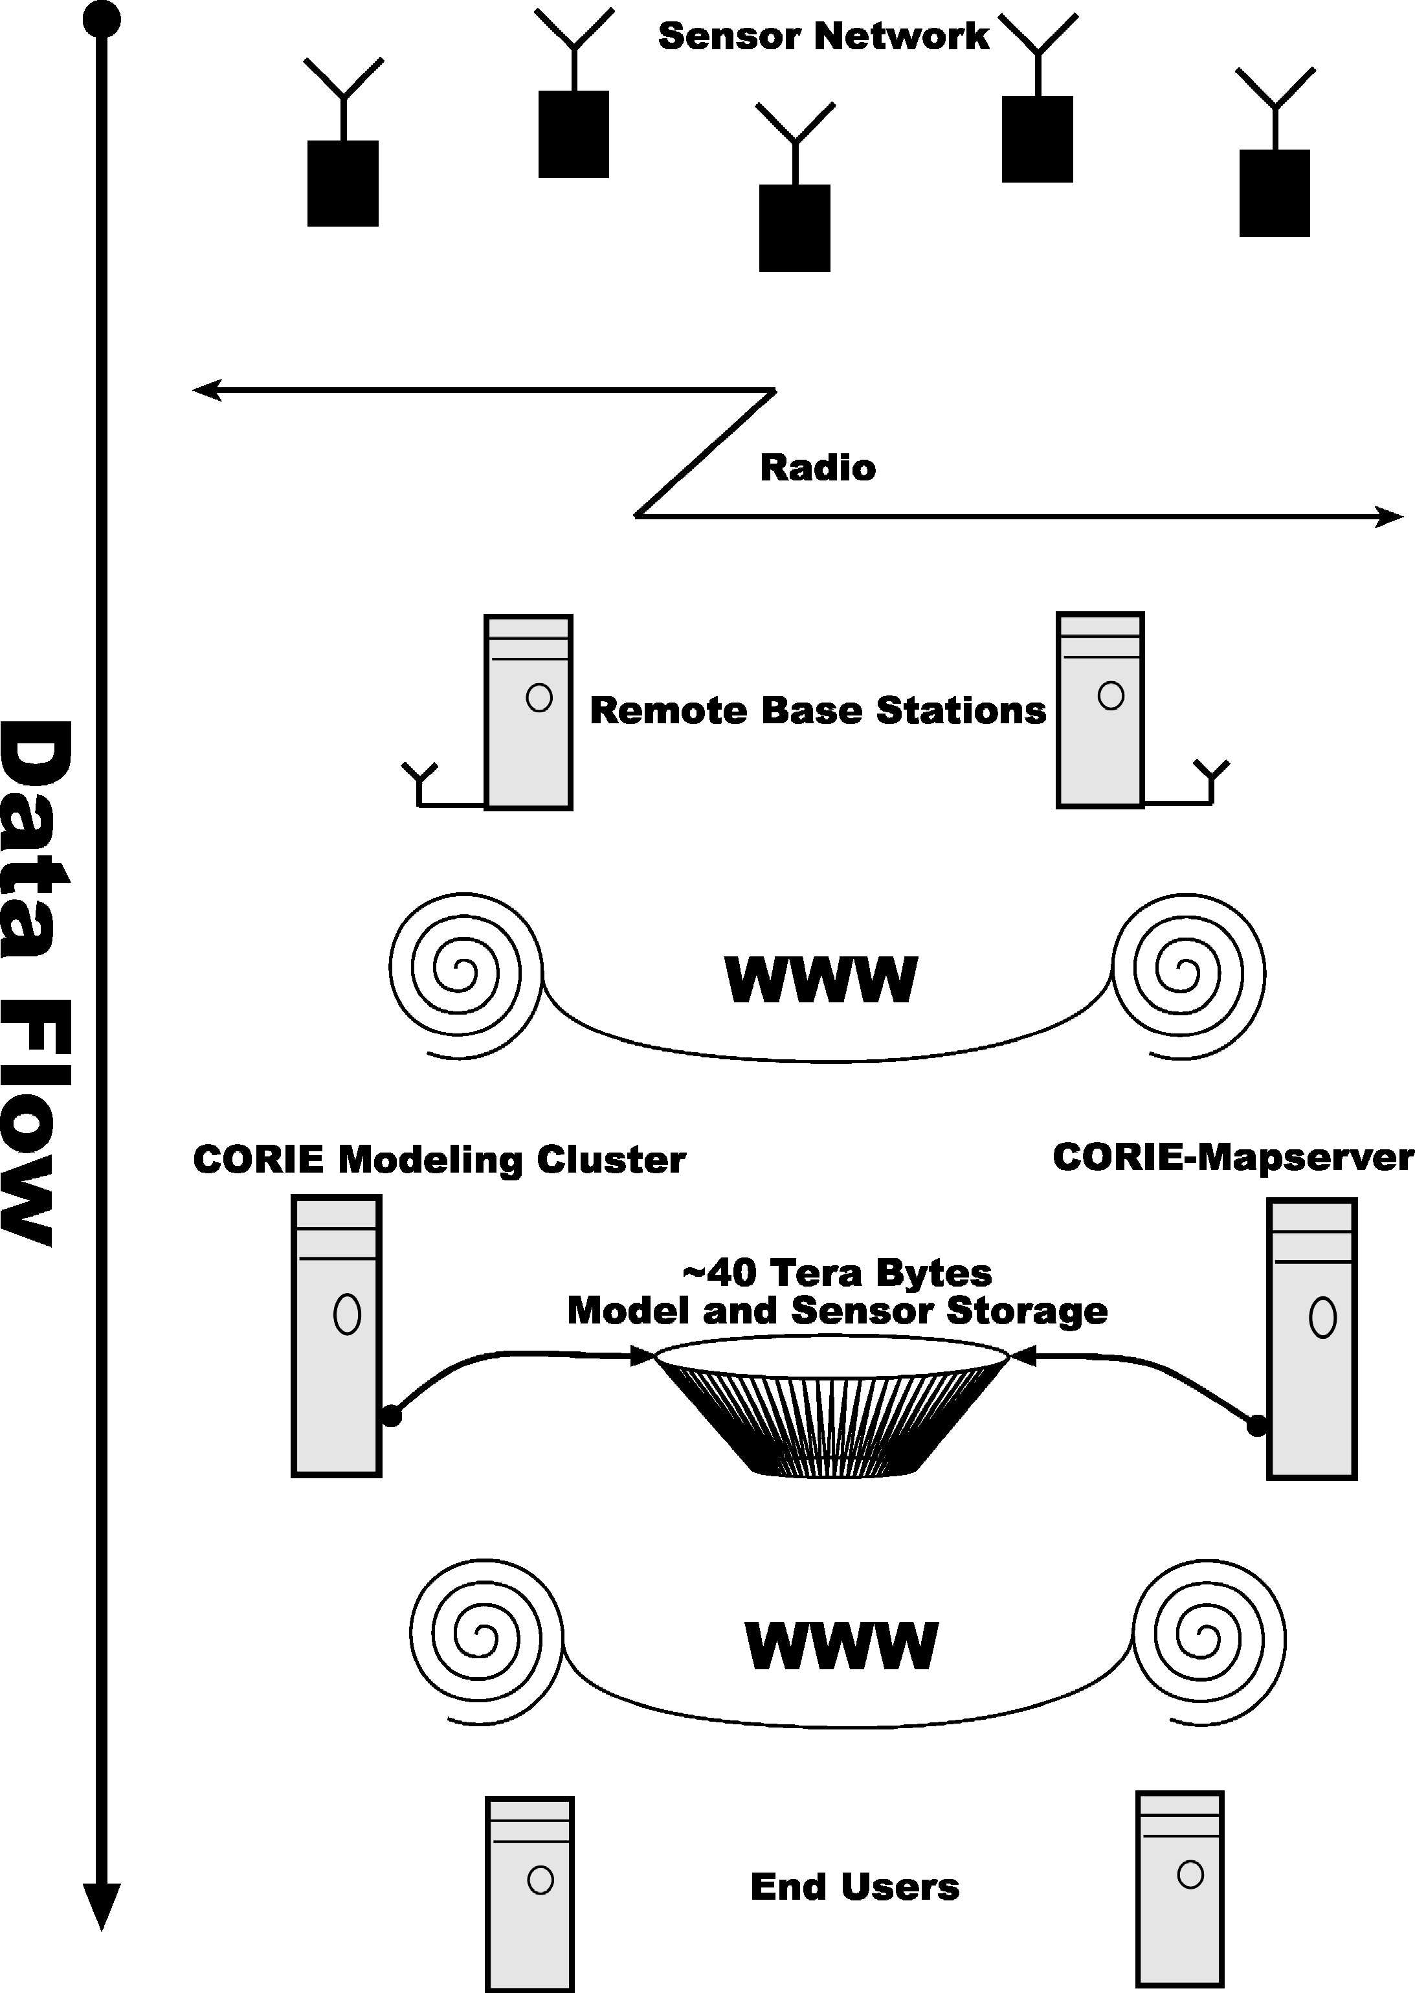
Figure 1. System data flow diagram.
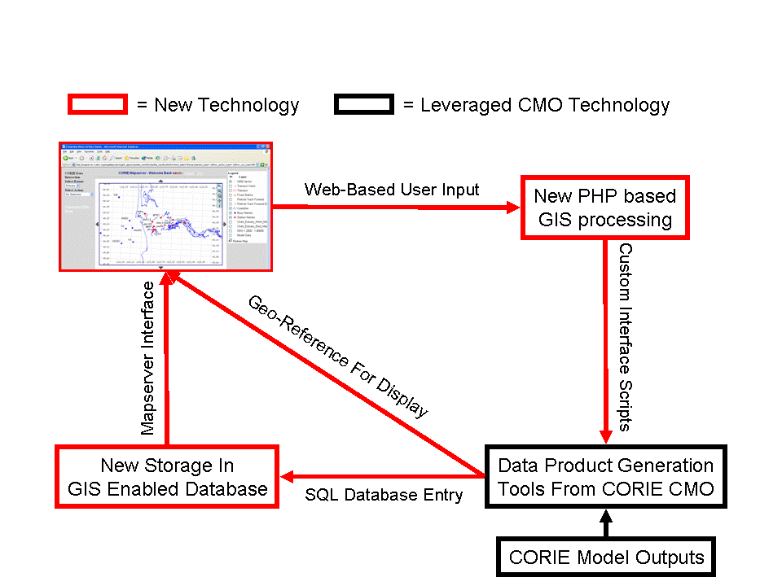
Figure 2. How CORIE-Mapserver fits into the existing CMO infrastructure. The new CORIE-Mapserver technology utilizes existing CMO tools to create a new interactive user interface.
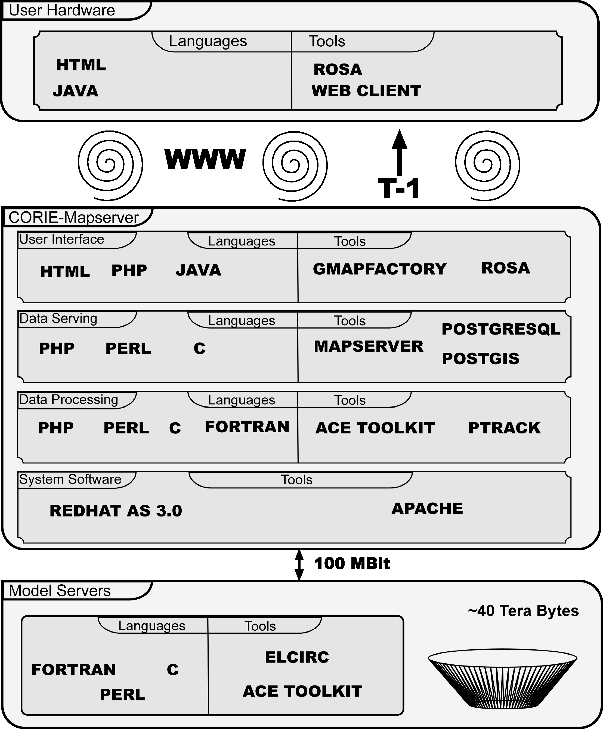
Figure 3. CORIE-Mapserver software diagram.
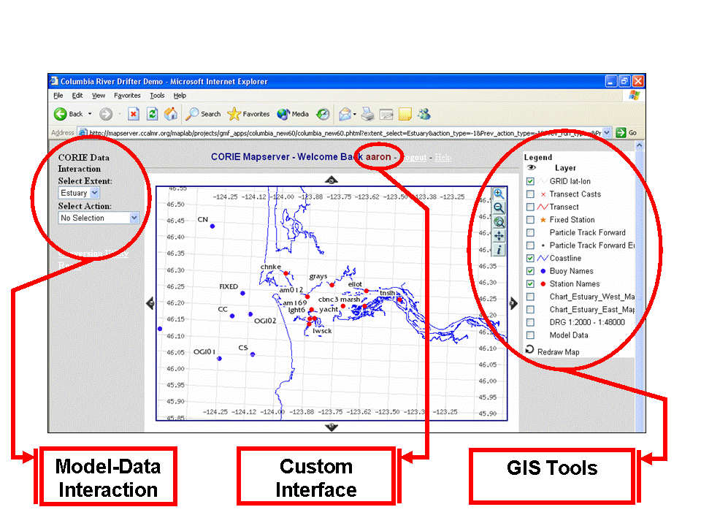
Figure 4. CORIE-Mapserver user interface. Left side of screen represents the user interactive menu system. The middle of the screen contains the main map area. The right side of the screen contains the legend and layer control for the main map.

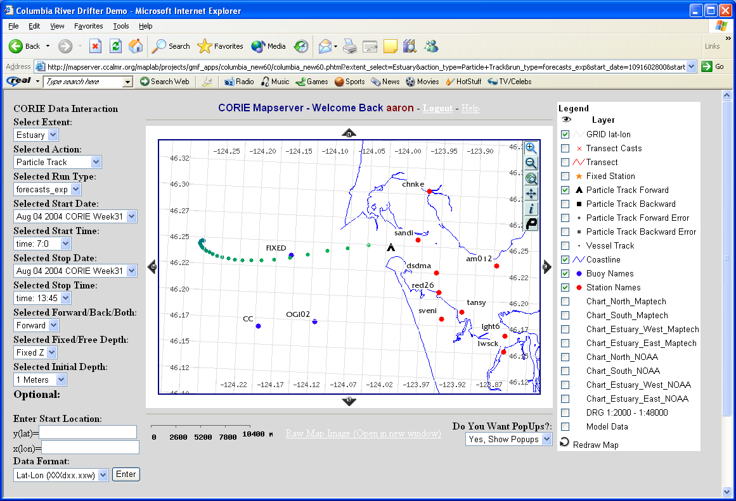
Figure 5. Particle tracking utility example. Particle track is selected via user click on main map. 3-D Lagrangian particle track is calculated using model velocity fields and stored as a GIS layer in PostgreSQL. Particle display changes color as time progresses.

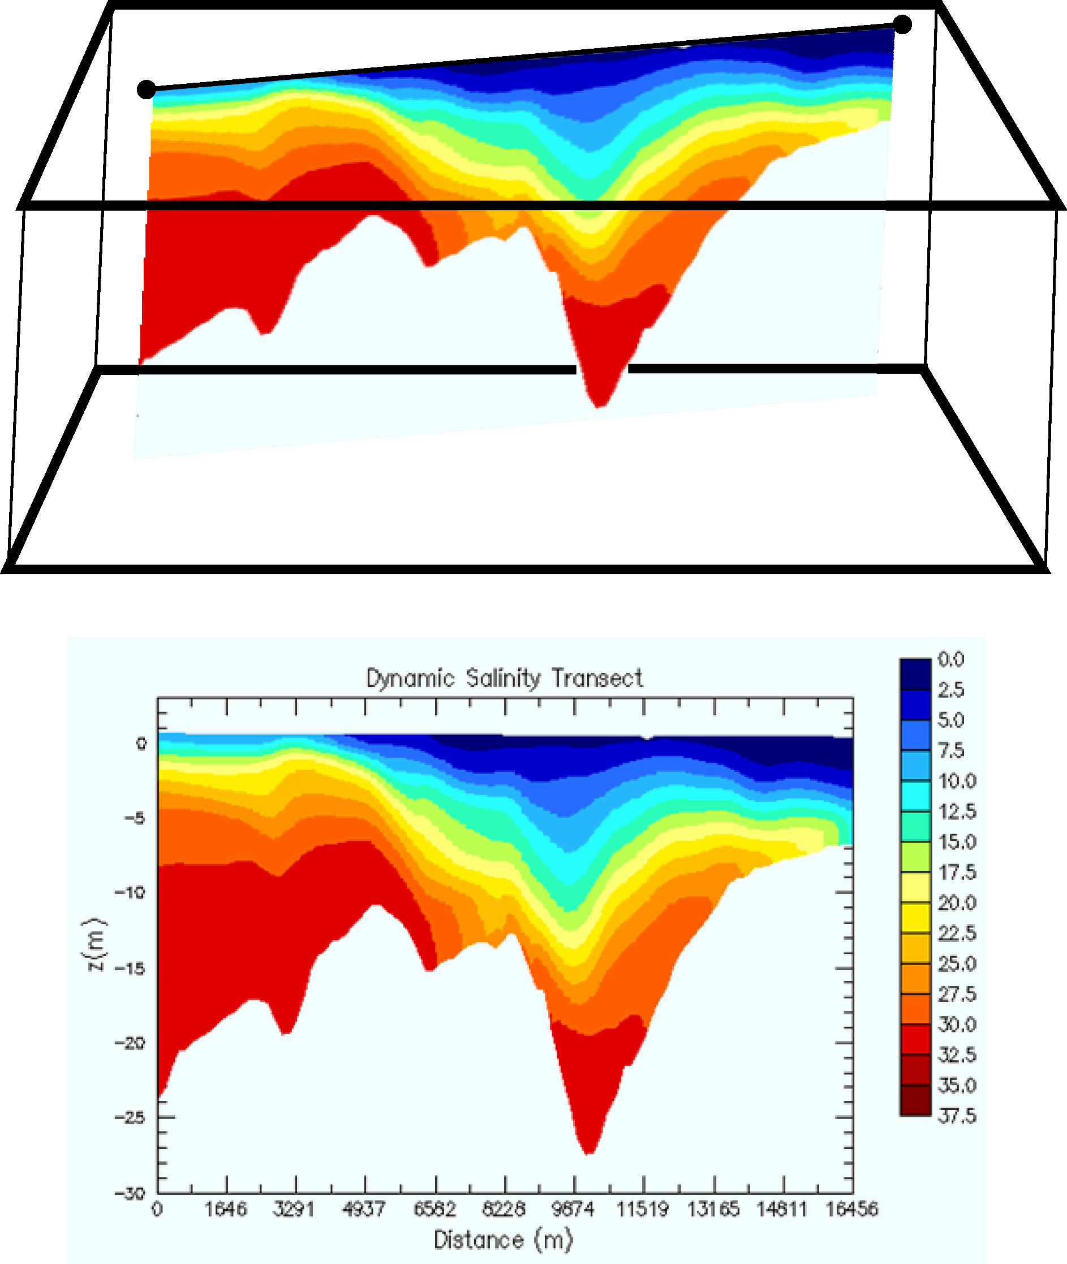
Figure 6. Stationary transect image generation.

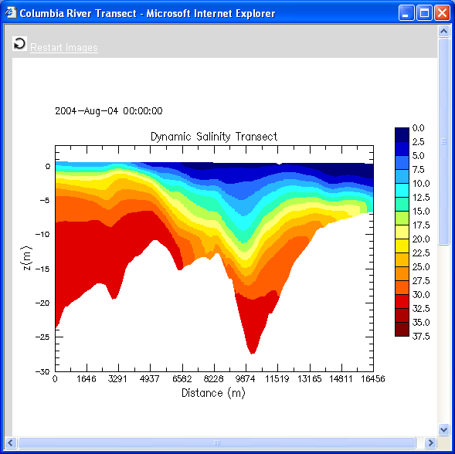
Figure 7. Example stationary transect output image. This is a salinity animation of forecast model output for 24 hours. The transect is defined via mouse clicks on the main map in the CORIE-Mapserver tool.

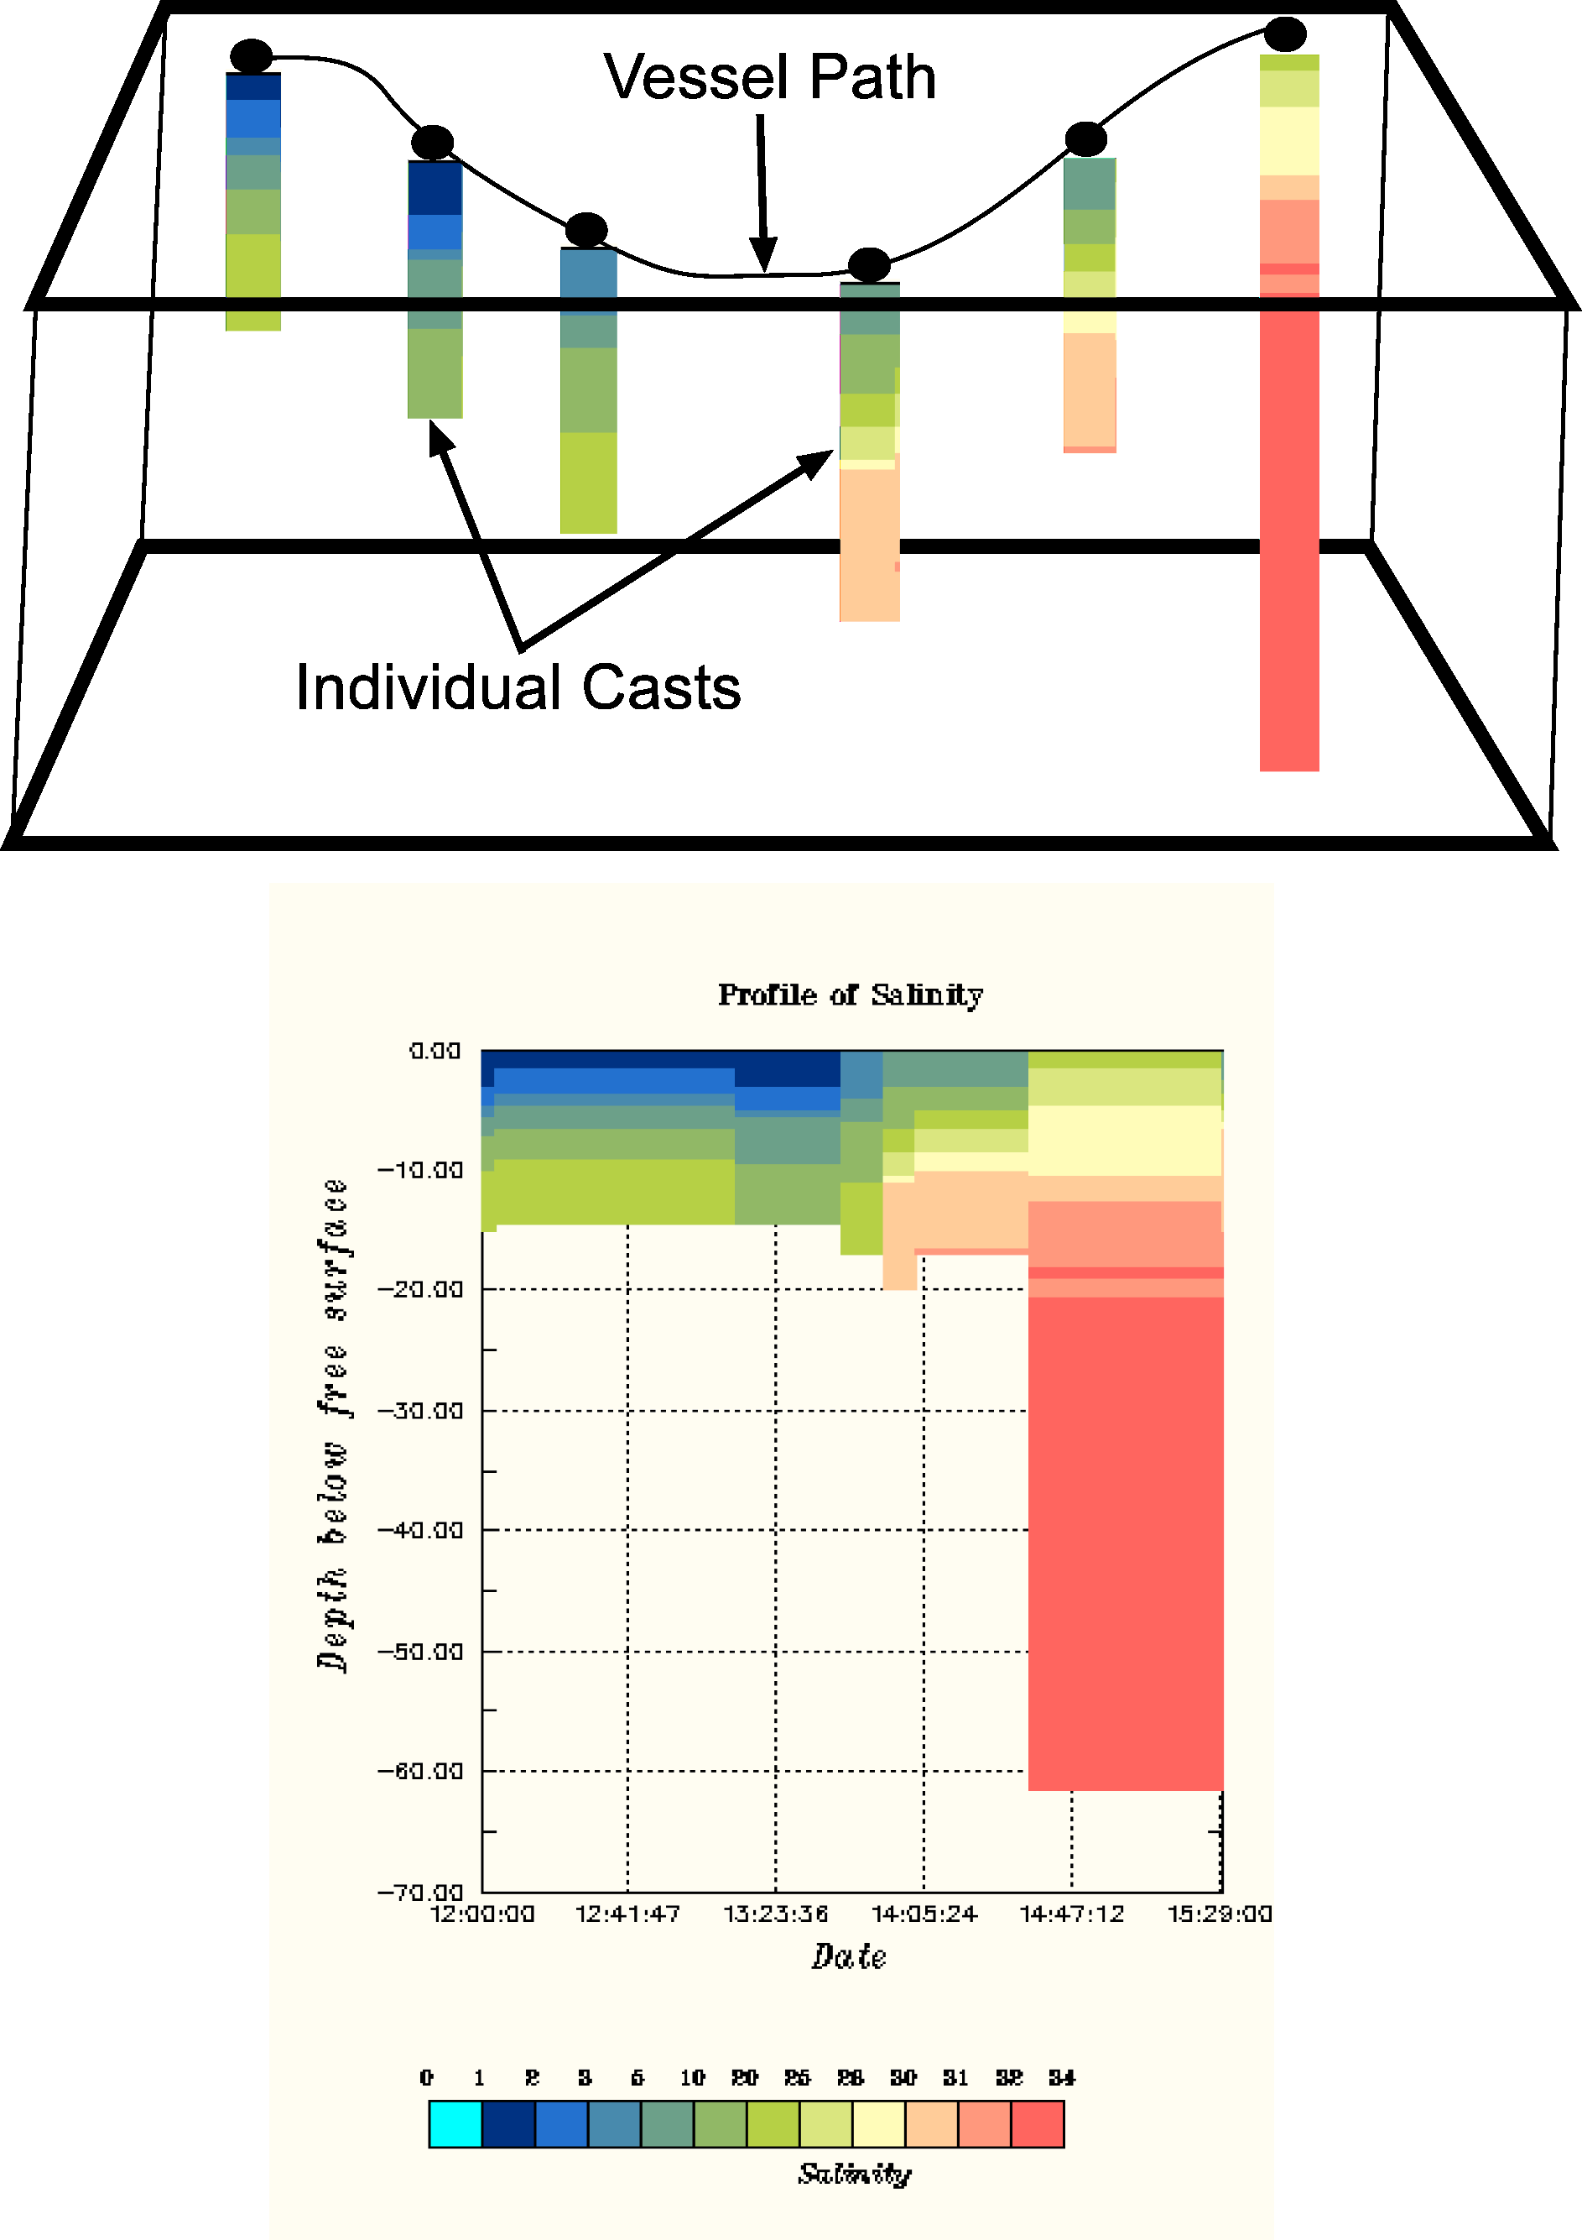
Figure 8. Vessel transect image generation.
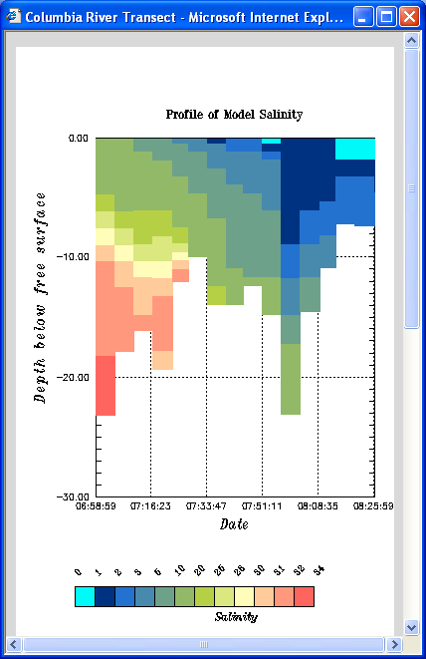
Figure 9. Example vessel transect output image. This is a graph of predicted model salinity, at the cast locations marked on the map, at the time the cast is to be taken.

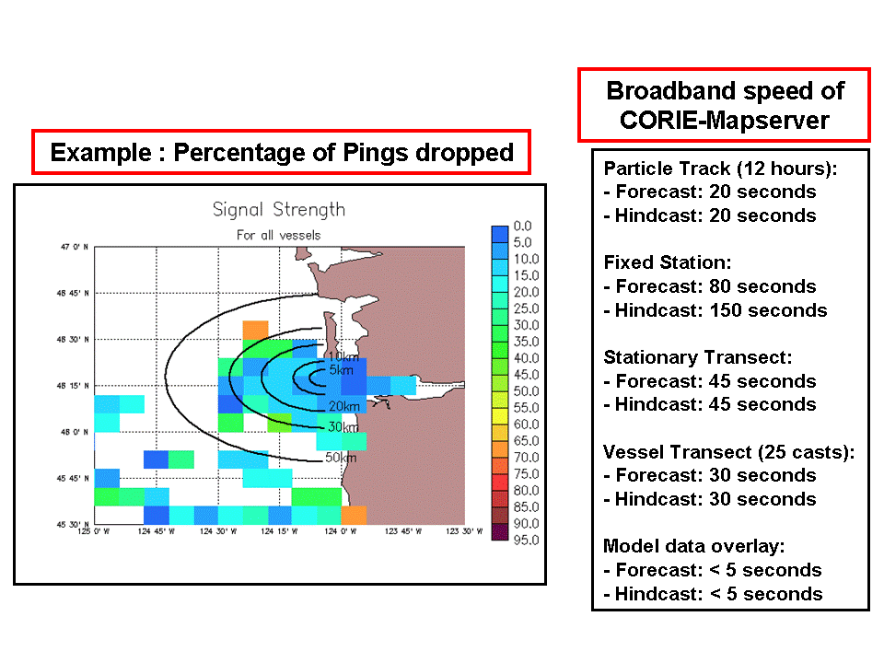
Figure 10. CORIE-Mapserver performance statistics. Example signal strength map based on pings dropped from network connections to roaming vessels in the Columbia River estuary and plume.

Table 1
Particle Tracking Database Table Definition

Column | Type | Modifiers
------------------------+------------------+-----------
id | integer |
time_step | integer |
particle_id | text |
spatial_error_distance | double precision |
forward_back | integer |
z_val | double precision |
element_num | integer |
level_num | integer |
eta_val | double precision |
iwet | integer |
u_val | double precision |
v_val | double precision |
w_val | double precision |
z2_val | double precision |
the_geom | geometry |
Check constraints:
"$1" CHECK (srid(the_geom) = -1)
"$2" CHECK (geometrytype(the_geom) = 'POINT'::text OR
the_geom IS NULL)

Table 2
Fixed Station Database Table Definition

Column | Type | Modifiers
-------------+------------------+-----------
id | integer |
web_address | text |
the_geom | geometry |
Check constraints:
"$1" CHECK (srid(the_geom) = -1)
"$2" CHECK (geometrytype(the_geom) = 'POINT'::text OR the_geom IS NULL)

Table 3
Stationary Transect Database Table Definition

Column | Type | Modifiers
-------------+----------+-----------
id | integer |
web_address | text |
the_geom | geometry |
Check constraints:
"$1" CHECK (srid(the_geom) = -1)
"$2" CHECK (geometrytype(the_geom) = 'LINESTRING'::text OR the_geom IS NULL)

Table 4
Vessel Transect Database Table Definition

Column | Type | Modifiers
-------------+----------+-----------
id | integer |
web_address | text |
the_geom | geometry |
Check constraints:
"$1" CHECK (srid(the_geom) = -1)
"$2" CHECK (geometrytype(the_geom) = 'POINT'::text OR the_geom IS NULL)

Table 5
Buoy Database Table Definition

Column | Type | Modifiers
--------------+----------+-----------
station_name | text |
the_geom | geometry |
Check constraints:
"$1" CHECK (srid(the_geom) = -1)
"$2" CHECK (geometrytype(the_geom) = 'POINT'::text OR the_geom IS NULL)

CHAPTER 3

REAL-TIME CRUISE PLANNING

USING WEB-BASED OPEN SOURCE GIS

3.1 Abstract

Leveraging web-based GIS in Coastal Margin Observatories is showing promise in improving accessibility and understanding of model outputs. The CORIE Coastal Margin Observatory has been built around an array of in-situ sensors located in both the estuary and plume regions of the Columbia River. Currently ELCIRC, a 3-D circulation model providing water elevation, velocity, salinity and temperature predictions for the Columbia River estuary and plume is being run operationally in the domain. With the operational cost of in-situ vessel cruises being high, it is clear that a real-time cruise planning method is needed to maximize efficiency and ensure capture of high quality data targeted at specific scientific questions. This section will introduce the use of a new web-based tool called CORIE-Mapserver, which is GIS enabled and fully integrated with the CORIE modeling system. The CORIE-Mapserver tool integrates point data, transects, particle trajectories and model imagery with contextual data in a spatially explicit and graphical form. Data is stored in an open-source database, accessed via an Open Geospatial Consortium standard interface and viewed via an open-source GIS. To validate this tool four individual 24-48 hour cruises were conducted in July of 2004. With the use of on-board Internet connectivity, real-time cruise planning decisions were made based upon CORIE model interaction using CORIE-Mapserver. This experience clearly shows long term benefit of on-demand product generation for cruise planning.

3.2 Introduction

Historically there has been a delicate balance in choosing when and how scientists collect long term in-situ data. Keeping costs low and sensors located in areas where they can withstand the environment often prevails over the desire to have densely spaced sensors with high sampling frequencies.
CORIE is a Coastal Margin Observatory (CMO) monitoring and modeling coastal circulation in the Columbia River Estuary [Baptista et al. 1999; Baptista, 2002; CORIE Coastal Margin Observatory, 2004]. The CORIE domain extends from the northern California coast to the south tip of Vancouver Island, Canada. The domain is bounded by Bonneville Dam 146.1 miles to the east of the mouth. To the west the domain is bounded by the continental shelf and the near coastal ocean. A dynamic estuary exists at the interface between the Columbia River and the Pacific Ocean. The CORIE CMO project currently has 17 permanent sensors in the estuary, one permanent sensor in the plume, and one seasonal sensor also located in the plume region.
CORIE currently uses the open-source model ELCIRC [Zhang & Baptista, 2004; Baptista et al., 2005], a 3-D circulation model capable of high resolution. While CORIE has the ability to integrate with alternative numerical models, ELCIRC was chosen for its ability to accurately represent the CORIE domain. ELCIRC numerically solves a coupled set of hydrostatic equations based on mass conservation, momentum conservation, and conservation of salt and heat. The ELCIRC model outputs water elevations, velocity fields, salinity and temperature. With a current model grid containing 50389 elements it can easily be demonstrated that the approximately 20 in-situ sensors providing observational data gives just a glimpse into how well the model is actually performing. It is this lack of observational data that drives the need for complimentary methods of data gathering in addition to traditional in-situ sensors.
One such alternative method is the use of a mobile station, which can move into geographical areas of interest based upon a scientific hypothesis. The downside to this method, like most other in-situ data gathering methods, is that it is very expensive. Due to the high cost associated with operation of these vessels it is of great importance to be able to: (1) make smart decisions dictating the location of mobile data gathering and (2) make these decisions in real-time as to utilize the most accurate predictions of physical parameters and reduce cruise costs.
The CORIE-Mapserver tool is a web-based GIS system linked to the CORIE CMO that uses standard CORIE data products and ELCIRC model output to produce on-demand data products (Chapter 2). This tool allows for the accurate prediction of cruise paths and locations while doing it in real time to reduce operational cost. Since CORIE-Mapserver is a GIS, utilization of other geo-referenced data sets is also made available through the interface (Appendix B).
To illustrate the challenges involved in cruise planning and how the CORIE-Mapserver environment helps solve many of the planning issues, we consider a set of four scientific cruises conducted in the CORIE domain during July 2004. During these cruises different scientific objectives were defined with the intent of using real-time model interaction to dictate spatial and temporal parameters of the cruise paths. We have included descriptions of pre-cruise analysis, methods for determining routes and sample times, overview of observed data and post-processing analysis.
After this introduction, subsection 3.3 presents the system application during the July 2004 Columbia River estuary and plume cruises. Subsection 3.4 analyses the strengths and limitations of using the CORIE-Mapserver tool as well as introduces directions for future research.

3.3 System Application – Cruise Planning, July 2004 Cruises

3.3.1 Scientific Objective
The thesis cruises of July 2004 related to the CORIE CMO had the intention of addressing two main issues:
1) Evaluation of the CORIE-Mapserver interface as a viable tool for making real-time cruise plans from a mobile vessel intended to study feature-based phenomena in the Columbia River estuary and plume.
2) Evaluate the ELCIRC model forecast ability to represent the following 4 features of the Columbia River estuary and plume system:
- Fresh-water plume-front gradients.
- Fresh-water plume shape, extent and dissipation characteristics.
- Salt wedge propagation within the south-shipping channel.
- Salt wedge propagation within the north-shipping channel.
With these scientific objectives in mind it was the intention of these cruises to use the CORIE-Mapserver tool in selecting both transect and fixed station locations best suited to provide field data for model-data comparisons. The general plan for the July cruises was to spend three 24-hour cruise shifts and one 48-hour cruise shift looking at the features outlined above. During the 24-hour cruises, 13 hours would be dedicated to an anchored fixed station that would give stationary insight into a full tidal cycle. The path for transects to be done over 5-8 of the remaining hours would be selected approximately one hour prior to leaving the fixed station and determined via use of the CORIE-Mapserver tool operated from the mobile vessel.
Using a set of five buoys, two from the CORIE CMO project and three from the River Influences on Shelf Ecosystem project [RISE, 2004], as points of reference, a determination of the best path to do four transects would be chosen. An effort to limit the water depth to 30 meters for all fixed stations would allow for the hull mounted Acoustic Doppler Current Profiler (ADCP) operational range criteria to be met.
First, using the standard plume-surface salinity animations produced by the current CORIE forecast model, general characteristics of surface plume movement are evaluated. Next, using the CORIE-Mapserver tool and the study features defined above, evaluation of the plume along different stationary transects for the current day are done to determine which of these transects would allow for the best chance to view the feature of interest. Finally, a determination of which locations along the transect paths to gather cast information is made.
A verification of this analysis is then done using the CORIE-Mapserver “Vessel Transect” tool, which allows for the definition of cast characteristics of a transect. This transect-path definition incorporates cast distance and boat speed inputs, which allow for the tool to generate placement criteria for the CTD casts. Cast images from model data are produced to verify that the final transects produce results aimed at answering the initial scientific questions.
Finally, post-cruise analysis is done to evaluate in-situ cruise data to that of forecast simulations. An analysis of the model’s ability to represent these plume and channel features will help determine how well the model is representing reality in the Columbia River System and how one might improve the model for future simulations.

3.3.2 Methods

3.3.2.1 Geographical Area of Interest. The geographical area of interest for the July cruises extends from the edge of the near-shore fresh-water plume off the mouth of the Columbia River Estuary to the salt-propagation interface upstream in the estuary. During the summer months, with low river discharge and typically light northerly winds, the plume tends to stay relatively close to the mouth of the estuary. For our purposes we will consider the plume to be bounded by 45-48 degrees north latitude and 126-123 degrees west longitude (Figure 11).

3.3.2.2 Equipment. The ship used for these studies was the MV Forerunner. Forerunner is a 50-foot research vessel, weighing 35 registered tons that is operated by the Clatsop Community College. A converted fishing vessel, this water-based classroom is now used cooperatively between Clatsop Community College and the CORIE CMO for both seamanship training and scientific research. The Forerunner is equipped with two CTD instruments, one located mid-ship as a flow through surface CTD, and the other mounted on a crane used for depth-integrated CTD casts. Both instruments are manufactured by Ocean Sensors with a model number OS200.
The Forerunner is equipped with one downward-looking hull-mounted ADCP. This instrument is manufactured by RD Instruments. The ADCP uses a 1200 KHz broadband signal and operating in direct-reading mode, this instrument can accurately profile current direction and speed. This system is integrated with a satellite gyro compass from Furuno.
During the July 2004 cruises, CORIE had two deployed ocean buoys. These buoys are equipped with meteorological stations as well as 10-meter-depth CTD sensors. The RISE project also had three buoys in the domain of this project during the July 2004 cruises.

3.3.2.3 Sampling Technique. CTD casts were typically done at 15 minute intervals. At stationary locations, this time interval allowed for the capture of the general processes we were interested in viewing while not overtaxing the crew doing this manual task. When the boat is doing transects the speed of the boat and features one is looking for start to influence the cast rate. Typically the Forerunner is able to maintain between 5-10 knots, depending on wind and current conditions. At this speed range a 15 minute cast rate produces a 1.25 – 2.5 nautical-mile cast spread. Where detailed features such as fresh water plume gradients were being recorded cast rates of down to 5 minutes were used, producing a .41 - .83 nautical-mile cast spread.

3.3.2.4 Metrics for Analyzing Cruise Results. Cast data is post-processed to generate graphs of salinity and temperature in color graduated form. These graphs are valuable for comparison with model data graphs of the same form generated from the GPS location and time information embedded in the original observation data. This side by side comparison allows for the qualitative assessment of model-observation accuracy both in feature structure and data values.
Another method for analyzing the observation and model data is to plot the differences between them. Through the use of this simple difference graph one can tell much about the nature of the model-data differences.

3.3.3 Contextual Data
The period of time in which the July 2004 cruises were held was marked by very typical Pacific Northwest summer weather (Figure 12). Moderate river discharge and variable winds marked a majority of the cruise period. Strong tidal range was observed and captured during 13-hour fixed station periods.
3.3.4 Cruise 1 – Plume Gradient Structure
The cruise plan for Cruise 1 started with capturing 13 hours of CTD casts at a fixed location in the mouth of the Columbia River. This fixed station period allowed for one full tidal cycle including a large ebb and large flood to be recorded and allowed for the boat to leave anchor and commence with a transect at approximately 11:30am on 07/13/2004. CORIE forecast model predictions were scheduled to finish by approximately 9am, so we planned to have 2.5 hours to plan the transect portion of the cruise before pulling anchor.
On the transect portion of the cruise, we attempted to look at the forecast model ability to represent the plume-front structure. In order to do this we had a goal to traverse into the center of the plume and back two times from four different directions.
At 9:45 am we gained access to all of the model run results for the 07/13/2004. We quickly determined from surface salinity plots overlaid on the base map that the plume was migrating north from the mouth of the river. From the model output we were able to determine a position of the middle of the fresh water plume both at the time of departure from the fixed station area as well as when we predicted our arrival at plume center. This location was determined to be 46.28 ºN, 124.11ºW. From this location information, fixed-station images were generated that indicated the dynamic nature of the plume center throughout the time period transects were to be taken. From this point it was determined that a northerly transect between the original anchor location, plume center, the RISE North (CN) buoy and back to the original anchor location would provide a unique look at the gradient structure of the northern side of the fresh water plume (Figure 13). A second shorter transect would be done linking the original anchor location to the RISE Central (CC) buoy, OGI02 buoy and back to the original anchor location.
The results of these two transects are graphically represented by two charts showing the observed cast data and the corresponding model data (Figure 14). It can be seen that while the model represents the general shape and structure of the fresh water plume, the model consistently underestimates the salinity of the plume region.

3.3.5 Cruise 2 – Plume Size and Shape
The cruise plan for Cruise 2 started with capturing 13 hours at a fixed location in the mouth of the Columbia River Estuary to capture one full tidal cycle including a large ebb and large flood. After capturing the fixed-station data the goal was to look at the model’s ability to represent the plume size and extent. To that end the intention was to traverse through the center of the plume northward observing the ability of the model to predict the plume length. Secondly we wanted to traverse the outer-west edge of the plume to see if the width was well represented.
A light southerly wind had the plume heading north on 07/15/04. A transect heading north along the shore to the mouth of Willipa Bay was determined to best capture the length feature of the plume as represented in the model. From this location, heading south-west toward RISE North buoy (CN) allowed for the traversal along the outer edge of the plume looking at width characteristics. Finally, heading back to the original anchor location gave another view at the gradient structure representation of the plume (Figure 15). The transect distance was determined to be 61.71 nautical miles. The turn-around location at Willipa Bay was determined to be 46.73ºN, 124.16ºW.
The results of these two transects are graphically represented by two charts showing the observed cast data and the corresponding model data (Figure 16). It can be seen that the model consistently underestimates the thickness of the plume region while consistently overestimating the freshness of the plume itself. This observation shows similar results to Cruise 1 with the consistent overestimation of salinity values while representing the general length and width features well.

3.3.6 Cruise 3a – Estuary– South Channel Salt Wedge Propagation
The cruise plan for cruise 3a was to focus on the South Channel in the middle part of the estuary to try and characterize the model response to tide-induced salt-wedge propagation up river. A 13-hour fixed-location casting duration in the South Channel was determined via interaction with CORIE-Mapserver to capture one full tidal cycle including a large ebb and large flood.
The final location chosen for the South Channel estuary fixed station was near the Red26 CORIE station, on the deep (south) side of the South Channel (Figure 17). The CORIE-Mapserver tool was used to generate a set of time series images to show what the ELCIRC model forecasts predicted (Figure 18).
The results of this fixed station show that the model drastically overestimates the fresh water presence during the entire fixed station. Again, the general structure looks promising, but both salt propagation and salt mixing need to be examined in future revisions of the model.

3.3.7 Cruise 3b – Plume Dissipation
On this part of the cruise, we wanted to then look at the model’s ability to represent the plume size and location during a plume dissipation period. The goal was not to traverse into the center of the plume, but instead to look at the outer portions of the plume as it dissipates into the off-shore ocean.
For the first leg of the transect we decided to follow the South Channel out into the mouth. This transect had a distance of 11.01 nautical miles with a cast interval of 9.5 minutes. This cast rate gave a total of 11 casts starting at 11:15am and ending at 12:59pm. The pre-generated model cast images indicated that we would see a slightly stratified system on the way to the mouth of the estuary.
The second transect, predicted using the vessel-transect tool, indicated a transect distance of 30.12 nautical miles with a cast interval of 13.25 minutes. This cast rate gave a total of 18 casts starting at 12:30 am and ending at 4:28pm (Figures 19).
The results of this transect showed the model consistently overestimates the thickness of the plume region while consistently overestimating the freshness of the plume itself (Figure 20). This is a consistent observation for the CORIE model predictions with good representation of the general fresh water plume structure.

3.3.8 Cruise 4 – Estuary – North Channel Salt Wedge Propagation
Due to timing constraints and tidal influences it was decided before the start of Cruise 4 that the 48 hour total duration would be divided into an initial transect followed by two fixed station sessions in the North Channel.
On this cruise we wanted to first look at the model’s ability to represent the North Channel salinity structure. In order to do this the goal was to traverse from the outer mouth of the estuary up to the start of the North Channel and then do 3 transects of the North Channel as far up as the CORIE sensor AM12. The three transects corresponded to the north, middle, and south sides of the main North Channel. After doing the transects, it was determined that a 25-hour fixed location in the North Channel to catch two full tidal cycles including two large ebbs and two large floods would be beneficial. Following the 25-hour fixed location, another 13-hour station near the confluence of the North and South Channels was chosen.
The first part of the transect was to head out to the mouth of the estuary and then back toward the North Channel. Using the CORIE-Mapserver tool a transect was selected that was 17.75 nautical miles with a cast interval of 5.75 minutes. With this cast rate a total of 34 casts where done starting at 4:30pm and ending at 7:45pm (Figure 21). A profile of predicted salinity was generated along the transect to help guide expectations of cast measurements.
The results of this transect are graphically represented by two charts showing the observed cast data and the corresponding model data (Figure 22). It can be seen that the model consistently overestimates the thickness of the fresh water region of the salt wedge while consistently underestimating the distance the salt wedge propagates up the river. This observation has led to current investigations into the bottom drag coefficients for different regions of the ELCIRC domain.
The fixed stations for this cruise were located near CORIE station AM12 and the confluence of the North and South Channels in the estuary. These stations were chosen due to their proximity to important processes of the fresh-water salt-water interface, namely the passing of the estuarine salt wedge. The results of these fixed stations showed that the model drastically overestimates the fresh water presence during the entire fixed station. Again, the general structure is well represented, but both salt propagation and salt mixing need to be looked at in future revisions of the model.

3.4 Results and Future Direction

Application of the CORIE-Mapserver tool to the July 2004 thesis cruises has shown that real-time interaction with model data can provide positive results in the field. The ability to inexpensively generate predictive cruise plans with up-to-date model data in the field is an active area of investigation that is showing great promise.
The use of the CORIE-Mapserver tool in the July 2004 cruises proved to be useful due to its low bandwidth requirements, easy-to-navigate interface and rich modeling data set. With a goal of observing four physical estuarine features, we were able to predicatively do so without ever stepping on shore or utilizing resources outside of the boat and Internet connection.
In the future we intend to expand the utilization of the CORIE-Mapserver tool to applications currently underserved by the observation and modeling community. As an example, the opportunity exists to link circulation modeling with the application of water-based search and rescue. Through the use of particle tracking software and real-time model predictions, it is possible to predict both location and error metrics associated with search and rescue scenarios in the Columbia River system.
New methods of model interaction are proving promising in the area of educational outreach. Through the use of scenario-based curricula, students at all levels have the potential to answer scientific questions related to water based ecosystems. It is hoped that the CORIE-Mapserver system will exist as a link between science and education while acting as a catalyst for learning.
Fish habitat in estuarine systems is closely tied to the circulation of water and the physical parameters of their environment. Through the use of GIS capabilities it is envisioned that metrics such as fresh-water plume volume and freshwater-saltwater interface delineation can be visualized on the fly. Linking this classification technology with “smart” particle tracking software that links biological behavior to physical surroundings shows promise in enabling insight into fish habitat and migration issues.
Real-time environmental-hazard response is another area where GIS has begun to show real promise. Through the use of flow-field information and the ability of GIS to display vector and raster data layers, it is becoming possible to visualize hazard and response scenarios in real time. Through the use of open-source tools over the web, it is envisioned that this type of tool would become more available to larger groups of people than ever before.
Model data comparisons from the four cruises completed in July 2004 have led to investigations of both salt propagation in the estuary and salt mixing in the entire domain of the ELCIRC model. Through this study, it was also determined that the background salinity imposed at the ocean boundary was underestimated in the ELCIRC model. Corrective actions taken because of the cruise data gathered in July 2004 have significantly improved the CORIE CMO ability to model and predict the physical parameters of the Columbia River system.
All cruise CTD and ADCP data for the July cruises as well as model-data comparisons can be found on the CORIE CMO web site.

3.5 References

Baptista, A. M., Wilkin, M., Pearson, P., Turner, P., McCandlish, C., and Barrett, P. (1999) Coastal and estuarine forecast systems: a multi-purpose infrastructure for the Columbia River. Earth System Monitor. 9: 1-2, 4-5, 16.

Baptista, A. M. (2002) Environmental observation and forecasting systems. In Encyclopedia of Physical Science and Technology, 3rd Ed. (Meyers, R. A., Ed.), Academic, San Diego, pp. 565-581.

Baptista, A. M., Zhang, Y. L., Chawla, A., Zulauf, M. A., Seaton, C., Myers, E. P., Kindle, J., Wilkin, M., Burla, M., and Turner, P. J. (2005) A cross-scale model for 3D baroclinic circulation in estuary-plume-shelf systems: II. Application to the Columbia River. Continental Shelf Research, in press.

CORIE Coastal Margin Observatory. Available: http://www.ccalmr.ogi.edu/CORIE/ [Viewed: December, 2004]

RISE - River Influences on Shelf Ecosystem. Available: http://www.ocean.washington.edu/rise/index.htm [Viewed: December, 2004]

Zhang, Y., and Baptista, A. M. (2004) A cross-scale model for 3D baroclinic circulation in estuary-plume-shelf systems: I. Formulation and skill assessment. Continental Shelf Research 24: 2187-2214.

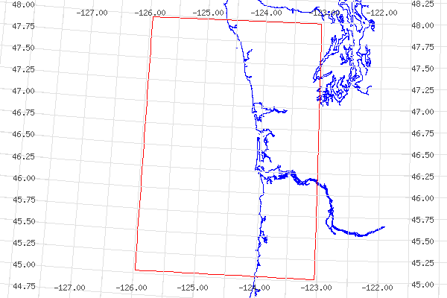
Figure 11. Geographical area of interest for July 2004 cruises: 48-45 degrees north latitude and 126-123 degrees west longitude.

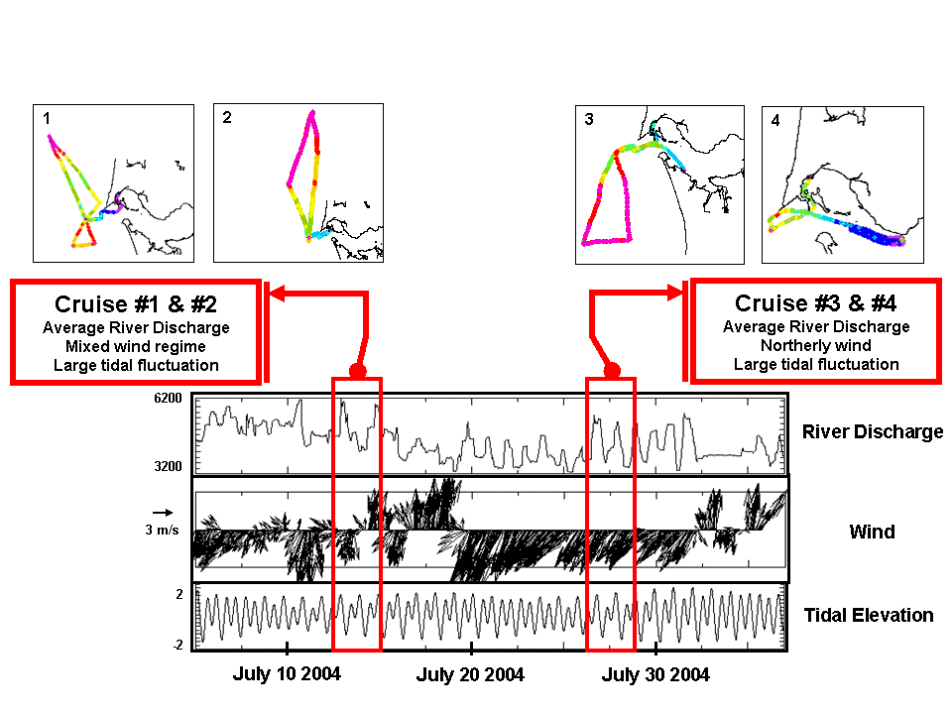
Figure 12. Graphs of system forcing during the July 2004 cruises. Bonneville Dam river flux, near shore wind direction and magnitude, and tidal range.

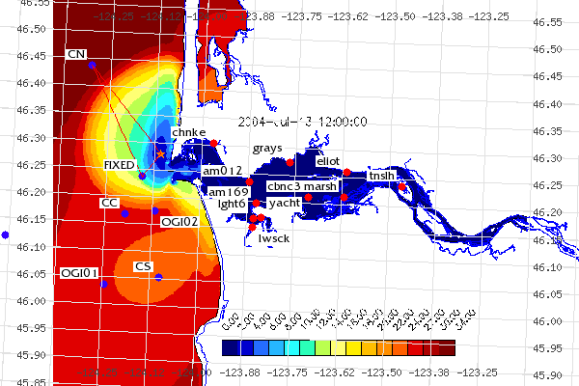
Figure 13. Cruise 1 – Plume gradient transect overlaying forecast model data.

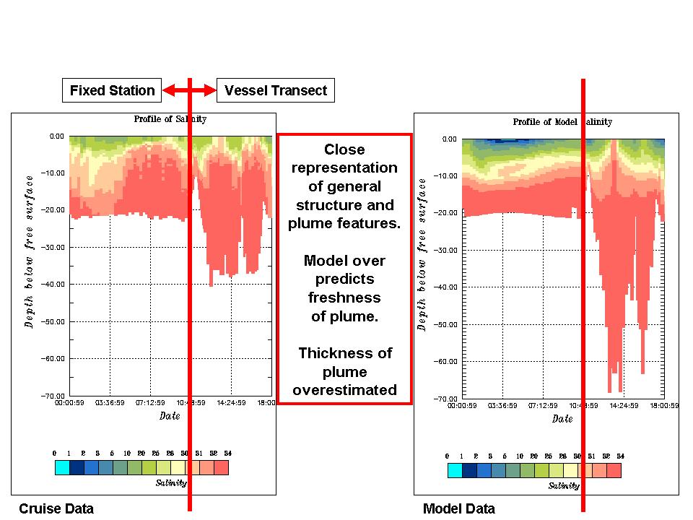
Figure 14. Cruise 1 – Model-Data comparison.

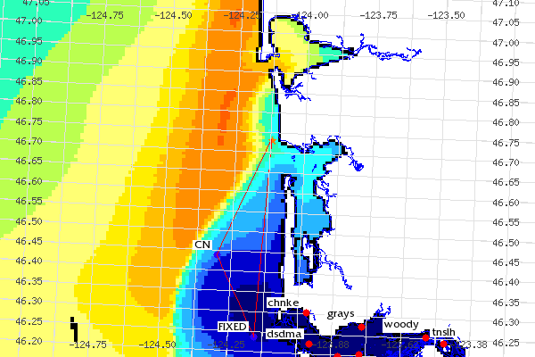
Figure 15. Cruise 2 – Transect path looking at plume length and width.

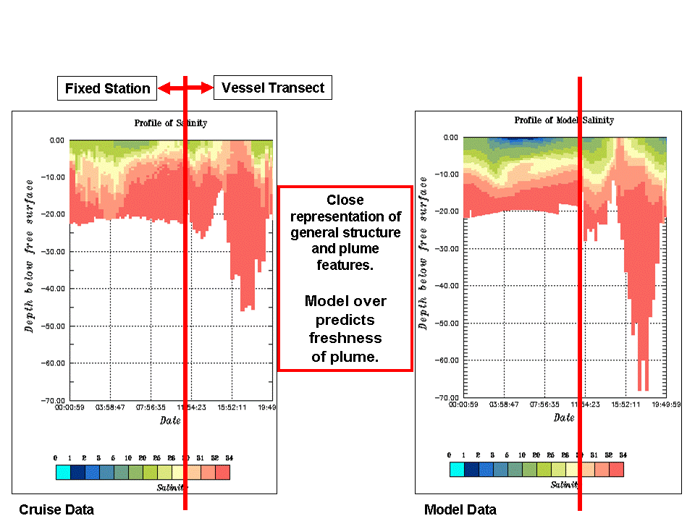
Figure 16. Cruise 2 – Model-Data comparison.

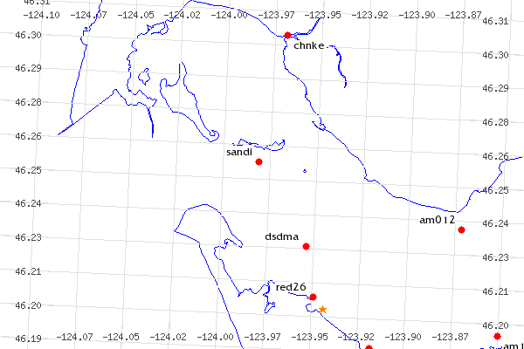
Figure 17. Cruise 3a – Fixed location indicated by a star.

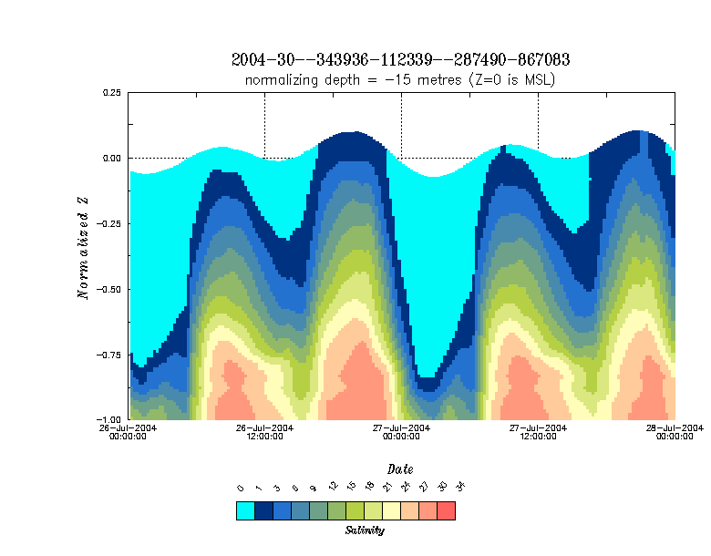
Figure 18. Cruise 3a – Model salinity profile for South Channel fixed station.
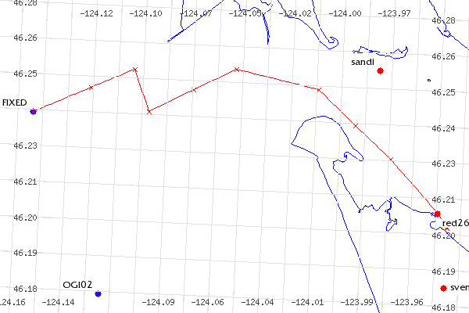
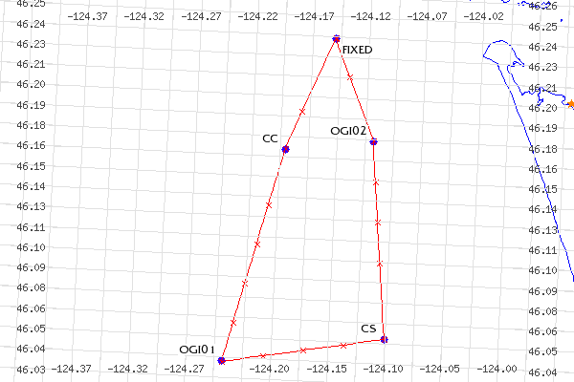
Figure 19. Cruise 3b – Transect and cast locations for plume dissipation study.

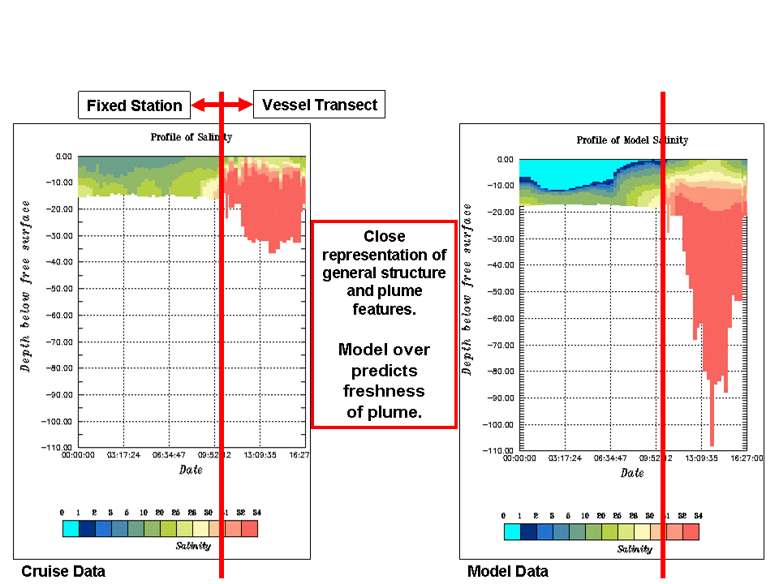
Figure 20. Cruise 3 – Model-Data comparison.

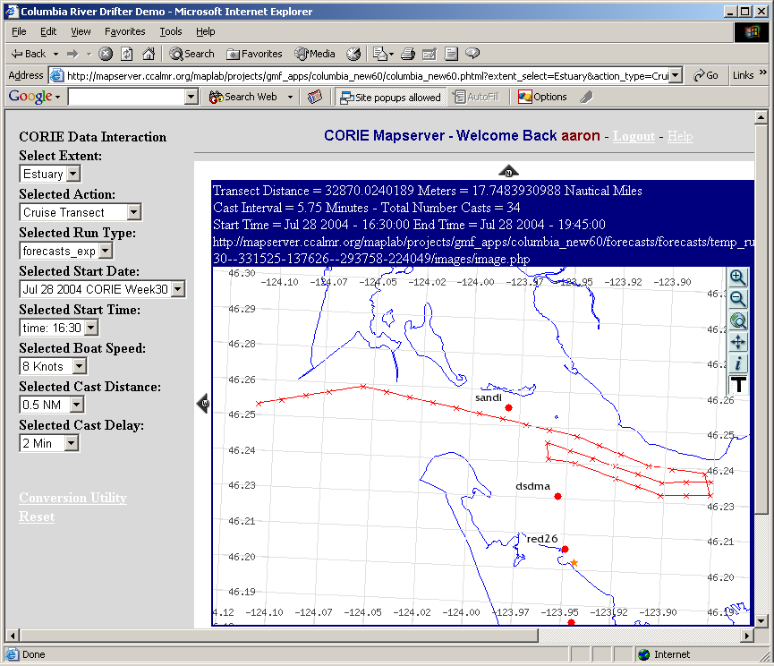
Figure 21. Cruise 4 – Transect path and cast locations.

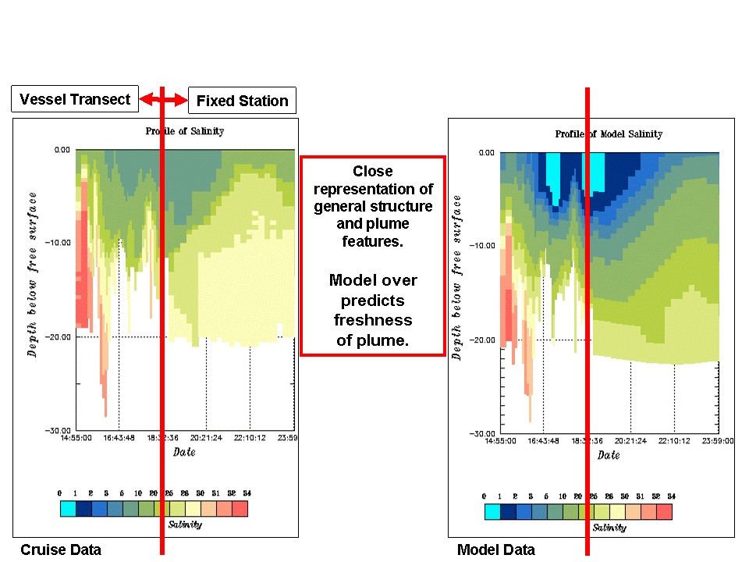
Figure 22. Cruise 4 – Model-Data comparison.

CHAPTER 4

FINAL CONSIDERATIONS

4.1 Synthesis and Conclusions

What started as an idea to bring web-based GIS to a small application within a CMO has grown into a new direction for user-based interaction with observation and forecasting data. No longer is it acceptable to have a limited number of images of model data available to end users. No longer is it acceptable to have observation data only accessible via table-driven interfaces. Users expect spatially explicit data to be presented in a spatially explicit format. User friendly interfaces are expected from scientists and managers alike. Finally, a diverse user base requires an interface that is both accessible and extensible.
We have shown that, through systematic development using open-source tools, it is possible to bring web-based GIS to CMOs. In doing so we have also shown that we have only scratched the surface of the potential of this technology. The CORIE-Mapserver environment has served the purpose of creating an example of using web-based GIS to navigate spatially explicit data in a user friendly manner.
The July 2004 cruises were used as a testing ground to show the feasibility and benefit of using a web-based GIS tool to interact with a CMO. Through the utilization of both production data products and the CORIE-Mapserver tool we were able to conduct four successful cruises targeted at specific scientific objectives in a more systematic and informed manner than ever before. Using model forecast data in real time from the cruise vessel, four cruise paths were determined that directly resulted in data capture that has improved the numerical models. This project was done with low development cost and high operational economic savings.

4.2 Contributions

The thesis cruises of July 2004 contributed to identifying limitation of the CORIE predictions of salinity in both the estuary and plume regions. These deficiencies have since been partially addressed by separate work (Figure 23), including the development of a new model called SELFE [Zhang, Y. L., & Baptista, A. M., unpublished data].
Open-source web-based GIS technology has now become an integral part of the CORIE CMO development path. Projects are currently underway to not only help end users interact with model data, but to allow people to set up modeling systems in a spatially explicit and user friendly manner to help solve problems in their local regions. These new systems are showing improvement in both functionality and usability (Figure 24), but are based upon the foundations of CORIE-Mapserver [Turner, P. & Baptista, A. M., unpublished data]. The CORIE-Mapserver project has been a launch pad for future development in the CORIE CMO system and will hopefully provide a similar motivation to other CMOs.
It is the intention over time to feed the CORIE development products back into the open-source community. Just as we have built this system on open-source products, we hope that our contributions will help others advance the science of CMOs and the field of web-based GIS (Appendices A and C).

4.3 Implications

The power of GIS in the realm of CMOs has just started to be realized. Implications on model development, data visualization, and user interaction are becoming apparent. Web-based technologies are of particular interest because of the scope of the user base of this wide-reaching medium.
Through the use of standards based GIS protocols we hope to not only enhance the ability of the CORIE CMO to affect local issues, but to interconnect with other CMOs at the regional and national level. There are already efforts to create such an interconnection through regional organizations such as the Northwest Association of Networked Ocean Observing Systems [NANOOS. 2004] and at the national level through the National Office for Integrated and Sustained Ocean Observations [Ocean.US, 2004]. The CORIE CMO is poised to help lead the way in implementing such a network of systems.

4.4 Acknowledgments

The National Science Foundation (ACI-0121475, OCE-0239072), Bonneville Power Administration (00019126) and National Oceanic and Atmospheric Administration (AB133F-04-SE-0304, AB133F-03-SE-1227, AB133F-04-RP-0033, NA17FE1026) provided financial support for this research. Any opinions, findings, and conclusions or recommendations expressed in this material are those of the author and do not necessarily reflect the views of these organizations.

4.5 References

NANOOS – Northwest Association of Networked Ocean Observing Systems. Available: http://www.nanoos.org/ [Viewed: December, 2004]

Ocean.US - National Office for Integrated and Sustained Ocean Observations. Available: http://www.ocean.us/ [Viewed: December, 2004]

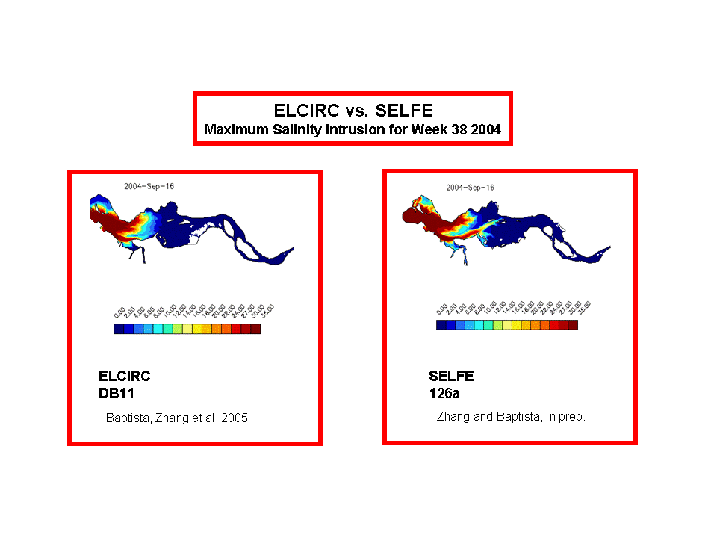

Figure 23. Model improvement influenced by CORIE-Mapserver. SELFE shows great improvement over ELCIRC in the ability to propagate salt into the estuary.

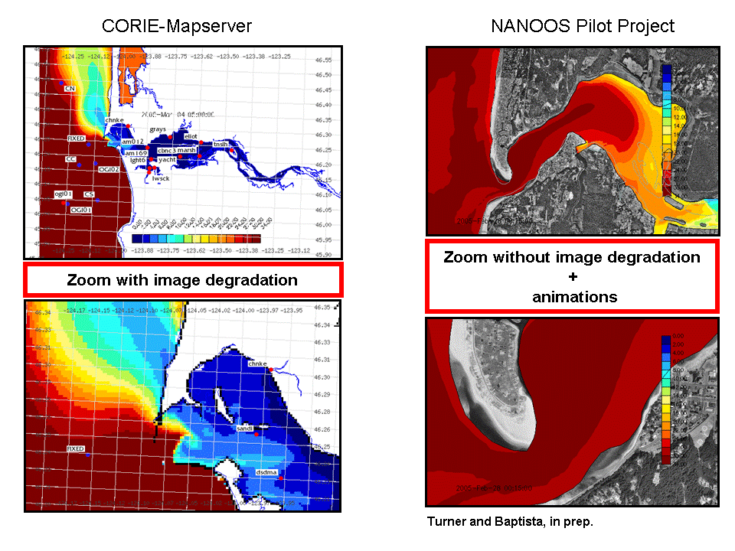

Figure 24. Tool improvement influenced by CORIE-Mapserver.

APPENDIX A – Mapserver Installation

The following is intended to serve as a reference for the installation procedure followed in creating the CORIE-Mapserver environment. This material is version specific and should only be viewed as a guide.

+++++++++++++++++++++++++++++++++++
Initial machine configuration
Intel Box, 1 Gig main memory
Dual 40 Gig, mirrored hard drives
Redhat Enterprise Linux 3.0 – AS
Apache web server

RPMS located in:
/src/RPMS/
All tar balls located in:
/src/package_name
+++++++++++++++++++++++++++++++++++

1) RPM removal/installation

All RPMS that are installed are stored in the /src/RPMS directory

Check RPM's that are needed and verify they are there:
Curl::
curl-devel-7.10.6-4.1
curl-7.10.6-4.1
JPEG::
libjpeg-6b-30
libjpeg-devel-6b-30
PNG::
libpng-1.2.2-16
libpng-devel-1.2.2-16

Now remove all RPM’s that are in conflict and need re-compile:
GD::
rpm -e gd-devel
rpm -e glibc-util
rpm -e glibc-utils
PHP::
rpm -e webalizer
rpm -e php-imap
rpm -e php-ldap
rpm -e php

Next, add the RPM's that are needed:
PDF::
wget ftp://speakeasy.rpmfind.net/linux/falsehope/home/gomez/libpdf/pdflib
-4.0.1-1.i386.rpm
rpm -Uvh pdflib-4.0.1-1.i386.rpm
MING::
wget ftp://ftp.task.gda.pl/vol/d35/ftp.pld-linux.org/dists/1.1/PLD/i386/PLD/RPMS/ming-0.2a-5.i386.rpm
rpm -Uvh ming-0.2a-5.i386.rpm

2) Update ldconfig
Add /usr/local/lib to /etc/ld.so.conf
Run : /sbin/ldconfig

3) PROJ4
cd proj4/
tar -xzvf proj-4.4.7.tar.gz
cd proj-4.4.7
cd nad/
wget ftp://ftp.remotesensing.org/pub/proj/proj-nad27-1.1.tar.gz
tar -xzvf proj-nad27-1.1.tar.gz
cd ..
./configure
make
make install

4) GDAL
cd gdal
ls
cd gdal-1.2.0
./configure
make
make ogr-all
make install

5) GD
cd gd
cd gd-2.0.22
./configure
make
make install

6) Postgresql
cd postgresql-7.4.2
NOTE the LDFLAGS here... this is to support GEOS for postGIS
LDFLAGS=-lstdc++ ./configure --with-perl
gmake
gmake install

Add the shared library path to /etc/ld.so.conf :
/usr/local/pgsql/lib
Run:: /sbin/ldconfig

Run make install in the ./doc directory to install the documentation

Finally add the following to the profile file to make paths available:
PATH=$PATH:/usr/local/pgsql/bin
MANPATH=$MANPATH:/usr/local/pgsql/man
export MANPATH

7) PHP
cd php/
cd php-4.3.4
rm config.cache
./configure --enable-force-cgi-redirect --with-config-file-path=/etc/httpd/ --with-gd=/usr/local --with-jpeg-dir=/usr/lib --with-png-dir=/usr/lib --with-tiff-dir=/usr/lib --with-zlib-dir=/usr/lib --with-freetype-dir --without-ttf --with-mysql --with-regex=system --with-ming=/usr/lib --enable-dbase --enable-dbx --enable-versioning --with-pgsql=/usr/local/pgsql
make
strip php
cp sapi/cgi/php /var/www/cgi-bin/
make install
cp php.ini-dist /etc/httpd/php.ini
emacs /etc/httpd/php.ini
Here change the following:
< extension_dir = /etc/httpd/php_mods
---
> extension_dir = ./

mkdir /etc/httpd/php_mods
emacs /etc/httpd/conf/httpd.conf

Add the following::

#
# For PHP scripts as CGI-BIN
#
AddType application/x-httpd-php-cgi .php .php4 .phtml
Action application/x-httpd-php-cgi /cgi-bin/php

Now re-start the server:
[root@mapserver php-4.3.4]# /etc/rc.d/init.d/httpd restart
Stopping httpd: [ OK ]
Starting httpd: [ OK ]
[root@mapserver php-4.3.4]#

8) GEOS
./configure
make
make install

9) Postgis
Just make sure that the Postgresql is configured with the LDFLAGS variable set and that the GEOS software is downloaded and installed from Refractions.

make
make install

Now we can create the database:

createdb -O postgres columbia
createlang -U postgres plpgsql columbia
psql -U postgres -d columbia -f ../share/contrib/postgis.sql
psql -U postgres -d columbia -f ../share/contrib/spatial_ref_sys.sql
psql columbia

Actually add a schema:

CREATE TABLE ptrack (ID int, time_step int, particle_id text, spatial_error_distance float, forward_back int, x_val float, y_val float, z_val float, element_num int, level_num int, eta_val float, iwet int, u_val float, v_val float, w_val float, z2_val float);

SELECT AddGeometryColumn('columbia', 'ptrack30', 'the_geom',-1, 'POINT', 2);

10) Mapserver

./configure --with-jpeg --with-gd --with-freetype --with-zlib --with-png --with-pdf --without-tiff --with-proj --with-threads --with-gdal --with-postgis --with-php=/src/mapserver_4_0_1/php/php-4.3.4
make

cp legend mapserv scalebar /var/www/cgi-bin/
cp mapscript/php3/php_mapscript.so /etc/httpd/php_mods/

11) Maplab
Create a var/www/html/maplab symbolic link to maplab download
Change permissions
Configure via the web

APPENDIX B – GIS data sources and Metadata

The GIS data sources for the CORIE-Mapserver project fall into two main categories. The first category is reference layers derived from external sources. Included are the coastline and Digital Raster Graphics (DRG) topographic layers. The second category is of internally produced layers for the CORIE Coastal Margin Observatory. Included are the particle track, transect, fixed station, estuary station, plume station and model data raster images.

Datum and projections

The CORIE project has chosen the Oregon State Plane Coordinate System (OSPCS) as the standard projection for all output in the modeling system. While this coordinate system has advantages in the local area of interest, it is not a commonly used coordinate system in the marine science community. To resolve this issue, the CORIE-Mapserver interface allows for requests to be input in either OSPCS or geographic latitude and longitude based on the NAD83 Datum. While the map display in the CORIE-Mapserver tool is in OSPCS, a latitude-longitude grid has been added as a default layer for use when in a field environment.
CORIE-Mapserver utilizes PROJ.4 to convert all map layers to OSPCS before the final map is generated.

Coastline

The coast line layer is from the National Geophysical Data Center at the National Oceanographic and Atmospheric Association. The Coastline Extractor utility was used to download the west coast data for the United States in ArcInfo format (http://oas.ngdc.noaa.gov/mgg/plsql/extractor.search_screen). This vector coastline is referenced to the WGS84 Datum and supplied in Latitude-Longitude. This data has been converted to an ESRI Shapefile.

Topographical maps

DRG’s are available for the Columbia River Estuary region. These maps are downloaded from the Oregon and Washington BLM web site located at http://www.or.blm.gov/gis/. This data is derived from the USGS quarter quads and maintained by the Oregon BLM office. The reference datum is NAD27. The GDAL library was used to create a tile-index that allows for raster tiling and more rapid display of raster graphics in UMN Mapserver.

Particle tracks, transects and fixed stations

All particle tracks, transects, and fixed stations are generated via custom software that reference the OSPCS. All of this data is stored in the PostgreSQL database and referenced via the PostGIS interface. The Proj.4 EPSG value of OSPCS (32026) is used for this layer.

Station locations

Estuary station locations are referenced via an ESRI Shapefile containing both name and location information for all CORIE stations. This data references the OSPCS and is updated on a regular basis via in field GPS measurements during installation and maintenance. The Proj.4 EPSG value of OSPCS (32026) is used for this layer.

Buoy locations

Remote plume buoy locations are stored in the PostgreSQL database and referenced via the PostGIS interface. All plume buoy locations reference geographic latitude-longitude based on the NAD83 Datum. Buoy locations are determined via GPS when deployed and updated on a regular basis.

Model data

All model data displayed is generated via the ACE toolset. The datum of reference is OSPCS. Original images are generated in GIF format and then converted to TIFF via the GDAL raster utility. TIFF World files, containing geo-referencing information for the images, are generated based upon output from the ACE toolset as to the extent and corner coordinates of the original images. The Proj.4 EPSG value of OSPCS (32026) is used for this layer.

APPENDIX C – CORIE-Mapserver Map File

Below is a copy of the UMN Mapserver mapfile at the time of publication. This material is installation sensitive and should only be used as a reference.

#######################################################################
MAP
NAME "Columbia River"
STATUS ON
# Extent in feet
EXTENT 1033464 853018 1256561 1013779
SIZE 600 400
SHAPEPATH "/src/mapserver_4_0_1/maplab/maplab-2.1-
rc3/projects/columbia/data_columbia"
SYMBOLSET "/src/mapserver_4_0_1/maplab/maplab-2.1-
rc3/projects/columbia/etc/symbols.sym"
FONTSET "/src/mapserver_4_0_1/maplab/maplab-2.1-
rc3/projects/columbia/etc/fonts.txt"
IMAGECOLOR 255 255 255
TRANSPARENT OFF
UNITS FEET
INTERLACE ON
IMAGETYPE PNG
IMAGEQUALITY 75
WEB
IMAGEPATH "/tmp/"
IMAGEURL "/tmp/"
END
QUERYMAP
STATUS OFF
SIZE -1 -1
COLOR 255 255 0
STYLE HILITE
END
PROJECTION
"init=epsg:32026"
END
LEGEND
STATUS OFF
KEYSIZE 20 10
KEYSPACING 5 5
LABEL
TYPE BITMAP
SIZE MEDIUM
OFFSET 5 5
BUFFER 0
MINDISTANCE -1
MINFEATURESIZE -1
COLOR 0 0 0
PARTIALS TRUE
FORCE FALSE
END
END
SCALEBAR
STATUS ON
COLOR 100 100 100
IMAGECOLOR 217 217 217
TRANSPARENT ON
UNITS METERS
SIZE 200 3
STYLE 1
POSITION LL
INTERLACE ON
LABEL
TYPE BITMAP
SIZE MEDIUM
OFFSET 5 5
BUFFER 0
MINDISTANCE -1
MINFEATURESIZE -1
COLOR 0 0 0
PARTIALS TRUE
FORCE FALSE
END
END

LAYER
NAME "Model Data"
STATUS ON
DATA "./model_data/blank.tif"
TYPE RASTER
PROJECTION
"init=epsg:32026"
"units=m"
END
END

LAYER
NAME "DRG 1:2000 - 1:48000"
STATUS OFF
TILEINDEX "drg_tile2.shp"
TILEITEM "location"
TYPE RASTER
PROJECTION
"init=epsg:26710"
END
MINSCALE 2000
MAXSCALE 48000
END

LAYER
NAME "Chart_Estuary_East_NOAA"
STATUS OFF
DATA "./chart_map/1739.tif"
TYPE RASTER
PROJECTION
"proj=merc"
"ellps=WGS84"
"lat_ts=46.206"
END
END

LAYER
NAME "Chart_Estuary_West_NOAA"
STATUS OFF
DATA "./chart_map/1737.tif"
TYPE RASTER
PROJECTION
"proj=merc"
"ellps=WGS84"
"lat_ts=46.217"
END
END

LAYER
NAME "Chart_South_NOAA"
STATUS OFF
DATA "./chart_map/1735.tif"
TYPE RASTER
PROJECTION
"proj=merc"
"ellps=WGS84"
"lat_ts=45.6666666666667"
END
END

LAYER
NAME "Chart_North_NOAA"
STATUS OFF
DATA "./chart_map/1730.tif"
TYPE RASTER
PROJECTION
"proj=merc"
"ellps=WGS84"
"lat_ts=47.0"
END
END

LAYER
NAME "Chart_Estuary_East"
STATUS OFF
DATA "./bsb/18523_1.tif"
TYPE RASTER
PROJECTION
"proj=latlong"
"datum=NAD83"
END
END

LAYER
NAME "Chart_Estuary_West"
STATUS OFF
DATA "./bsb/18521_1.tif"
TYPE RASTER
PROJECTION
"proj=latlong"
"datum=NAD83"
END
END

LAYER
NAME "Chart_South"
STATUS OFF
DATA "./bsb/18504_1.tif"
TYPE RASTER
PROJECTION
"proj=latlong"
"datum=NAD83"
END
END

LAYER
NAME "Chart_North"
STATUS OFF
DATA "./bsb/18500_1.tif"
TYPE RASTER
PROJECTION
"proj=latlong"
"datum=NAD83"
END
END

LAYER
NAME "Station Names"
STATUS DEFAULT
DATA "./station/station_ospn_feet_to_utm_wgs84_zone10N"
TYPE ANNOTATION
UNITS METERS
SIZEUNITS PIXELS
LABELITEM "STATION"
PROJECTION
"proj=utm"
"ellps=WGS84"
"zone=10"
"north"
END
CLASS
NAME "Station_Name_Class"
SYMBOL "circle"
COLOR 255 0 0
SIZE 8
MINSIZE 1
MAXSIZE 100
LABEL
TYPE TRUETYPE
FONT "fritqat"
SIZE 8
MINSIZE 4
MAXSIZE 256
POSITION AUTO
OFFSET 3 3
ANGLE 0.000000
BUFFER 1
MINDISTANCE 1
MINFEATURESIZE -1
COLOR 0 0 0
BACKGROUNDCOLOR 255 255 255
ANTIALIAS TRUE
PARTIALS TRUE
FORCE FALSE
END
END
END

LAYER
NAME "Buoy Names"
STATUS DEFAULT
DATA "the_geom from station_index_buoy2"
CONNECTIONTYPE POSTGIS
CONNECTION "user=XXX dbname=XXX host=XXX"
TYPE POINT
SIZEUNITS PIXELS
LABELITEM "station_name"
PROJECTION
"proj=latlong"
"datum=NAD83"
END
CLASS
NAME "Buoy_Name_Class"
SYMBOL "circle"
COLOR 50 0 255
SIZE 8
MINSIZE 1
MAXSIZE 100
LABEL
TYPE TRUETYPE
FONT "fritqat"
SIZE 8
MINSIZE 4
MAXSIZE 256
POSITION AUTO
OFFSET 3 3
ANGLE 0.000000
BUFFER 1
MINDISTANCE 1
MINFEATURESIZE -1
COLOR 0 0 0
BACKGROUNDCOLOR 255 255 255
ANTIALIAS TRUE
PARTIALS TRUE
FORCE FALSE
END
END
END

LAYER
NAME "Coastline"
STATUS DEFAULT
DATA "./coastline/coastline_GEO83_to_nad27_utm_zone10N"
TYPE LINE
UNITS METERS
SIZEUNITS PIXELS
PROJECTION
"proj=utm"
"ellps=clrk66"
"zone=10"
"north"
END
CLASS
NAME "Coastline_Class"
SYMBOL 0
COLOR 0 0 255
SIZE 1
MINSIZE 1
MAXSIZE 100
END
END

LAYER
NAME "Vessel Track"
STATUS ON
DATA "the_geom from cruise_blank"
TYPE POINT
CONNECTIONTYPE POSTGIS
CONNECTION "user= user=XXX dbname=XXX host=XXX"
UNITS METERS
TOLERANCE 3
TOLERANCEUNITS PIXELS
TEMPLATE "ttt.html"
PROJECTION
"proj=latlong"
END
CLASS
SYMBOL "circle"
COLOR 55 55 55
SIZE 2
END
END

LAYER
NAME "Particle Track Backward Error"
STATUS OFF
DATA "the_geom from (SELECT ptrack61.oid, ptrack61.* FROM ptrack61
WHERE particle_id != 'Test_1') as foo USING UNIQUE oid USING
SRID=-1"
TYPE POINT
CONNECTIONTYPE POSTGIS
CONNECTION "user=XXX dbname=XXX host=XXX"
UNITS METERS
TOLERANCE 3
TOLERANCEUNITS PIXELS
TEMPLATE "ttt.html"
PROJECTION
"init=epsg:32026"
"units=m"
END
CLASS
SYMBOL "square"
COLOR 81 76 83
SIZE 4
END
END

LAYER
NAME "Particle Track Forward Error"
STATUS OFF
DATA "the_geom from (SELECT ptrack60.oid, ptrack60.* FROM ptrack60
WHERE particle_id != 'Test_1') as foo USING UNIQUE oid USING
SRID=-1"
TYPE POINT
CONNECTIONTYPE POSTGIS
CONNECTION "user=XXX dbname=XXX host=XXX"
UNITS METERS
TOLERANCE 3
TOLERANCEUNITS PIXELS
TEMPLATE "ttt.html"
PROJECTION
"init=epsg:32026"
"units=m"
END
CLASS
SYMBOL "circle"
COLOR 81 76 83
SIZE 4
END
END

LAYER
NAME "Particle Track Backward"
STATUS OFF
DATA "the_geom from (SELECT ptrack61.oid, ptrack61.* FROM ptrack61
WHERE particle_id = 'Test_1') as foo USING UNIQUE oid USING
SRID=-1"
TYPE POINT
CONNECTIONTYPE POSTGIS
CONNECTION "user=XXX dbname=XXX host=XXX"
UNITS METERS
TOLERANCE 3
TOLERANCEUNITS PIXELS
TEMPLATE "ttt.html"
PROJECTION
"init=epsg:32026"
"units=m"
END
CLASS
SYMBOL "square"
COLOR 0 0 0
SIZE 6
END
END

LAYER
NAME "Particle Track Forward"
STATUS DEFAULT
DATA "the_geom from (SELECT ptrack60.oid, ptrack60.* FROM ptrack60
WHERE particle_id = 'Test_1') as foo USING UNIQUE oid USING
SRID=-1"
TYPE POINT
CONNECTIONTYPE POSTGIS
CONNECTION "user=XXX dbname=XXX host=XXX"
UNITS METERS
TOLERANCE 3
TOLERANCEUNITS PIXELS
TEMPLATE "ttt.html"
PROJECTION
"init=epsg:32026"
"units=m"
END
END

LAYER
NAME "Fixed Station"
STATUS DEFAULT
DATA "the_geom from (SELECT data_gen60.oid, data_gen60.*
FROM data_gen60) as foo USING UNIQUE oid USING SRID=-1"
TYPE POINT
CONNECTIONTYPE POSTGIS
CONNECTION "user=XXX dbname=XXX host=XXX"
UNITS METERS
TOLERANCE 3
TOLERANCEUNITS PIXELS
TEMPLATE "ttt.html"
PROJECTION
"init=epsg:32026"
"units=m"
END
CLASS
NAME "Data_Gen_Class"
SYMBOL "star"
COLOR 255 128 0
SIZE 8
MINSIZE 1
MAXSIZE 100
END
END

LAYER
NAME "Transect"
STATUS DEFAULT
DATA "the_geom from (SELECT transect60.oid, transect60.*
FROM transect60) as foo USING UNIQUE oid USING SRID=-1"
TYPE LINE
CONNECTIONTYPE POSTGIS
CONNECTION "user=XXX dbname=XXX host=XXX"
UNITS METERS
TOLERANCE 3
TOLERANCEUNITS PIXELS
TEMPLATE "ttt.html"
PROJECTION
"init=epsg:32026"
"units=m"
END
CLASS
NAME "Transect_Class"
COLOR 255 0 0
SIZE 1
MINSIZE 1
MAXSIZE 100
END
END

LAYER
NAME "Transect Casts"
STATUS DEFAULT
DATA "the_geom from (SELECT transect_cast60.oid, transect_cast60.*
FROM transect_cast60) as foo USING UNIQUE oid USING SRID=-1"
TYPE POINT
CONNECTIONTYPE POSTGIS
CONNECTION "user=XXX dbname=XXX host=XXX"
UNITS METERS
TOLERANCE 3
TOLERANCEUNITS PIXELS
TEMPLATE "ttt.html"
PROJECTION
"init=epsg:32026"
"units=m"
END
CLASS
NAME "Transect_Cast_Class"
SYMBOL "cross"
COLOR 255 0 0
SIZE 5
END
END

LAYER
NAME "GRID lat-lon"
PROJECTION
"proj=latlong"
"ellps=WGS84"
"datum=WGS84"
END
TYPE LINE
STATUS DEFAULT
CLASS
COLOR 225 225 225
LABEL
TYPE BITMAP
SIZE SMALL
COLOR 70 70 70
END
END
GRID
END
END

END
#######################################################################

BIOGRAPHICAL SKETCH

The author was born on March 13, 1974, in Coupeville Washington. He entered the University of Washington in September 1992 and received his Bachelor of Science degree in Computer Science in June 1996.
After working as an embedded software engineer in Portland, Oregon, he entered the OGI School of Science & Engineering at Oregon Health & Science University in September 2002. Under the supervision of Dr. António M. Baptista, he was awarded his Master of Science in Environmental Science and Engineering in April, 2005.

This chapter is to be submitted to Transactions in GIS.
Although this is not an open-source product, it is based upon the open-source Linux kernel and is considered to be a stable “server grade” Linux distribution as compared to its near relative Redhat Fedora [Redhat White Paper, 2003].
ACE also consists of other tools not utilized by the CORIE-Mapserver project including G3 and GREdit. Please refer to the ACE online documentation for more information.
www.dmsolutions.ca
www.refractions.net
This chapter is to be submitted to the Journal of Atmospheric and Oceanic Technology.
www.clatsopcollege.com
www.oceansensors.com/os200_ctd.htm
www.rdinstruments.com
www.furuno.com
http://www.ccalmr.ogi.edu/CORIE/cruises/cap.html
www.maptools.org

