REAL-TIME CRUISE PLANNING USING WEB-BASED OPEN SOURCE GIS

Aaron Paul Racicot  OGI School of Science & Engineering  at Oregon Health & Science University | António M. Baptista  OGI School of Science & Engineering  at Oregon Health & Science University

Key Words: GIS, Open Source, Web, Observatories, Cruise

Correspondence addressed to:
António M. Baptista
OGI School of Science & Engineering at OHSU
20000 NW Walker Rd
Beaverton, OR 97006
EMAIL: baptista@ccalmr.ogi.edu

Abstract

Leveraging web-based GIS in Coastal Margin Observatories is showing promise in improving accessibility and understanding of model outputs. The CORIE Coastal Margin Observatory has been built around an array of in-situ sensors located in both the estuary and plume regions of the Columbia River. Currently ELCIRC, a 3-D circulation model providing water elevation, velocity, salinity and temperature predictions for the Columbia River estuary and plume is being run operationally in the domain. With the operational cost of in-situ vessel cruises being high, it is clear that a real-time cruise planning method is needed to maximize efficiency and ensure capture of high quality data targeted at specific scientific questions. This section will introduce the use of a new web-based tool called CORIE-Mapserver, which is GIS enabled and fully integrated with the CORIE modeling system. The CORIE-Mapserver tool integrates point data, transects, particle trajectories and model imagery with contextual data in a spatially explicit and graphical form. Data is stored in an open-source database, accessed via an Open Geospatial Consortium standard interface and viewed via an open-source GIS. To validate this tool four individual 24-48 hour cruises were conducted in July of 2004. With the use of on-board Internet connectivity, real-time cruise planning decisions were made based upon CORIE model interaction using CORIE-Mapserver. This experience clearly shows long term benefit of on-demand product generation for cruise planning.

1 Introduction

Historically there has been a delicate balance in choosing when and how scientists collect long term in-situ data. Keeping costs low and sensors located in areas where they can withstand the environment often prevails over the desire to have densely spaced sensors with high sampling frequencies.
CORIE is a Coastal Margin Observatory (CMO) monitoring and modeling coastal circulation in the Columbia River Estuary [Baptista et al. 1999; Baptista, 2002; CORIE Coastal Margin Observatory, 2004]. The CORIE domain extends from the northern California coast to the south tip of Vancouver Island, Canada. The domain is bounded by Bonneville Dam 146.1 miles to the east of the mouth. To the west the domain is bounded by the continental shelf and the near coastal ocean. A dynamic estuary exists at the interface between the Columbia River and the Pacific Ocean. The CORIE CMO project currently has 17 permanent sensors in the estuary, one permanent sensor in the plume, and one seasonal sensor also located in the plume region.
CORIE currently uses the open-source model ELCIRC [Zhang & Baptista, 2004; Baptista et al., 2005], a 3-D circulation model capable of high resolution. While CORIE has the ability to integrate with alternative numerical models, ELCIRC was chosen for its ability to accurately represent the CORIE domain. ELCIRC numerically solves a coupled set of hydrostatic equations based on mass conservation, momentum conservation, and conservation of salt and heat. The ELCIRC model outputs water elevations, velocity fields, salinity and temperature. With a current model grid containing 50389 elements it can easily be demonstrated that the approximately 20 in-situ sensors providing observational data gives just a glimpse into how well the model is actually performing. It is this lack of observational data that drives the need for complimentary methods of data gathering in addition to traditional in-situ sensors.
One such alternative method is the use of a mobile station, which can move into geographical areas of interest based upon a scientific hypothesis. The downside to this method, like most other in-situ data gathering methods, is that it is very expensive. Due to the high cost associated with operation of these vessels it is of great importance to be able to: (1) make smart decisions dictating the location of mobile data gathering and (2) make these decisions in real-time as to utilize the most accurate predictions of physical parameters and reduce cruise costs.
The CORIE-Mapserver tool is a web-based GIS system linked to the CORIE CMO that uses standard CORIE data products and ELCIRC model output to produce on-demand data products (Chapter 2). This tool allows for the accurate prediction of cruise paths and locations while doing it in real time to reduce operational cost. Since CORIE-Mapserver is a GIS, utilization of other geo-referenced data sets is also made available through the interface (Appendix B).
To illustrate the challenges involved in cruise planning and how the CORIE-Mapserver environment helps solve many of the planning issues, we consider a set of four scientific cruises conducted in the CORIE domain during July 2004. During these cruises different scientific objectives were defined with the intent of using real-time model interaction to dictate spatial and temporal parameters of the cruise paths. We have included descriptions of pre-cruise analysis, methods for determining routes and sample times, overview of observed data and post-processing analysis.
After this introduction, subsection 3.3 presents the system application during the July 2004 Columbia River estuary and plume cruises. Subsection 3.4 analyses the strengths and limitations of using the CORIE-Mapserver tool as well as introduces directions for future research.

2 System Application – Cruise Planning, July 2004 Cruises

2.1 Scientific Objective
The thesis cruises of July 2004 related to the CORIE CMO had the intention of addressing two main issues:
1) Evaluation of the CORIE-Mapserver interface as a viable tool for making real-time cruise plans from a mobile vessel intended to study feature-based phenomena in the Columbia River estuary and plume.
2) Evaluate the ELCIRC model forecast ability to represent the following 4 features of the Columbia River estuary and plume system:
- Fresh-water plume-front gradients.
- Fresh-water plume shape, extent and dissipation characteristics.
- Salt wedge propagation within the south-shipping channel.
- Salt wedge propagation within the north-shipping channel.
With these scientific objectives in mind it was the intention of these cruises to use the CORIE-Mapserver tool in selecting both transect and fixed station locations best suited to provide field data for model-data comparisons. The general plan for the July cruises was to spend three 24-hour cruise shifts and one 48-hour cruise shift looking at the features outlined above. During the 24-hour cruises, 13 hours would be dedicated to an anchored fixed station that would give stationary insight into a full tidal cycle. The path for transects to be done over 5-8 of the remaining hours would be selected approximately one hour prior to leaving the fixed station and determined via use of the CORIE-Mapserver tool operated from the mobile vessel.
Using a set of five buoys, two from the CORIE CMO project and three from the River Influences on Shelf Ecosystem project [RISE, 2004], as points of reference, a determination of the best path to do four transects would be chosen. An effort to limit the water depth to 30 meters for all fixed stations would allow for the hull mounted Acoustic Doppler Current Profiler (ADCP) operational range criteria to be met.
First, using the standard plume-surface salinity animations produced by the current CORIE forecast model, general characteristics of surface plume movement are evaluated. Next, using the CORIE-Mapserver tool and the study features defined above, evaluation of the plume along different stationary transects for the current day are done to determine which of these transects would allow for the best chance to view the feature of interest. Finally, a determination of which locations along the transect paths to gather cast information is made.
A verification of this analysis is then done using the CORIE-Mapserver “Vessel Transect” tool, which allows for the definition of cast characteristics of a transect. This transect-path definition incorporates cast distance and boat speed inputs, which allow for the tool to generate placement criteria for the CTD casts. Cast images from model data are produced to verify that the final transects produce results aimed at answering the initial scientific questions.
Finally, post-cruise analysis is done to evaluate in-situ cruise data to that of forecast simulations. An analysis of the model’s ability to represent these plume and channel features will help determine how well the model is representing reality in the Columbia River System and how one might improve the model for future simulations.

2.2 Methods

2.2.1 Geographical Area of Interest. The geographical area of interest for the July cruises extends from the edge of the near-shore fresh-water plume off the mouth of the Columbia River Estuary to the salt-propagation interface upstream in the estuary. During the summer months, with low river discharge and typically light northerly winds, the plume tends to stay relatively close to the mouth of the estuary. For our purposes we will consider the plume to be bounded by 45-48 degrees north latitude and 126-123 degrees west longitude (Figure 11).

2.2.2 Equipment. The ship used for these studies was the MV Forerunner. Forerunner is a 50-foot research vessel, weighing 35 registered tons that is operated by the Clatsop Community College. A converted fishing vessel, this water-based classroom is now used cooperatively between Clatsop Community College and the CORIE CMO for both seamanship training and scientific research. The Forerunner is equipped with two CTD instruments, one located mid-ship as a flow through surface CTD, and the other mounted on a crane used for depth-integrated CTD casts. Both instruments are manufactured by Ocean Sensors with a model number OS200.
The Forerunner is equipped with one downward-looking hull-mounted ADCP. This instrument is manufactured by RD Instruments. The ADCP uses a 1200 KHz broadband signal and operating in direct-reading mode, this instrument can accurately profile current direction and speed. This system is integrated with a satellite gyro compass from Furuno.
During the July 2004 cruises, CORIE had two deployed ocean buoys. These buoys are equipped with meteorological stations as well as 10-meter-depth CTD sensors. The RISE project also had three buoys in the domain of this project during the July 2004 cruises.

2.2.3 Sampling Technique. CTD casts were typically done at 15 minute intervals. At stationary locations, this time interval allowed for the capture of the general processes we were interested in viewing while not overtaxing the crew doing this manual task. When the boat is doing transects the speed of the boat and features one is looking for start to influence the cast rate. Typically the Forerunner is able to maintain between 5-10 knots, depending on wind and current conditions. At this speed range a 15 minute cast rate produces a 1.25 – 2.5 nautical-mile cast spread. Where detailed features such as fresh water plume gradients were being recorded cast rates of down to 5 minutes were used, producing a .41 - .83 nautical-mile cast spread.

2.2.4 Metrics for Analyzing Cruise Results. Cast data is post-processed to generate graphs of salinity and temperature in color graduated form. These graphs are valuable for comparison with model data graphs of the same form generated from the GPS location and time information embedded in the original observation data. This side by side comparison allows for the qualitative assessment of model-observation accuracy both in feature structure and data values.
Another method for analyzing the observation and model data is to plot the differences between them. Through the use of this simple difference graph one can tell much about the nature of the model-data differences.

2.3 Contextual Data
The period of time in which the July 2004 cruises were held was marked by very typical Pacific Northwest summer weather (Figure 12). Moderate river discharge and variable winds marked a majority of the cruise period. Strong tidal range was observed and captured during 13-hour fixed station periods.
2.4 Cruise 1 – Plume Gradient Structure
The cruise plan for Cruise 1 started with capturing 13 hours of CTD casts at a fixed location in the mouth of the Columbia River. This fixed station period allowed for one full tidal cycle including a large ebb and large flood to be recorded and allowed for the boat to leave anchor and commence with a transect at approximately 11:30am on 07/13/2004. CORIE forecast model predictions were scheduled to finish by approximately 9am, so we planned to have 2.5 hours to plan the transect portion of the cruise before pulling anchor.
On the transect portion of the cruise, we attempted to look at the forecast model ability to represent the plume-front structure. In order to do this we had a goal to traverse into the center of the plume and back two times from four different directions.
At 9:45 am we gained access to all of the model run results for the 07/13/2004. We quickly determined from surface salinity plots overlaid on the base map that the plume was migrating north from the mouth of the river. From the model output we were able to determine a position of the middle of the fresh water plume both at the time of departure from the fixed station area as well as when we predicted our arrival at plume center. This location was determined to be 46.28 ºN, 124.11ºW. From this location information, fixed-station images were generated that indicated the dynamic nature of the plume center throughout the time period transects were to be taken. From this point it was determined that a northerly transect between the original anchor location, plume center, the RISE North (CN) buoy and back to the original anchor location would provide a unique look at the gradient structure of the northern side of the fresh water plume (Figure 13). A second shorter transect would be done linking the original anchor location to the RISE Central (CC) buoy, OGI02 buoy and back to the original anchor location.
The results of these two transects are graphically represented by two charts showing the observed cast data and the corresponding model data (Figure 14). It can be seen that while the model represents the general shape and structure of the fresh water plume, the model consistently underestimates the salinity of the plume region.

2.5 Cruise 2 – Plume Size and Shape
The cruise plan for Cruise 2 started with capturing 13 hours at a fixed location in the mouth of the Columbia River Estuary to capture one full tidal cycle including a large ebb and large flood. After capturing the fixed-station data the goal was to look at the model’s ability to represent the plume size and extent. To that end the intention was to traverse through the center of the plume northward observing the ability of the model to predict the plume length. Secondly we wanted to traverse the outer-west edge of the plume to see if the width was well represented.
A light southerly wind had the plume heading north on 07/15/04. A transect heading north along the shore to the mouth of Willipa Bay was determined to best capture the length feature of the plume as represented in the model. From this location, heading south-west toward RISE North buoy (CN) allowed for the traversal along the outer edge of the plume looking at width characteristics. Finally, heading back to the original anchor location gave another view at the gradient structure representation of the plume (Figure 15). The transect distance was determined to be 61.71 nautical miles. The turn-around location at Willipa Bay was determined to be 46.73ºN, 124.16ºW.
The results of these two transects are graphically represented by two charts showing the observed cast data and the corresponding model data (Figure 16). It can be seen that the model consistently underestimates the thickness of the plume region while consistently overestimating the freshness of the plume itself. This observation shows similar results to Cruise 1 with the consistent overestimation of salinity values while representing the general length and width features well.

2.6 Cruise 3a – Estuary– South Channel Salt Wedge Propagation
The cruise plan for cruise 3a was to focus on the South Channel in the middle part of the estuary to try and characterize the model response to tide-induced salt-wedge propagation up river. A 13-hour fixed-location casting duration in the South Channel was determined via interaction with CORIE-Mapserver to capture one full tidal cycle including a large ebb and large flood.
The final location chosen for the South Channel estuary fixed station was near the Red26 CORIE station, on the deep (south) side of the South Channel (Figure 17). The CORIE-Mapserver tool was used to generate a set of time series images to show what the ELCIRC model forecasts predicted (Figure 18).
The results of this fixed station show that the model drastically overestimates the fresh water presence during the entire fixed station. Again, the general structure looks promising, but both salt propagation and salt mixing need to be examined in future revisions of the model.

2.7 Cruise 3b – Plume Dissipation
On this part of the cruise, we wanted to then look at the model’s ability to represent the plume size and location during a plume dissipation period. The goal was not to traverse into the center of the plume, but instead to look at the outer portions of the plume as it dissipates into the off-shore ocean.
For the first leg of the transect we decided to follow the South Channel out into the mouth. This transect had a distance of 11.01 nautical miles with a cast interval of 9.5 minutes. This cast rate gave a total of 11 casts starting at 11:15am and ending at 12:59pm. The pre-generated model cast images indicated that we would see a slightly stratified system on the way to the mouth of the estuary.
The second transect, predicted using the vessel-transect tool, indicated a transect distance of 30.12 nautical miles with a cast interval of 13.25 minutes. This cast rate gave a total of 18 casts starting at 12:30 am and ending at 4:28pm (Figures 19).
The results of this transect showed the model consistently overestimates the thickness of the plume region while consistently overestimating the freshness of the plume itself (Figure 20). This is a consistent observation for the CORIE model predictions with good representation of the general fresh water plume structure.

2.8 Cruise 4 – Estuary – North Channel Salt Wedge Propagation
Due to timing constraints and tidal influences it was decided before the start of Cruise 4 that the 48 hour total duration would be divided into an initial transect followed by two fixed station sessions in the North Channel.
On this cruise we wanted to first look at the model’s ability to represent the North Channel salinity structure. In order to do this the goal was to traverse from the outer mouth of the estuary up to the start of the North Channel and then do 3 transects of the North Channel as far up as the CORIE sensor AM12. The three transects corresponded to the north, middle, and south sides of the main North Channel. After doing the transects, it was determined that a 25-hour fixed location in the North Channel to catch two full tidal cycles including two large ebbs and two large floods would be beneficial. Following the 25-hour fixed location, another 13-hour station near the confluence of the North and South Channels was chosen.
The first part of the transect was to head out to the mouth of the estuary and then back toward the North Channel. Using the CORIE-Mapserver tool a transect was selected that was 17.75 nautical miles with a cast interval of 5.75 minutes. With this cast rate a total of 34 casts where done starting at 4:30pm and ending at 7:45pm (Figure 21). A profile of predicted salinity was generated along the transect to help guide expectations of cast measurements.
The results of this transect are graphically represented by two charts showing the observed cast data and the corresponding model data (Figure 22). It can be seen that the model consistently overestimates the thickness of the fresh water region of the salt wedge while consistently underestimating the distance the salt wedge propagates up the river. This observation has led to current investigations into the bottom drag coefficients for different regions of the ELCIRC domain.
The fixed stations for this cruise were located near CORIE station AM12 and the confluence of the North and South Channels in the estuary. These stations were chosen due to their proximity to important processes of the fresh-water salt-water interface, namely the passing of the estuarine salt wedge. The results of these fixed stations showed that the model drastically overestimates the fresh water presence during the entire fixed station. Again, the general structure is well represented, but both salt propagation and salt mixing need to be looked at in future revisions of the model.

3 Results and Future Direction

Application of the CORIE-Mapserver tool to the July 2004 thesis cruises has shown that real-time interaction with model data can provide positive results in the field. The ability to inexpensively generate predictive cruise plans with up-to-date model data in the field is an active area of investigation that is showing great promise.
The use of the CORIE-Mapserver tool in the July 2004 cruises proved to be useful due to its low bandwidth requirements, easy-to-navigate interface and rich modeling data set. With a goal of observing four physical estuarine features, we were able to predicatively do so without ever stepping on shore or utilizing resources outside of the boat and Internet connection.
In the future we intend to expand the utilization of the CORIE-Mapserver tool to applications currently underserved by the observation and modeling community. As an example, the opportunity exists to link circulation modeling with the application of water-based search and rescue. Through the use of particle tracking software and real-time model predictions, it is possible to predict both location and error metrics associated with search and rescue scenarios in the Columbia River system.
New methods of model interaction are proving promising in the area of educational outreach. Through the use of scenario-based curricula, students at all levels have the potential to answer scientific questions related to water based ecosystems. It is hoped that the CORIE-Mapserver system will exist as a link between science and education while acting as a catalyst for learning.
Fish habitat in estuarine systems is closely tied to the circulation of water and the physical parameters of their environment. Through the use of GIS capabilities it is envisioned that metrics such as fresh-water plume volume and freshwater-saltwater interface delineation can be visualized on the fly. Linking this classification technology with “smart” particle tracking software that links biological behavior to physical surroundings shows promise in enabling insight into fish habitat and migration issues.
Real-time environmental-hazard response is another area where GIS has begun to show real promise. Through the use of flow-field information and the ability of GIS to display vector and raster data layers, it is becoming possible to visualize hazard and response scenarios in real time. Through the use of open-source tools over the web, it is envisioned that this type of tool would become more available to larger groups of people than ever before.
Model data comparisons from the four cruises completed in July 2004 have led to investigations of both salt propagation in the estuary and salt mixing in the entire domain of the ELCIRC model. Through this study, it was also determined that the background salinity imposed at the ocean boundary was underestimated in the ELCIRC model. Corrective actions taken because of the cruise data gathered in July 2004 have significantly improved the CORIE CMO ability to model and predict the physical parameters of the Columbia River system.
All cruise CTD and ADCP data for the July cruises as well as model-data comparisons can be found on the CORIE CMO web site.

???????????????????????????????????????????????????

4.1 Synthesis and Conclusions

What started as an idea to bring web-based GIS to a small application within a CMO has grown into a new direction for user-based interaction with observation and forecasting data. No longer is it acceptable to have a limited number of images of model data available to end users. No longer is it acceptable to have observation data only accessible via table-driven interfaces. Users expect spatially explicit data to be presented in a spatially explicit format. User friendly interfaces are expected from scientists and managers alike. Finally, a diverse user base requires an interface that is both accessible and extensible.
We have shown that, through systematic development using open-source tools, it is possible to bring web-based GIS to CMOs. In doing so we have also shown that we have only scratched the surface of the potential of this technology. The CORIE-Mapserver environment has served the purpose of creating an example of using web-based GIS to navigate spatially explicit data in a user friendly manner.
The July 2004 cruises were used as a testing ground to show the feasibility and benefit of using a web-based GIS tool to interact with a CMO. Through the utilization of both production data products and the CORIE-Mapserver tool we were able to conduct four successful cruises targeted at specific scientific objectives in a more systematic and informed manner than ever before. Using model forecast data in real time from the cruise vessel, four cruise paths were determined that directly resulted in data capture that has improved the numerical models. This project was done with low development cost and high operational economic savings.

4.2 Contributions

The thesis cruises of July 2004 contributed to identifying limitation of the CORIE predictions of salinity in both the estuary and plume regions. These deficiencies have since been partially addressed by separate work (Figure 23), including the development of a new model called SELFE [Zhang, Y. L., & Baptista, A. M., unpublished data].
Open-source web-based GIS technology has now become an integral part of the CORIE CMO development path. Projects are currently underway to not only help end users interact with model data, but to allow people to set up modeling systems in a spatially explicit and user friendly manner to help solve problems in their local regions. These new systems are showing improvement in both functionality and usability (Figure 24), but are based upon the foundations of CORIE-Mapserver [Turner, P. & Baptista, A. M., unpublished data]. The CORIE-Mapserver project has been a launch pad for future development in the CORIE CMO system and will hopefully provide a similar motivation to other CMOs.
It is the intention over time to feed the CORIE development products back into the open-source community. Just as we have built this system on open-source products, we hope that our contributions will help others advance the science of CMOs and the field of web-based GIS (Appendices A and C).

4.3 Implications

The power of GIS in the realm of CMOs has just started to be realized. Implications on model development, data visualization, and user interaction are becoming apparent. Web-based technologies are of particular interest because of the scope of the user base of this wide-reaching medium.
Through the use of standards based GIS protocols we hope to not only enhance the ability of the CORIE CMO to affect local issues, but to interconnect with other CMOs at the regional and national level. There are already efforts to create such an interconnection through regional organizations such as the Northwest Association of Networked Ocean Observing Systems [NANOOS. 2004] and at the national level through the National Office for Integrated and Sustained Ocean Observations [Ocean.US, 2004]. The CORIE CMO is poised to help lead the way in implementing such a network of systems.

4.4 Acknowledgments

The National Science Foundation (ACI-0121475, OCE-0239072), Bonneville Power Administration (00019126) and National Oceanic and Atmospheric Administration (AB133F-04-SE-0304, AB133F-03-SE-1227, AB133F-04-RP-0033, NA17FE1026) provided financial support for this research. Any opinions, findings, and conclusions or recommendations expressed in this material are those of the author and do not necessarily reflect the views of these organizations.

4.5 References

NANOOS – Northwest Association of Networked Ocean Observing Systems. Available: http://www.nanoos.org/ [Viewed: December, 2004]

Ocean.US - National Office for Integrated and Sustained Ocean Observations. Available: http://www.ocean.us/ [Viewed: December, 2004]

References

Baptista, A. M., Wilkin, M., Pearson, P., Turner, P., McCandlish, C., and Barrett, P. (1999) Coastal and estuarine forecast systems: a multi-purpose infrastructure for the Columbia River. Earth System Monitor. 9: 1-2, 4-5, 16.

Baptista, A. M. (2002) Environmental observation and forecasting systems. In Encyclopedia of Physical Science and Technology, 3rd Ed. (Meyers, R. A., Ed.), Academic, San Diego, pp. 565-581.

Baptista, A. M., Zhang, Y. L., Chawla, A., Zulauf, M. A., Seaton, C., Myers, E. P., Kindle, J., Wilkin, M., Burla, M., and Turner, P. J. (2005) A cross-scale model for 3D baroclinic circulation in estuary-plume-shelf systems: II. Application to the Columbia River. Continental Shelf Research, in press.

CORIE Coastal Margin Observatory. Available: http://www.ccalmr.ogi.edu/CORIE/ [Viewed: December, 2004]

RISE - River Influences on Shelf Ecosystem. Available: http://www.ocean.washington.edu/rise/index.htm [Viewed: December, 2004]

Zhang, Y., and Baptista, A. M. (2004) A cross-scale model for 3D baroclinic circulation in estuary-plume-shelf systems: I. Formulation and skill assessment. Continental Shelf Research 24: 2187-2214.

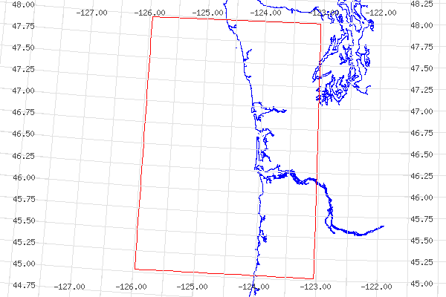
Figure 1. Geographical area of interest for July 2004 cruises: 48-45 degrees north latitude and 126-123 degrees west longitude.

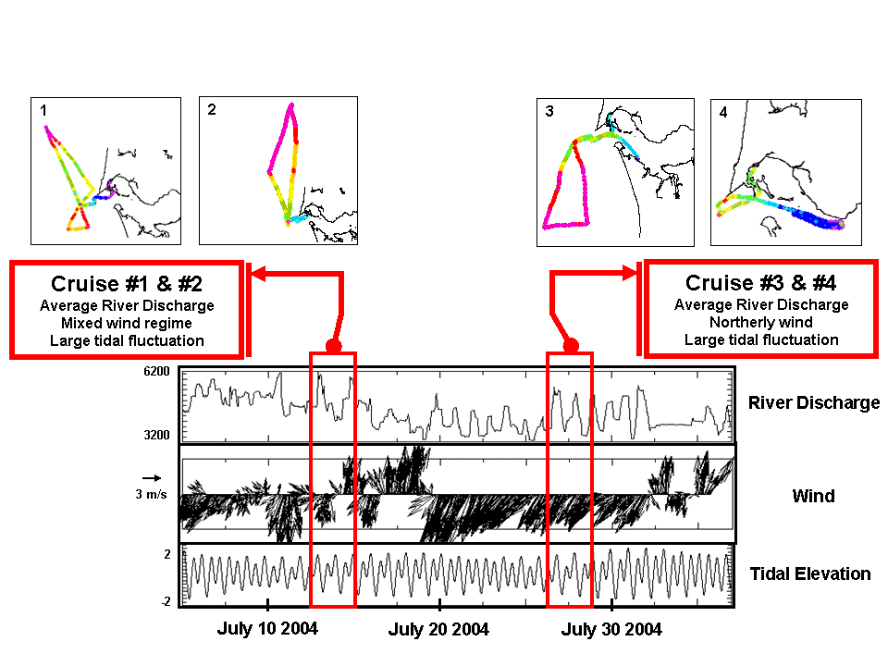
Figure 2. Graphs of system forcing during the July 2004 cruises. Bonneville Dam river flux, near shore wind direction and magnitude, and tidal range.

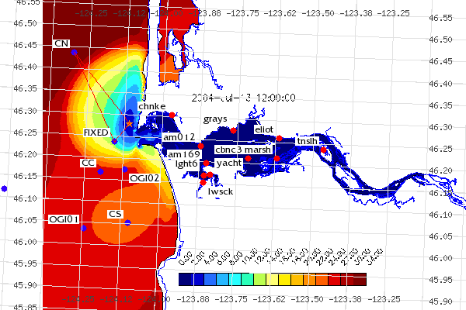
Figure 3. Cruise 1 – Plume gradient transect overlaying forecast model data.

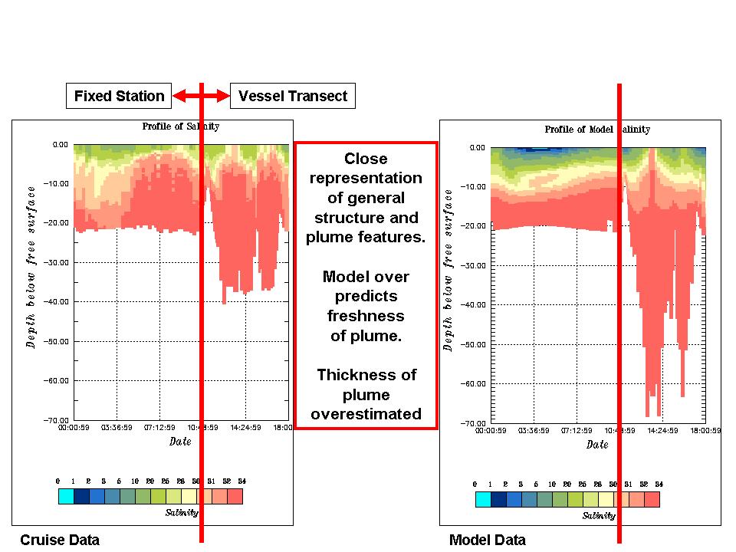
Figure 4. Cruise 1 – Model-Data comparison.

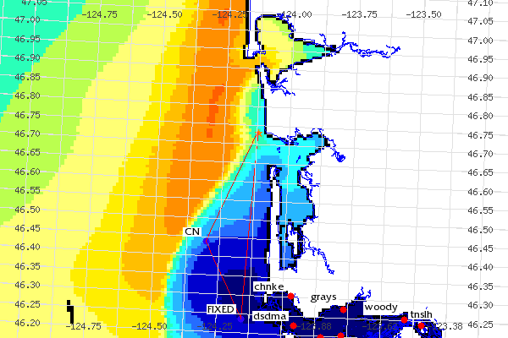
Figure 5. Cruise 2 – Transect path looking at plume length and width.

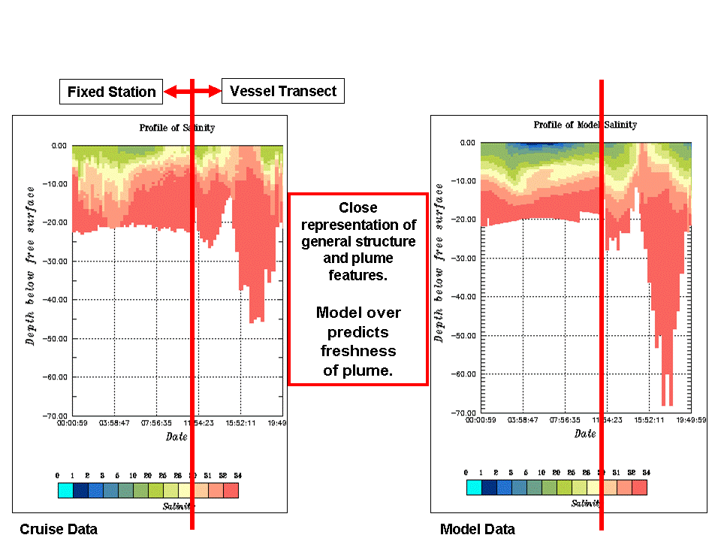
Figure 6. Cruise 2 – Model-Data comparison.

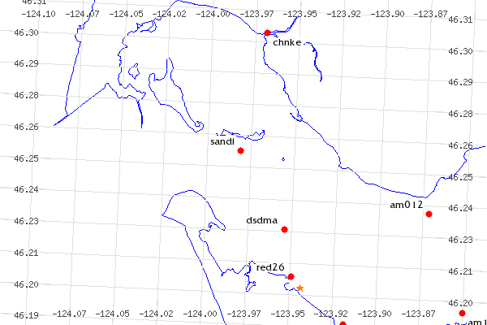
Figure 7. Cruise 3a – Fixed location indicated by a star.

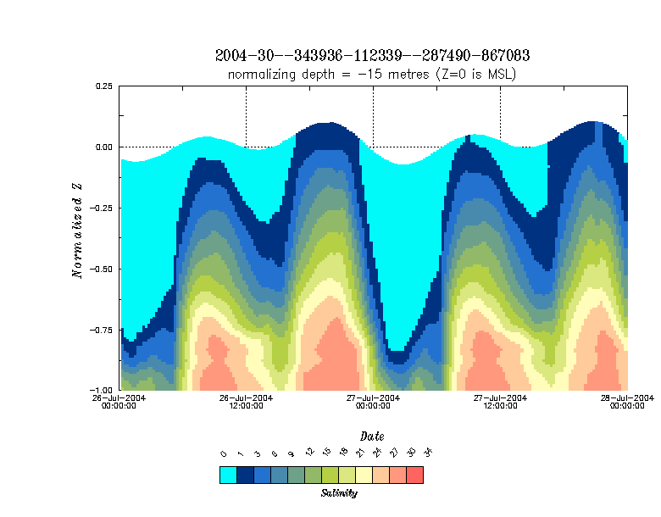
Figure 8. Cruise 3a – Model salinity profile for South Channel fixed station.
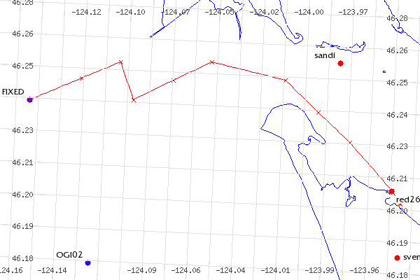
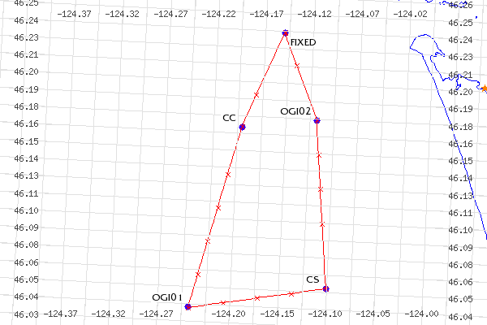
Figure 9. Cruise 3b – Transect and cast locations for plume dissipation study.

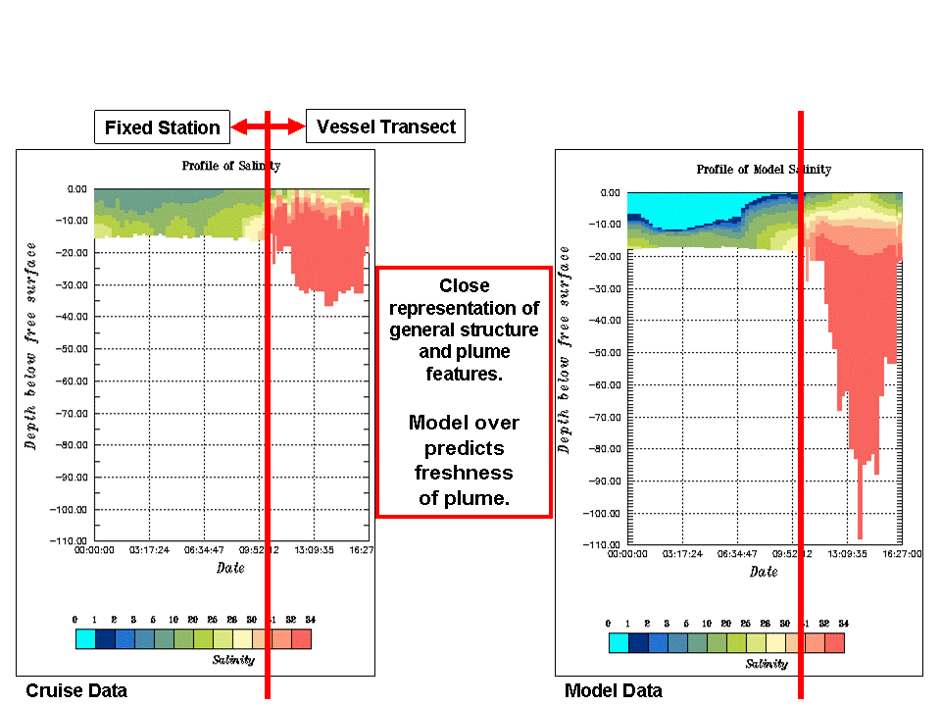
Figure 10. Cruise 3 – Model-Data comparison.

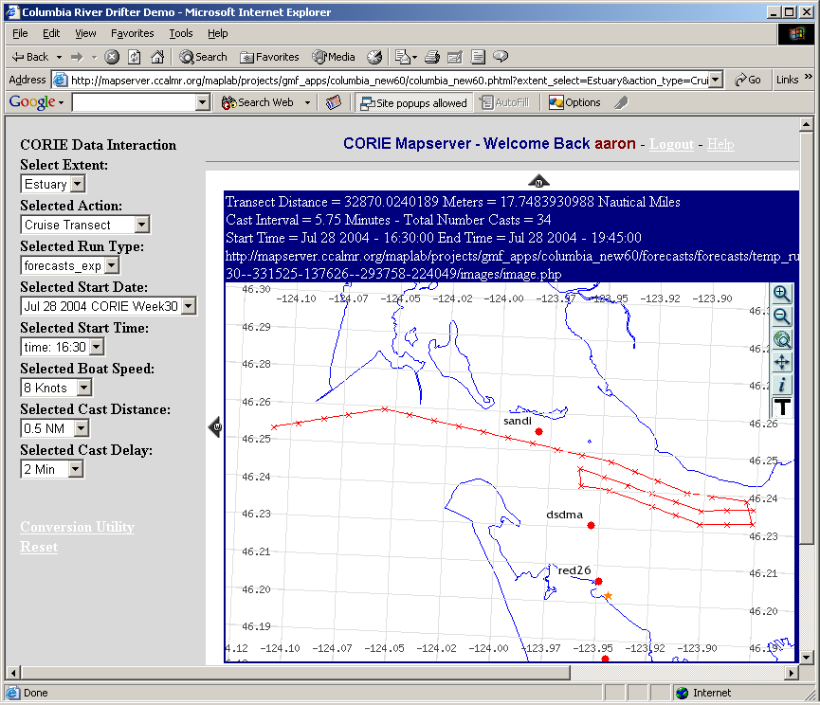
Figure 11. Cruise 4 – Transect path and cast locations.

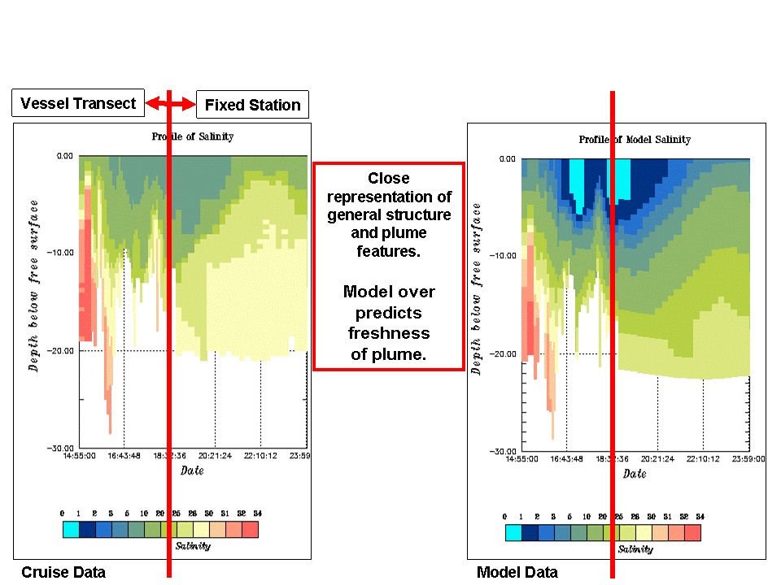
Figure 12. Cruise 4 – Model-Data comparison.

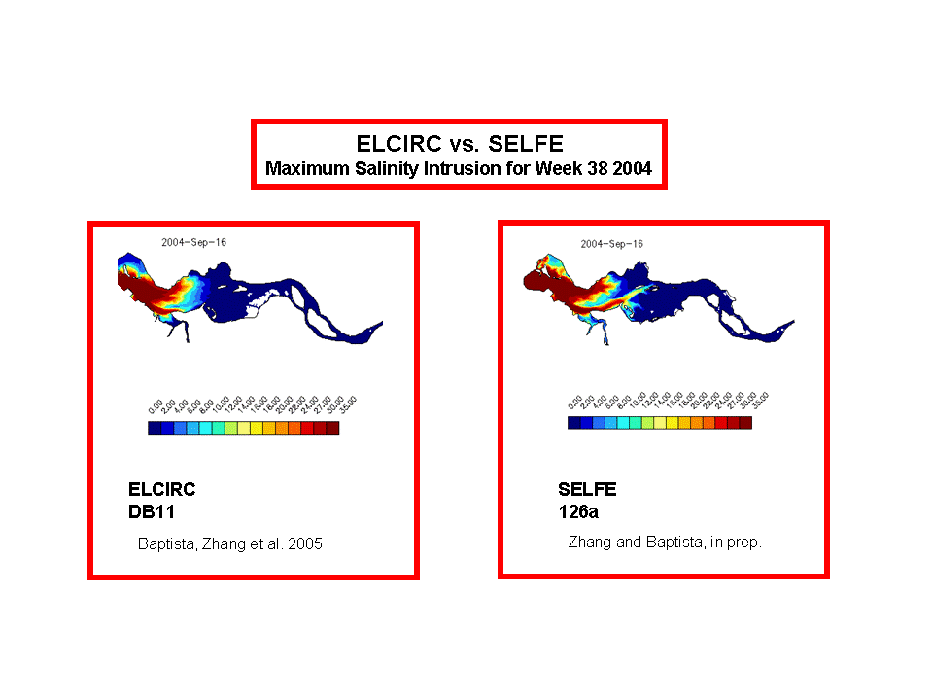

Figure 13. Model improvement influenced by CORIE-Mapserver. SELFE shows great improvement over ELCIRC in the ability to propagate salt into the estuary.

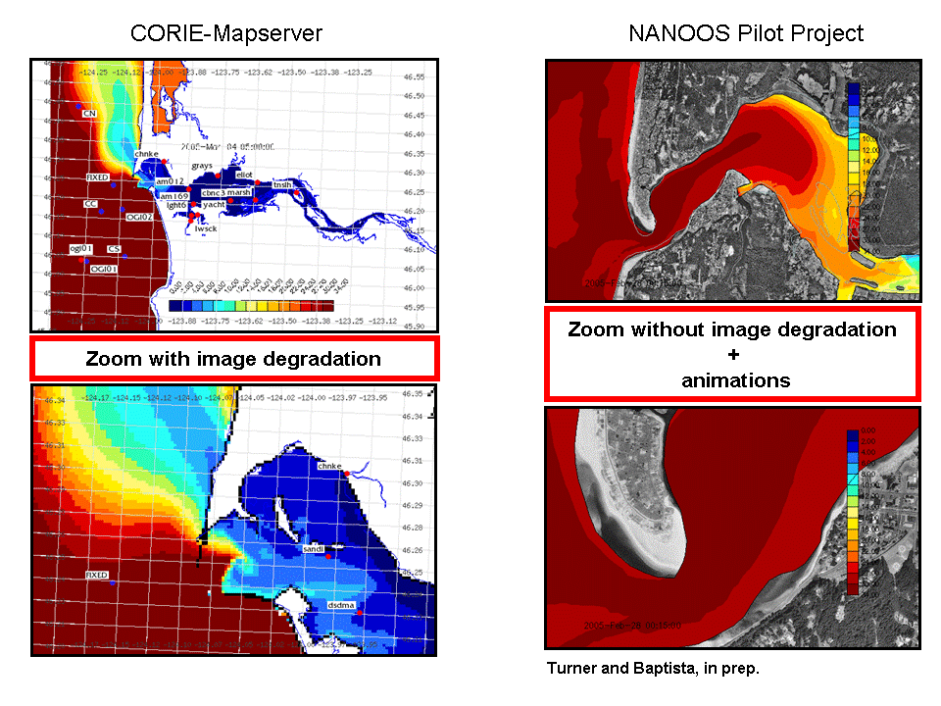

Figure 14. Tool improvement influenced by CORIE-Mapserver.

www.clatsopcollege.com
www.oceansensors.com/os200_ctd.htm
www.rdinstruments.com
www.furuno.com
http://www.ccalmr.ogi.edu/CORIE/cruises/cap.html

