DEVELOPING A WEB-BASED OPEN SOURCE GIS INTERFACE
FOR COASTAL MARGIN OBSERVATORIES

Aaron Paul Racicot  OGI School of Science & Engineering  at Oregon Health & Science University | António M. Baptista  OGI School of Science & Engineering  at Oregon Health & Science University

Key Words: GIS, Open Source, Web, Observatories

Correspondence addressed to:
António M. Baptista
OGI School of Science & Engineering at OHSU
20000 NW Walker Rd
Beaverton, OR 97006
EMAIL: baptista@ccalmr.ogi.edu

Abstract

The growth of the Internet and its capabilities has increased the appeal of web-based GIS systems. This paper discusses the integration of web-based GIS to a Coastal Margin Observatory focusing on coastal circulation in the Columbia River estuary and plume. Numerical model outputs are used in conjunction with graphics-generation software to produce imagery of hindcast and forecast predictions of circulation. A web-based GIS is utilized to store and display dynamic user-driven point, transect and particle trajectory data along with static imagery generated via the production system. Much of the dynamically generated data is stored in a PostgreSQL database enabled with PostGIS, an Open GIS Consortium compliant data interface. A GIS-based user interface utilizing the University of Minnesota Mapserver (UMN Mapserver) application gives spatial capabilities to viewing and manipulating these datasets. This system provides a broad user community with unprecedented flexibility interacting with the Coastal Margin Observatory system, while doing it at speeds comfortably viewable over the web. As a GIS system, tasks such as overlaying topographical maps for spatial context become trivial. This simplification to viewing and interacting with model outputs is of great benefit when undertaking tasks such as cruise planning and drifter studies.

1 Introduction

A Geographic Information System (GIS) is a computer system for capturing, storing, querying, analyzing and displaying geographic data [Chang, 2002]. There have been many successful attempts at integrating environmental modeling systems into desktop GIS frameworks, with examples including coastal zone management [Fedra & Feoli, 1998], forest dynamics [Goodchild et al., 1996], and hydrological pollution models [DiLuzio et al., 2004]. Leveraging web-based GIS in environmental modeling is showing great promise in improving accessibility and understanding of model outputs [Argent & Grayson, 2001]. However, these studies have also indicated that traditional desktop GIS applications can be costly to develop and are not accessible to a wide user base due to technical challenges in developing and operating the software [Anderson & Moreno-Sanchez, 2003].
The growth of the Internet has created an opportunity to overcome many of the challenges inherent in developing and deploying a GIS-based interface [Abel et al., 1998; Dragicevic et al., 2000]. The migration of many visualization and analysis capabilities of desktop GIS, such as viewing geo-referenced model output images and running particle tracking algorithms, to web-enabled technologies has only recently become feasible. Much research has gone into the development of web-based GIS architectures [Abel et al., 1998; Peng, 2003; Tsou & Buttenfield, 2002]. Utilizing simplified and universal GIS operations [Albrecht, 1996] in web-based GIS systems has allowed for the development of simplified user interfaces and therefore larger user communities. Adoption of open-source software principles in web-based GIS is allowing for the code sharing and distributed development missing in many proprietary software development practices, hence reducing costs [Anderson & Morena-Sanchez, 2003; Open Source GIS, 2004; Open Source Initiative, 2004]. Open-specification principles are helping to create simplified software architectures and enable fragments of software to inter-operate and be reused. [Anderson & Morena-Sanchez, 2003; Open Geospatial Consortium, 2004].
Coastal Margin Observatories (CMOs) are complex systems that integrate environmental sensor networks, sophisticated data management systems, and advanced numerical models in order to characterize and predict complex processes [Baptista, 2002]. In marine environments, CMOs produce large amounts of data, much of which has been underutilized [Wright et al., 2003]. Historically, oceanography and marine science have relied on examining small amounts of raw observational data along with derived images to determine the behavior of complex systems. With the recent growth of CMOs under the Integrated Ocean Observing Systems (IOOS) initiative, it is possible to get a much clearer view of Coastal Margins. As geographic domains of CMOs have grown, so have the challenges of generating enough imagery to give insight into the entire domain. While there are examples of web-based interfaces to ocean observing systems that are attempting to integrate GIS to observation and modeling efforts [GoMOOS, 2004; SEACOOS, 2004], many web-based interfaces fall short of allowing users to interact with and visualize data on-demand. One such shortcoming is that web-based interfaces are perceived as too slow in serving imagery and data sets [Tu et al., 2001]. Another problem is that the lack of common-data architectures has led to the development of many closed interface systems that lack interoperability [Anderson & Morena-Sanchez, 2003]. It can be seen that there is a need for an economical web-based GIS solution that gives new and expanded user groups the ability to interact with scientific data never before available to them.
The present project, termed CORIE-Mapserver, is a client-server software system that allows for the integration of the CORIE CMO with a web-based GIS called UMN Mapserver [Open Source GIS Conference, 2004; UMN Mapserver 2004]. CORIE is a CMO monitoring and modeling coastal circulation parameters in the Columbia River estuary and plume [Baptista et al., 1999; Baptista 2002; CORIE Coastal Margin Observatory, 2004]. The CORIE domain extends from the southern California coast to the south tip of Vancouver Island in Canada. The eastern boundary is defined by the Bonneville Dam, 146.1 miles from the mouth of the Columbia River. The western boundary extends past the Continental Shelf into the near ocean. A dynamic estuary exists at the interface between the Columbia River and the Pacific Ocean. The CORIE-Mapserver is a thin-client [Abel et al., 1998] web-based GIS, accomplishing all but basic user interface tasks on the server side of the software architecture. CORIE utilizes open-source models such as ELCIRC [Zhang & Baptista, 2004, Baptista et al., 2005], a 3-D circulation model capable of high resolution. ELCIRC numerically solves a coupled set of hydrostatic equations based on mass conservation, momentum conservation, and conservation of salt and heat. Outputs are water elevations, velocity fields, salinity and temperature. The CORIE CMO operationally produces a fixed set of imaging products defined to aid in model development and validation. The CORIE-Mapserver system integrates the ELCIRC model outputs and CORIE fixed-imaging products into a user-interactive interface based on the UMN Mapserver web-based GIS (Figure 1).
In this paper we will show how the implementation of a web-based GIS solution is showing potential to enable new user groups the ability to interact with model data never before available to those communities. We present a case study of dynamically generating on-demand geo-referenced imaging products for the CORIE CMO. Utilizing the capabilities of GIS tools we will show the successful integration of pre-existing tools, such as model image generation and particle tracking, and new tools such as cruise-planning utilities into a web-based interface for CORIE (Figure 2). The CORIE-Mapserver software system has been built primarily with open-source technology and is freely available to the CMO community.
Subsection 2.3 presents the underlying technology behind the CORIE-Mapserver system including hardware and system software, interface to the ELCIRC model, data processing and visualization techniques, utilization of open-source GIS tools and new user interface technologies. Subsection 2.4 presents the CORIE-Mapserver capabilities and discusses its strengths and limitations. Subsection 2.5 presents the directions for future research.

2 Underlying Software and Hardware Technology

The CORIE-Mapserver tool has been developed using both third-party and custom software to support user interaction with the CORIE CMO. In this section we describe the underlying hardware and software technology used for the CORIE-Mapserver system. In the spirit of the open-source philosophy [Open Source Initiative, 2004], whenever possible software tools used in the CORIE-Mapserver system are open-source software based (Appendix A).
The CORIE-Mapserver software architecture is a client-server based system consisting of four distinct layers: (1) system software, (2) data processing, (3) data serving, and (4) user interface (Figure 3). The first three layers reside solely on the server side of the architecture, while the user interface layer spans both the server and client. This system is a thin-client architecture allowing for the majority of the data processing to take place on the server side of the system [Abel et al., 1998]. Even though burdening the server can potentially cause speed and processor loading issues, isolating the majority of processing to the server increases platform independence by not relying on the capabilities of end-user hardware and software.

2.1 System Software Layer
The system software layer of the CORIE-Mapserver software architecture is composed of a set of software modules that interface the hardware system to the rest of the software architecture. The system software layer consists of two distinct sub-layers, namely the operating system and the web server. The system software used in the CORIE-Mapserver tool was chosen to keep acquisition costs at a minimum while still providing the performance and compatibility needs of a robust web services environment. The operating system is Redhat Linux AS 3.0. The Redhat Linux AS 3.0 kernel has been installed in the most basic form, utilizing only the functionality needed for web services hosting such as scripting languages and internet connectivity.
The web server technology used is Apache, a server grade open-source standard for web services deployment around the world [Apache Software Foundation, 2004]. Known for its widespread acceptance and great stability, Apache sits at the core of the web-based GIS system.

2.2 Data Processing Layer
The data processing layer is a set of software modules that are used to link the CMO model binary output to the UMN Mapserver GIS system. CORIE is capable of using many standard numerical models with the ELCIRC model being used operationally. Output fields from the ELCIRC model are produced for transport of salinity and temperature, velocity magnitudes and directions, and water elevations. These output parameters are calculated based upon unstructured input grids that are generated to best represent the spatial and temporal resolution of the domain. The current grids being used for the ELCIRC model applied to the CORIE system contain 33634 horizontal nodes, 50389 horizontal elements, and a vertical resolution of 62 levels. ELCIRC is run with a 1.5-minute computational time step and a 15-minute output time step. ELCIRC produces binary output files of approximately 700MB for horizontal velocity and 350MB for vertical velocity, salinity and temperature per day of simulation.
The ELCIRC model binary output structure is defined by a common header for all output files followed by scalar or vector representations of physical parameters in sequential time steps. This common data format allows for simplified access to model data. Through the use of a self-describing grid structure in the header of each file, it is possible for application developers to interact with the model data in efficient methods. Namely, it is possible to sub-sample the data sets based on spatial or temporal criteria without having to read the entire file, or even an entire time step.
To support ELCIRC modeling visualization and grid editing efforts, an open-source library called ACE has been developed through the CORIE project [ACE Toolkit, 2004]. CORIE-Mapserver uses two open-source visualization tools: (1) ACE/gr and (2) ACE/vis as well as the ELIO (ELcirc Input Output) C library from the ACE toolkit.
ACE/gr is an x, y plotting tool for workstations or X-terminals. Features of ACE/gr utilized include user-defined scaling, tick marks, labels, symbols, line styles and colors. Batch-mode processing for unattended plotting is used by CORIE-Mapserver for scatter plots. ACE/vis is a 2-D visualization and image generation tool and is an integral part of the CORIE project image and visualization efforts. ACE/vis uses the X/Motif user interface library but also supplies a fully supported command line interface for off-line and batch mode processing, which CORIE-Mapserver utilizes when generating time series plots and animations.
Lastly, the ELIO library allows application developers to read and write ELCIRC binary data files. Through the ELIO library it is possible to efficiently parse headers, data fields, and model input parameters through C interfaces. The ELIO C Library is used in the CORIE-Mapserver system to interact closely with binary model output manipulating statistics and generating products. The ACE toolkit is freely available and can be downloaded from the CORIE website: www.ccalmr.ogi.edu/CORIE/software/.
Along with the ACE toolkit, many other processing tools have been created to support specific tasks within the CORIE-Mapserver project. Particle tracking code developed as part of the CORIE project has been modified to implement tracking scenarios via the CORIE-Mapserver tool. Particle tracking is done via code that uses horizontal and vertical velocities to predict 3-D particle tracks over the model grid domain. The Lagrangian particle tracks are based upon the integration of velocity along the particle path. Numerically weighted velocities are interpolated across grid element volumes at sub-timesteps. Currently 50 sub-steps are used as a default with a base time step of 15 minutes from the model output. The particle-tracking utility can scale to any number of particles and can span any length of time for which there is model output.
Numerical error introduced by the model into the particle trajectories is characterized through the use of a backtracking algorithm and closure error characterization. It is possible to run the particle trajectory forward, marking the end location, and then backward with a deviation from the initial starting location indicating the magnitude of model-induced numerical errors.
Deviation of particle trajectory due to initial uncertainty of particle placement in a high shear environment is characterized by surrounding the initial particle with four test particles at release. Watching the relative distance of the test particles to the original particle over time can help predict the estimated uncertainty in end location of the original particle due to uncertainty in initial placement. Given an estimated start location with a relative uncertainty of that initial placement (for example ±5 m), it is possible to then predict the spread of surrounding test particles over time due to shear current interaction. A good example of the usefulness of this capability in the CORIE project is predicting drifter locations while deploying them in areas of strong shear currents induced by high river flow and strong tidal influence. It is very realistic to have two drifters deployed only 10 meters apart at the same time to travel in opposite directions due to strong sheer currents.
A set of custom software was developed for the CORIE-Mapserver project for generating three types of imaging: (1) fixed-station images, (2) stationary transects and (3) vessel-based transects. A set of fixed-station images are defined by a Eularian time series representation of all modeled physical parameters for a specific physical location, called a station, in the model domain. A stationary transect is a slice of the domain defined by a poly-line in x, y space extending to the bottom of the water column and is stationary over time. A vessel-based transect is a slice of the domain defined by a poly-line in x, y, and t space, extending to the bottom of the water column, but also having a time-based variation.
The generation of fixed-station images, stationary transects and vessel-based transects is done using a set of modified open-source C and Perl scripts used in the generation of images for the CORIE project. Extracted model data is fed into the open-source ACE toolkit to generate formatted 2-D output images. Stationary transect image sets contain 24-hour animations of both salinity and temperature. Vessel transect image sets include graphical representations of salinity and temperature whose format is modeled after that of conductivity, temperature and depth (CTD) sensor cast images. The GIS interface enables the images to be generated at any location selected by the user via the GIS Java Applet interface. Linked to forecast and hindcast circulation databases, this tool enables researchers conducting field surveys to process model outputs with much more flexibility than ever before.

2.3 Data Serving Layer
The data serving software layer enables generation and transfer of GIS data. This layer bridges the gap between large amounts of complex scientific data and simple user interfaces by utilizing GIS technologies. The data serving layer of the CORIE-Mapserver software architecture consists of two Open-source tools: (1) UMN Mapserver [2004] web-based GIS and (2) PostgreSQL [2004] database.
UMN Mapserver is a web-based GIS system that implements basic GIS-related tasks over the World Wide Web. UMN Mapserver was initially developed by the University of Minnesota under the ForNet project in cooperation with NASA and the Minnesota Department of Natural Resources. The UMN Mapserver implementation is heavily on the standards set forth by the Open GIS Consortium (OGC), which provides many of the guiding standards for the GIS community. By following these standards the UMN Mapserver implementation is very flexible and easily integrated with other software systems’ standardized protocols such as WMS, WFS. UMN Mapserver can be deployed in many different configurations, from simple HTML-driven web pages over a CGI engine, to very complex Java-driven applications serving dynamic content.
CORIE-Mapserver uses the UMN Mapserver distribution compiled as a library for the popular scripting language PHP. This Mapscript environment allows for easy interaction with the PHP web development language via the Mapscript API. The option to compile UMN Mapserver as a library to many popular web development languages was originally provided via DMSolutions Inc. and now comes standard in the UMN Mapserver distribution.
The GDAL open-source library is used for raster processing in the UMN Mapserver environment and pre-processing in the CORIE-Mapserver project. GDAL is used to generate a tile index of multiple raster images allowing for rapid display of large raster data sets. Geographic projection issues in UMN Mapserver are addressed by the use of the PROJ.4 library. PROJ.4 allows for on-the-fly projection of individual layers originating from different projections to the common projection of the main map image.
PostgreSQL is an open-source relational database management system that is easily linked to the UMN Mapserver environment [PostgreSQL, 2004]. Refractions Research Inc. has provided an open-source extension to the PostgreSQL database project called PostGIS, which is based upon OGC standards for storage and transfer of GIS data [PostGIS, 2004]. The combination of these two products allows for easy integration of a spatially oriented dataset to UMN Mapserver. While most of the data produced by the CORIE modeling system is in binary formats, the PostgreSQL and PostGIS environment is utilized to store data products such as particle tracking runs (Table 1), fixed stations (Table 2), stationary transects (Table 3), vessel transects (Table 4) and in-situ station information (Table 5).

2.4 User Interface Layer
The user interface software layer provides the interactive front end to the CORIE-Mapserver system. DMSolutions Inc. has provided a UMN Mapserver application development environment called GmapFactory, which has been used as a template for the development of the CORIE-Mapserver interface. An open-source Java applet called ROSA provides very rudimentary tools used in developing user interfaces, including button manipulation and line drawing. The CORIE-Mapserver project has blended many of these commonly used tools and techniques used by the UMN Mapserver community to develop the current user interface.
PHPLib is a session-based authentication software library that provides both security and user-based customization to the CORIE-Mapserver interface. Sessions are used to store user-specific data and track user interaction over time. Users of the CORIE-Mapserver system are required to register to allow for the customization of the user interface to each individual user.

2.5 Hardware
The hardware platform used to support the implementation of the CORIE-Mapserver interface is a custom-built Intel-based PC. The machine is comprised of an Intel Pentium4 2.4 GHz single processor with 1 GB RAM and dual 40 GB hard drives. The machine is connected to the Internet via a T1 connection. ELCIRC model data is stored on NFS-mounted hard disk storage totaling approximately 40 Terabytes. All ELCIRC model data is accessed via a local area Ethernet running at 100 MBits/sec.

3 System Implementation

3.1 Problems Addressed in CORIE
There has never been an integrated system to allow for web-based interaction with CORIE model data. Tasks such as particle tracking and vessel CTD cast image generation have historically been run via command line interfaces that require access to internal machines for the CORIE project. This closed nature of model post-processing has made real-time interaction with the model impossible. CORIE-Mapserver now allows for the dynamic interaction with model output through the use of the World Wide Web. This “opening” of the model to a wider audience is seen as a great step toward applying the CORIE modeling results to real problems.
The CORIE CMO modeling system was built around the need for consistent and pre-defined model-data visualization that allows for cross-version and cross-time comparison of model results against observational data. Two problems arose during the construction of the CORIE CMO that until the introduction of the CORIE-Mapserver tool were left unaddressed. First, many images produced automatically for daily forecast and hindcast model runs never get viewed because they do not pertain to scientific questions currently being reviewed. Secondly, regions where images are generated are limited and often inadequate for addressing many scientific investigations. These two issues, coupled with a need to archive model run data and images, have led to an abundance of images that never get looked at and no method for dynamically generating images at arbitrary locations.
Of the 161 static “stations” for which CORIE model data images are automatically generated, very few ever get viewed consistently. This automatically generated group of images, along with domain and transect animations, currently comprise 1.5 GB of storage per two-day forecast run and 2.3 GB of storage per week of hindcasts. This automatic image generation consists of approximately 11 percent of the total disk space used for all model runs. Of equal concern to having unused images is not having access to a process of generating images at arbitrary locations in the model domain. It is easily seen that 161 static stations located in a model grid of approximately 30,000 horizontal nodes is not sufficient to evaluate model performance. A real need exists for scientific investigators to select the location of interest unencumbered by limitations imposed by pre-defined image generation. CORIE-Mapserver addresses these two issues by providing scientific investigators the ability to select “on-the-fly” locations within the model domain and generate model images. No longer are users of the model output tied to the historic list of available stations or transects.

3.2 Capabilities of the CORIE-Mapserver Tool
To highlight the abilities of the CORIE-Mapserver tool we will focus on the key features currently available and how they affect the usability of the CORIE CMO. This list is by no means exhaustive, but will provide the reader with a good view of the most-used features. The interface is broken up into three main areas; the CORIE interaction menus, the map-viewing area and the map legend (Figure 4). All user interaction with the CORIE model data related to location can be conducted through the Java Applet based tools on a map or via numerical input from the user. With this option it is equally easy to specify a transect or station location via typing raw coordinates or via selecting locations on a map with the use of a mouse click.

3.2.1 Three Main Geographic Extents. One of the features of a web-based GIS system is the ability to traverse imagery at different geographic extents. The CORIE-Mapserver interface allows for three general maximum geographic extents. These three extents correspond to the three main areas of interest for the CORIE research team; estuary, plume and far ocean. Along with these three settings the user is able to zoom and pan to any level desired via the Java Applet based tools available on the toolbar located on the right side of the map image. The ability to interactively zoom, pan, and query through the GIS interface is added functionality over any previous interface to CORIE model data.

3.2.2 Particle Tracking. Lagrangian particle tracks are made possible through the “Particle Track” action-menu selection. The menu selection process allows the user to select start and stop times, as well as whether the particles are to be held to a fixed depth or allowed to freely travel in the vertical. Finally, initial depth is specified before the particle tracking tool becomes available for invocation.
Once a location for releasing particles is selected, real-time processing takes place on the ELCIRC model output to produce location and contextual information for the particle at every time step. This data is then stored in the PostgreSQL database and made available for display via CORIE-Mapserver. Each particle step is color shifted to allow for ease of visualization (Figure 5). A pop-up window also appears upon completion of processing that contains a table of particle locations at every time step along with depth information. This particle-tracking layer can be queried as well as added or removed from the viewable layer list at any time.

3.2.3 Fixed Station. Standard image sets are made possible through the “Fixed Station” action-menu selection. This menu-selection process allows for the selection of run type (either hindcast or forecast) and start date before making the fixed station tool available for invocation. Once a location is selected, a pop-up window appears with a status icon indicating that a set of fixed station images is being generated for the location selected. Once the images appear, there will also be a mark that appears on the main map indicating the selected location.

3.2.4 Stationary Transect. Stationary transect images are generated via selection of the “Stationary Transect” action-menu selection. Through the use of sequential mouse clicks on the main map or manual coordinate input, the poly-line transect definition is stored in the Postgresql/PostGIS database and displayed via the transect layer on the main map. This transect type allows for the definition of a fixed spatial transect path that is interpreted over time via output animations (Figure 6). This type of transect is very useful for looking at temporal processes from fixed transect locations (Figure 7).

3.2.5 Vessel Transect. A vessel transect is input in a fashion similar to a stationary transect, either via mouse click or manual input. Menu selections guide the user through definition of the vessel transect including boat speed, instrument cast distance and delay. The unique feature of the vessel transect is the ability to move both spatially and temporally to generate an image. This image can be compared easily to the graphical representation of in-situ sampling done via CTD casting (Figure 8). Instead of animations, the spatially and temporally varying nature of the output dictates a single image (Figure 9).

3.2.6 View Model Images. Domain model images that are automatically generated via the ACE toolkit for all model runs are viewable as a layer via selecting the “View Model Data” action-menu selection. This menu selection will guide the user through the menus necessary to define which image is desired before loading the model data layer raster with the main map image. This feature is very useful when applying the CORIE-Mapserver tool in the field by allowing contextual model data to help define cruise paths and fixed station locations.

3.2.7 Utilities. The main utility function available via the CORIE-Mapserver interface is a web enabled interface that uses the PROJ.4 utility for converting between the two main coordinate systems used, namely Oregon State Plane Coordinate System (OSPCS) and geographic coordinate system NAD83 Latitude-Longitude. This tool is housed in a pop-up window separate from the main application and can be used to easily convert user specified locations from geographic coordinates to projected coordinates and vice-versa.

4 CORIE-Mapserver Performance
The CORIE-Mapserver user interface performance has been characterized by the time required to complete a given action-menu selection and ranges from five seconds to 150 seconds (Figure 10). Actions that require processing of large model output files to generate on-demand products, such as fixed station images, take more time than those actions only referencing pre-generated output. Likewise, actions performed on model forecast runs are typically faster than those performed on hindcast runs due to the difference in durations of the model runs.
The above characterization was done with use of a broadband internet connection and no secondary server load. In the field, Internet connection speeds are typically much slower and less consistent than hardwire broadband connections. CORIE-Mapserver is able to maintain positive performance characteristics in these low bandwidth situations since the majority of the data product processing and generation is done on the server side of the architecture.

5 Results and Future Direction

Through the use of open-source tools we have started to integrate functional GIS into the capabilities of CORIE. Never before has the ability existed to interact with ELCIRC model output in a web-based interactive environment. This web-based geo-referenced interaction with spatially explicit simulation data shows logistical promise, and is currently being used in planning and interpretation of estuarine and plume surveys for the Columbia River (Chapter 3).
Major advances have been realized in addressing the need to bring scientific research into the hands of a larger and more diverse audience through the CORIE-Mapserver project. We look forward to increasing the scope of applications for this type of technology, including search and rescue, fish migration patterns, and environmental hazard response as well as applying the technology to other CMOs around the world.
The future of web-based GIS is heading in the direction of web services. Through the use of open standards it is envisioned that data no longer needs to be stored locally to be viewed via a web-based GIS [Doyle & Daly, 2004]. The OGC has adopted standards for the integration of GIS into web services. Web Map Service (WMS) is a raster based web services protocol that allows for the standardized request for geo-referenced raster data and the standardized transmission of raster data over the World Wide Web. The CORIE modeling project has the ability to generate model-based imagery of a unique geographical region. It is the future goal of the CORIE project to serve this imagery via WMS for others to utilize in their GIS environment. Since UMN Mapserver can act as a WMS server, it is envisioned that a new integration between the graphics generation utilities in CORIE and the server features of UMN Mapserver will be possible. This new interface will allow for on-demand raster generation and transmission to WMS clients throughout the world.
Web Feature Service (WFS) and Web Coverage Service (WCS), two more OGC standards focusing on vector and grid-based data, are less developed at this time, but show great promises for allowing even greater integration of the CORIE CMO into the GIS community. OPeNDAP, another array-based data transfer standard, is also showing promise in allowing for the transfer and visualization of large array-based data sets. The CORIE development team is currently looking at integration possibilities of ELCIRC model data output into the WCS and OPeNDAP frameworks for data serving. Through the use of these developing protocols and standards it is envisioned that CORIE data will be served to a wide range of consumers in the years to come.
On the client side, UMN Mapserver has the ability to request and display layers via WMS, WFS, and WCS as well. Current development activity in the CORIE project is looking to integrate more of the base layers of the CORIE-Mapserver tool through web services rather than local copies. Web services are viewed as a long term benefit when looking at maintenance costs for large data sets. Integration with other oceanographic data sets is also of interest and currently being pursued [OpenIOOS, 2004].

Acknowledgments

Direction for the July 2004 cruises was based at the Center for Coastal and Land Margin Research at OGI School of Science and Engineering. Scientific oversight was directed by Aaron Racicot and António Baptista. Operational direction for the July 2004 cruises was directed by Mike Wilkin. The research vessel was staffed with captains Gene Bock and Dennis Degner, both Clatsop Community College Maritime instructors. Deckhand Brian Marshall, Associate of Science student at Clatsop Community College also provided assistance. I truly appreciate all of the help received from the crew of the MV Forerunner and the cooperation of Clatsop Community College while testing this project in the field.
Paul Turner provided much of the direction on interfacing with the CORIE modeling infrastructure and use of the ACE toolkit. Charles Seaton has been invaluable in helping with the interface between this project and the CORIE modeling and observation data.
The National Science Foundation (ACI-0121475, OCE-0239072), Bonneville Power Administration (00019126) and National Oceanic and Atmospheric Administration (AB133F-04-SE-0304, AB133F-03-SE-1227, AB133F-04-RP-0033, NA17FE1026) provided financial support for this research.
Lastly, we would like to thank all the developers and users of University of Minnesota Mapserver that have provided assistance and encouragement during the development of this project. Without the help of the very active UMN Mapserver community this project would not have been possible.

References

Abel, D. J., Taylor, K., Ackland, R., and Hungerford, S. (1998) An exploration of GIS architectures for internet environments. Computers, Environment and Urban Systems 22(1):7-23.

ACE Toolkit. Available: http://www.ccalmr.ogi.edu/CORIE/software/ace/recent.html [Viewed: December, 2004]

Albrecht, J. (1996) Universal GIS operations for environmental modeling. In Proceedings of the Third International Conference/Workshop on Integrating GIS and Environmental Modeling, Santa Fe, NM. Santa Barbara: National Center for Geographical Information and Analysis, published as CD and WWW page at http://www.ncgia.ucsb.edu/conf/santa_fe.

Anderson, G., and Moreno-Sanchez, R. (2003) Building web-based spatial information solutions around open specifications and open source software. Transactions in GIS 7(4): 447-466.

Apache Software Foundation. Available: http://www.apache.org [Viewed: December, 2004]

Argent, R. M., and Grayson, R. B. (2001) Design of information systems for environmental managers: an example using interface prototyping. Environmental Modelling and Software 16(5): 433-438.

Baptista, A. M. (2002) Environmental observation and forecasting systems. In Encyclopedia of Physical Science and Technology, 3rd Ed. (Meyers, R. A., Ed.), Academic Press, San Diego, pp. 565-581.
Baptista, A. M., Wilkin, M., Pearson, P., Turner, P., McCandlish, C., and Barrett, P. (1999) Coastal and estuarine forecast systems: a multi-purpose infrastructure for the Columbia River. Earth System Monitor 9: 1-2, 4-5, 16.

Baptista, A. M., Zhang, Y. L., Chawla, A., Zulauf, M. A., Seaton, C., Myers, E. P., Kindle, J., Wilkin, M., Burla, M., and Turner, P. J. (2005) A cross-scale model for 3D baroclinic circulation in estuary-plume-shelf systems: II. Application to the Columbia River. Continental Shelf Research, in press.

Chang, K.-T. (2002) Introduction to Geographic Information Systems. McGraw-Hill, Boston, 348 p.

CORIE Coastal Margin Observatory. Available: http://www.ccalmr.ogi.edu/CORIE/ [Viewed: December, 2004]

DiLuzio, M. D., Srinivasan, R., and Arnold, A. G. (2004) A GIS-coupled hydrological model system for the watershed assessment of agricultural nonpoint and point sources of pollution. Transactions in GIS 8(1):113-136.

Doyle, S., and Daly, M. Enabling Distributed GIS - OpenGIS in the Real World. GISCafe (www.giscafe.com) Available: http://www10.giscafe.com/nbc/articles/view_article.php?section=CorpNews&articleid=67677 [Viewed: December, 2004]

Dragicevic, S., Balram, S., and Lewis, J. (2000) The role of Web GIS tools in the environmental modeling and decision-making process. In Proceedings of the 4th International Conference on Integrating GIS and Environmental Modeling (GIS/EM4): Problems, Prospects and Research Needs. Banff, Alberta, Canada, September 2-8, 2000.

Fedra, K., and Feoli, E. (1998) GIS technology and spatial analysis in coastal zone management. EEZ Technology 3:171-179.

GoMOOS, Gulf of Maine Ocean Observing System. Available: http://www.gomoos.com/ [Viewed: December, 2004]

Goodchild, M. F., Steyaert, L. T., Parks, B. O., Johnston, C., Maidment, D., Crane, M., and Glendinning, S., Eds. (1996) GIS and Environmental Modeling: Progress and Research Issues. GIS World Books, Fort Collins, CO, 486 p.

Open Geospatial Consortium, Inc. (OGC). Available: http://www.opengis.org/ [Viewed: December, 2004]

OpenIOOS. Available: http://www.openioos.org/ [Viewed: December, 2004]

Open Source GIS. Available: http://opensourcegis.org [Viewed: December, 2004]

Open Source GIS Conference / Mapserver User Group Meeting Proceedings (2004). Ottawa, Canada, June 9-11. http://www.omsug.ca/osgis2004/proceedings.html [Viewed: December, 2004]

Open Source Initiative. Available: http://www.opensource.org [Viewed: December, 2004]

Peng, Z.-R. (2003) Internet GIS: Distributed Geographic Information Services for the Internet and Wireless Networks. Wiley, Hoboken, NJ, 679 p.

PostGIS, Refractions Research Inc. Available: http://postgis.refractions.net/ [Viewed: December, 2004]

PostgreSQL, Object-Relational Database Management System. Available: http://www.postgresql.org/ [Viewed: December, 2004]

Redhat White Paper (2003) “Migrating to Red Hat Enterprise Linux from Red Hat Linux.” Available: http://www.redhat.com [Viewed: December, 2004]

SEACOOS, Southeast Atlantic Coastal Ocean Observing System. Available: http://www.seacoos.org/ [Viewed: December, 2004]

Tsou, M.-H., and Buttenfield, B. P. (2002) A dynamic architecture for distributing geographic information services. Transactions in GIS 6(4): 355-381.

Tu, S., He, X., Li, X., and Ratcliff, J. J. (2001) A systematic approach to reduction of user-perceived response time for GIS web services, pp. 47-52. In Proceedings of the 9th ACM International Symposium on Advances in Geographic Information Systems, November 9-10, 2001, Atlanta, GA., ACM Press, New York.

UMN Mapserver. Available: http://mapserver.gis.umn.edu/ [Viewed: December, 2004]

Wright, D. J., O’Dea, E., Cushing, J. B., Cuny, J. E., and Toomey, D. R. (2003) Why Web GIS may not be enough: A case study with the virtual research vessel. Marine Geodesy 26(1-2): 73-86.

Zhang, Y., and Baptista, A. M. (2004) A cross-scale model for 3D baroclinic circulation in estuary-plume-shelf systems: I. Formulation and skill assessment. Continental Shelf Research 24: 2187-2214.

Table 1
Particle Tracking Database Table Definition

Column | Type | Modifiers
------------------------+------------------+-----------
id | integer |
time_step | integer |
particle_id | text |
spatial_error_distance | double precision |
forward_back | integer |
z_val | double precision |
element_num | integer |
level_num | integer |
eta_val | double precision |
iwet | integer |
u_val | double precision |
v_val | double precision |
w_val | double precision |
z2_val | double precision |
the_geom | geometry |
Check constraints:
"$1" CHECK (srid(the_geom) = -1)
"$2" CHECK (geometrytype(the_geom) = 'POINT'::text OR
the_geom IS NULL)

Table 2
Fixed Station Database Table Definition

Column | Type | Modifiers
-------------+------------------+-----------
id | integer |
web_address | text |
the_geom | geometry |
Check constraints:
"$1" CHECK (srid(the_geom) = -1)
"$2" CHECK (geometrytype(the_geom) = 'POINT'::text OR the_geom IS NULL)

Table 3
Stationary Transect Database Table Definition

Column | Type | Modifiers
-------------+----------+-----------
id | integer |
web_address | text |
the_geom | geometry |
Check constraints:
"$1" CHECK (srid(the_geom) = -1)
"$2" CHECK (geometrytype(the_geom) = 'LINESTRING'::text OR the_geom IS NULL)

Table 4
Vessel Transect Database Table Definition

Column | Type | Modifiers
-------------+----------+-----------
id | integer |
web_address | text |
the_geom | geometry |
Check constraints:
"$1" CHECK (srid(the_geom) = -1)
"$2" CHECK (geometrytype(the_geom) = 'POINT'::text OR the_geom IS NULL)

Table 5
Buoy Database Table Definition

Column | Type | Modifiers
--------------+----------+-----------
station_name | text |
the_geom | geometry |
Check constraints:
"$1" CHECK (srid(the_geom) = -1)
"$2" CHECK (geometrytype(the_geom) = 'POINT'::text OR the_geom IS NULL)

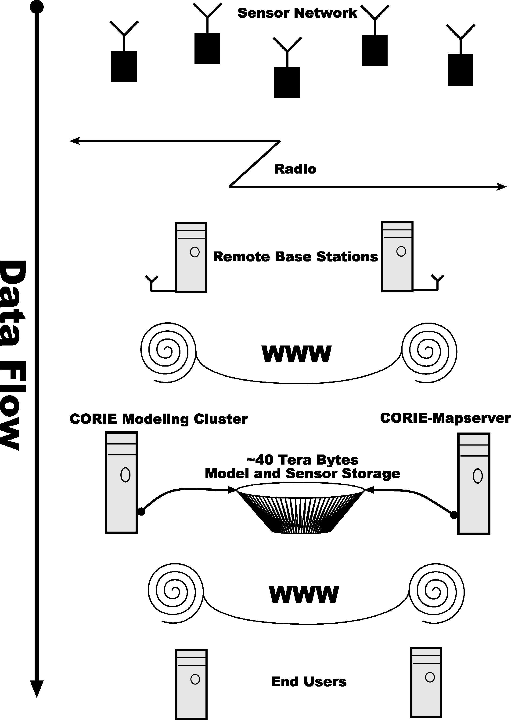
Figure 1. System data flow diagram.
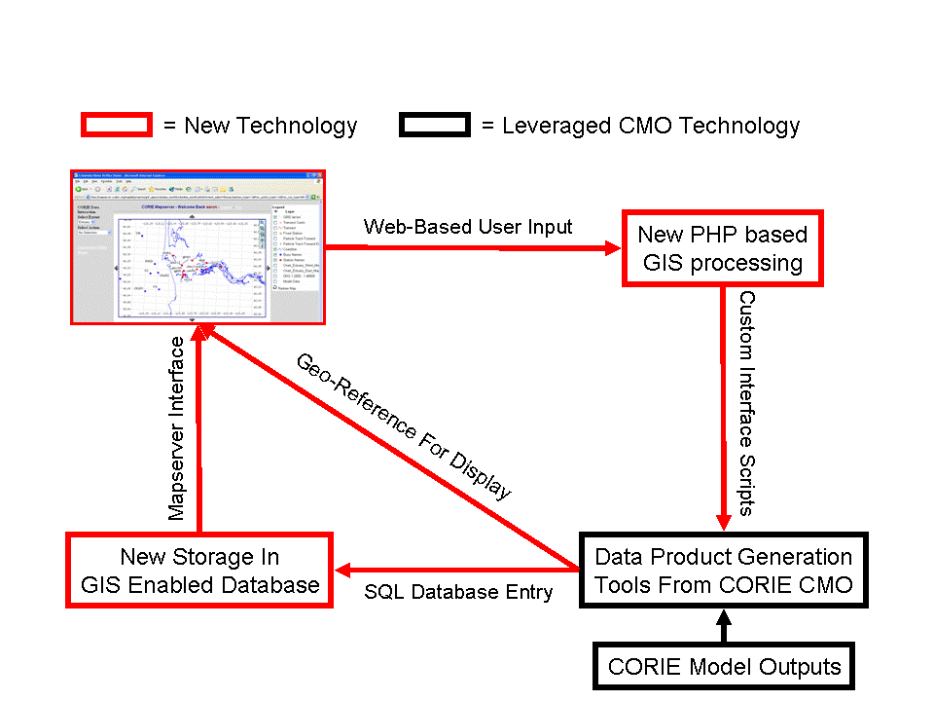
Figure 2. How CORIE-Mapserver fits into the existing CMO infrastructure. The new CORIE-Mapserver technology utilizes existing CMO tools to create a new interactive user interface.
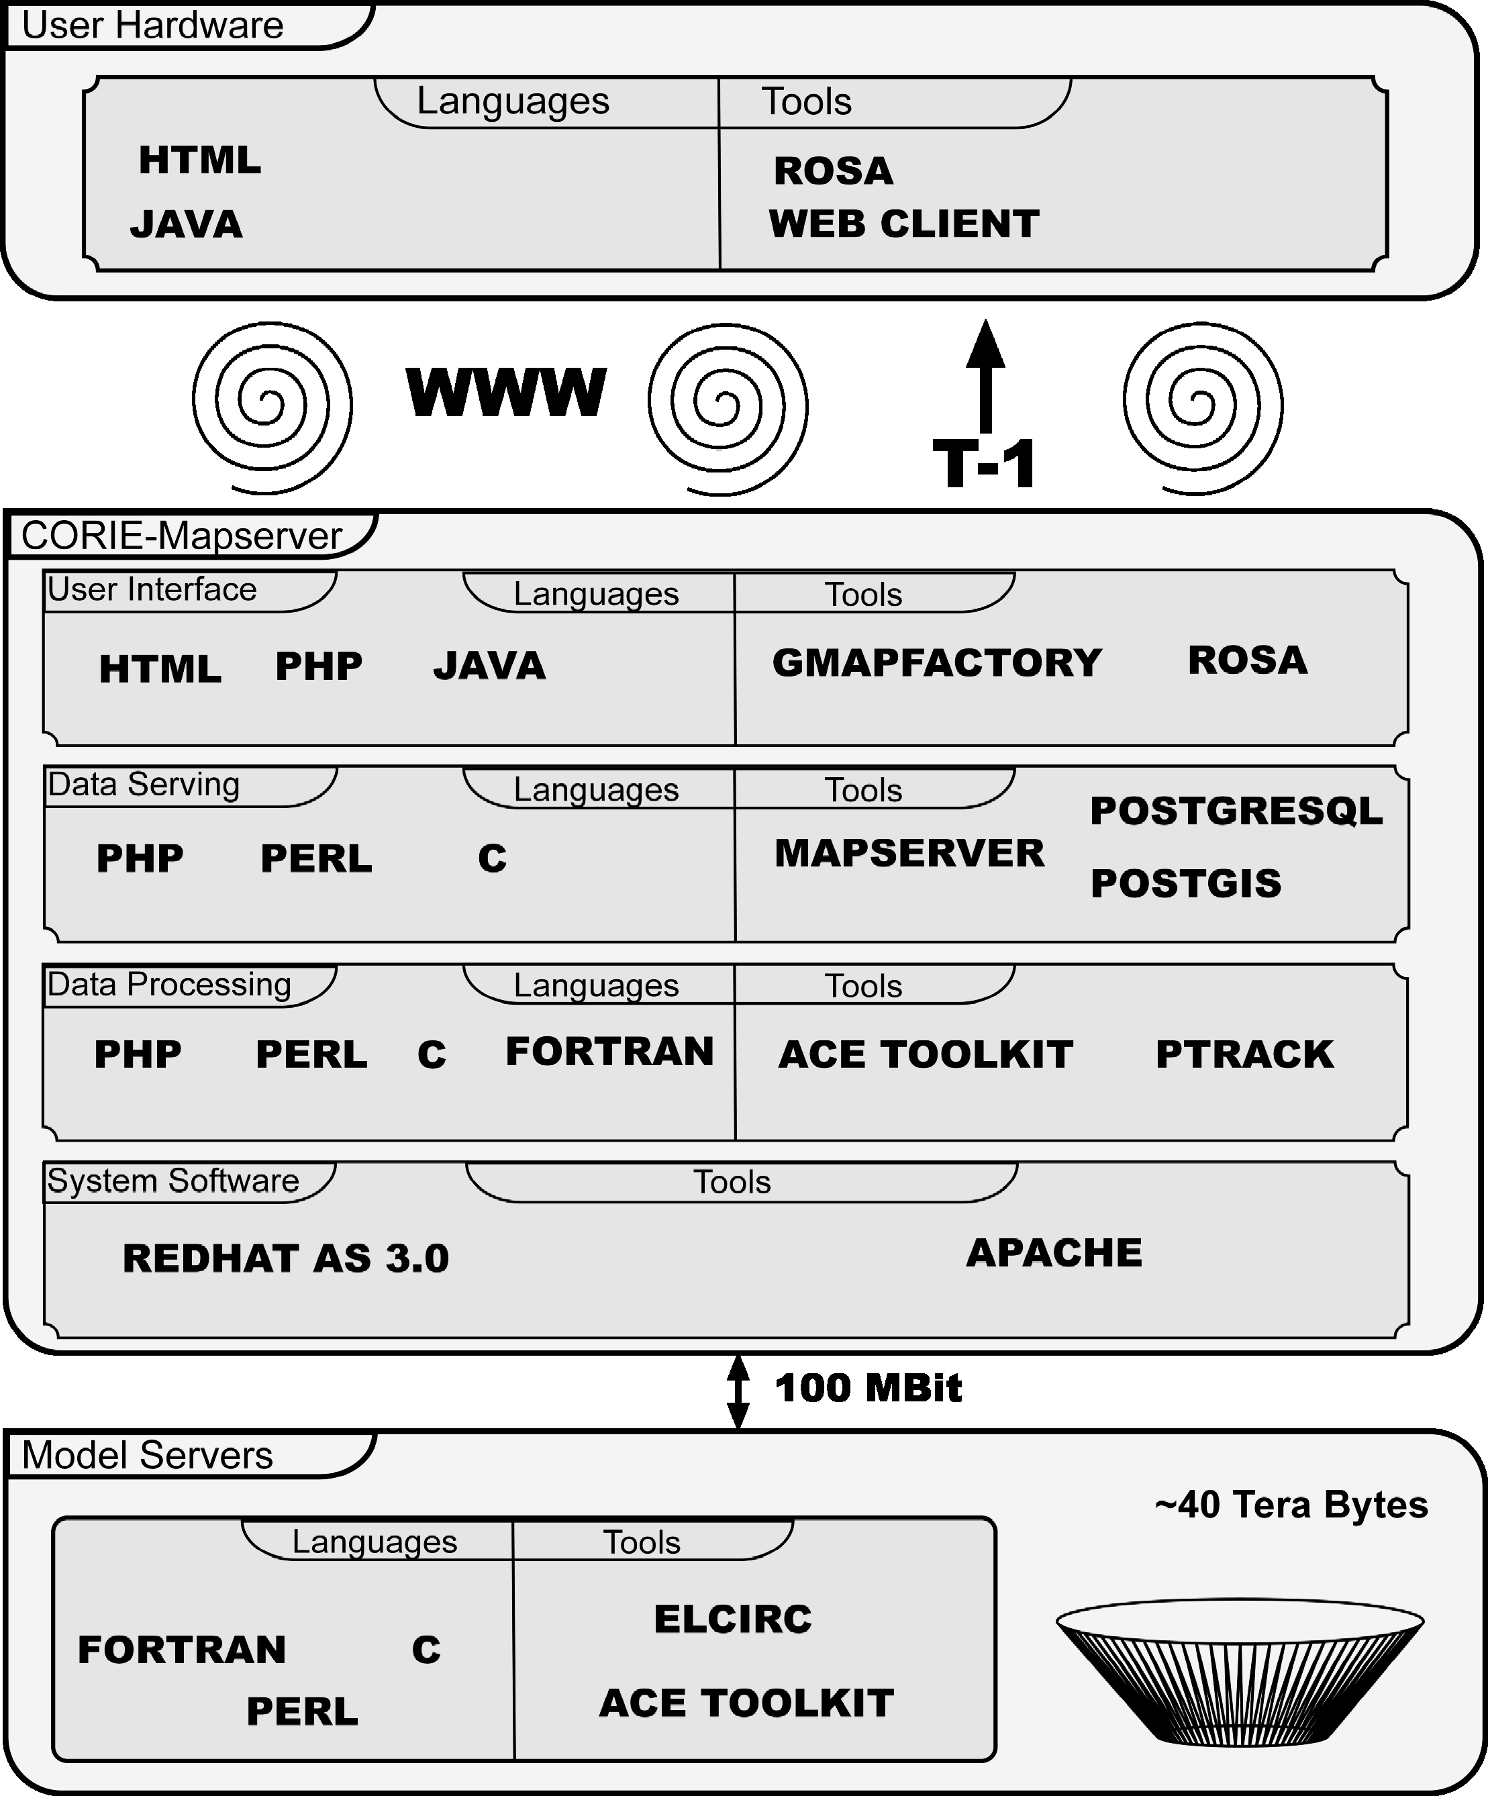
Figure 3. CORIE-Mapserver software diagram.
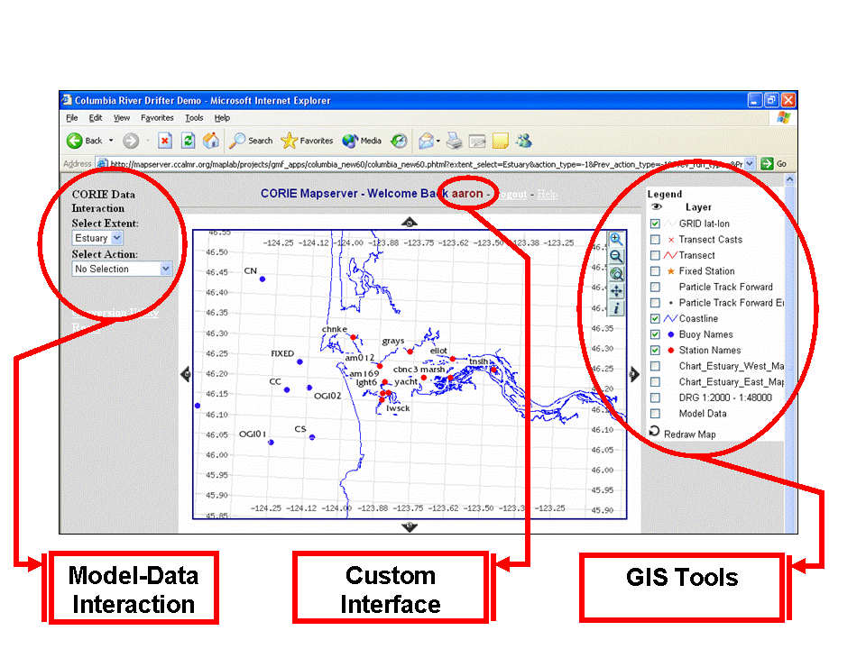
Figure 4. CORIE-Mapserver user interface. Left side of screen represents the user interactive menu system. The middle of the screen contains the main map area. The right side of the screen contains the legend and layer control for the main map.

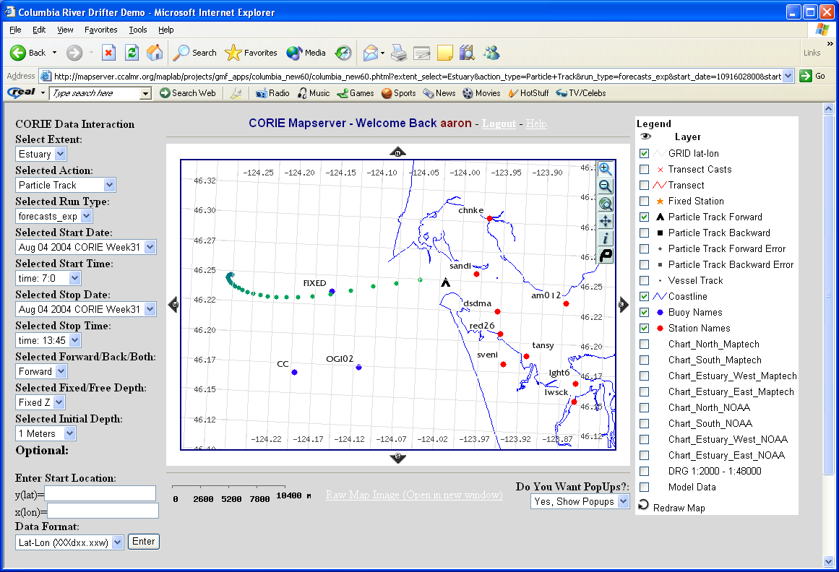
Figure 5. Particle tracking utility example. Particle track is selected via user click on main map. 3-D Lagrangian particle track is calculated using model velocity fields and stored as a GIS layer in PostgreSQL. Particle display changes color as time progresses.

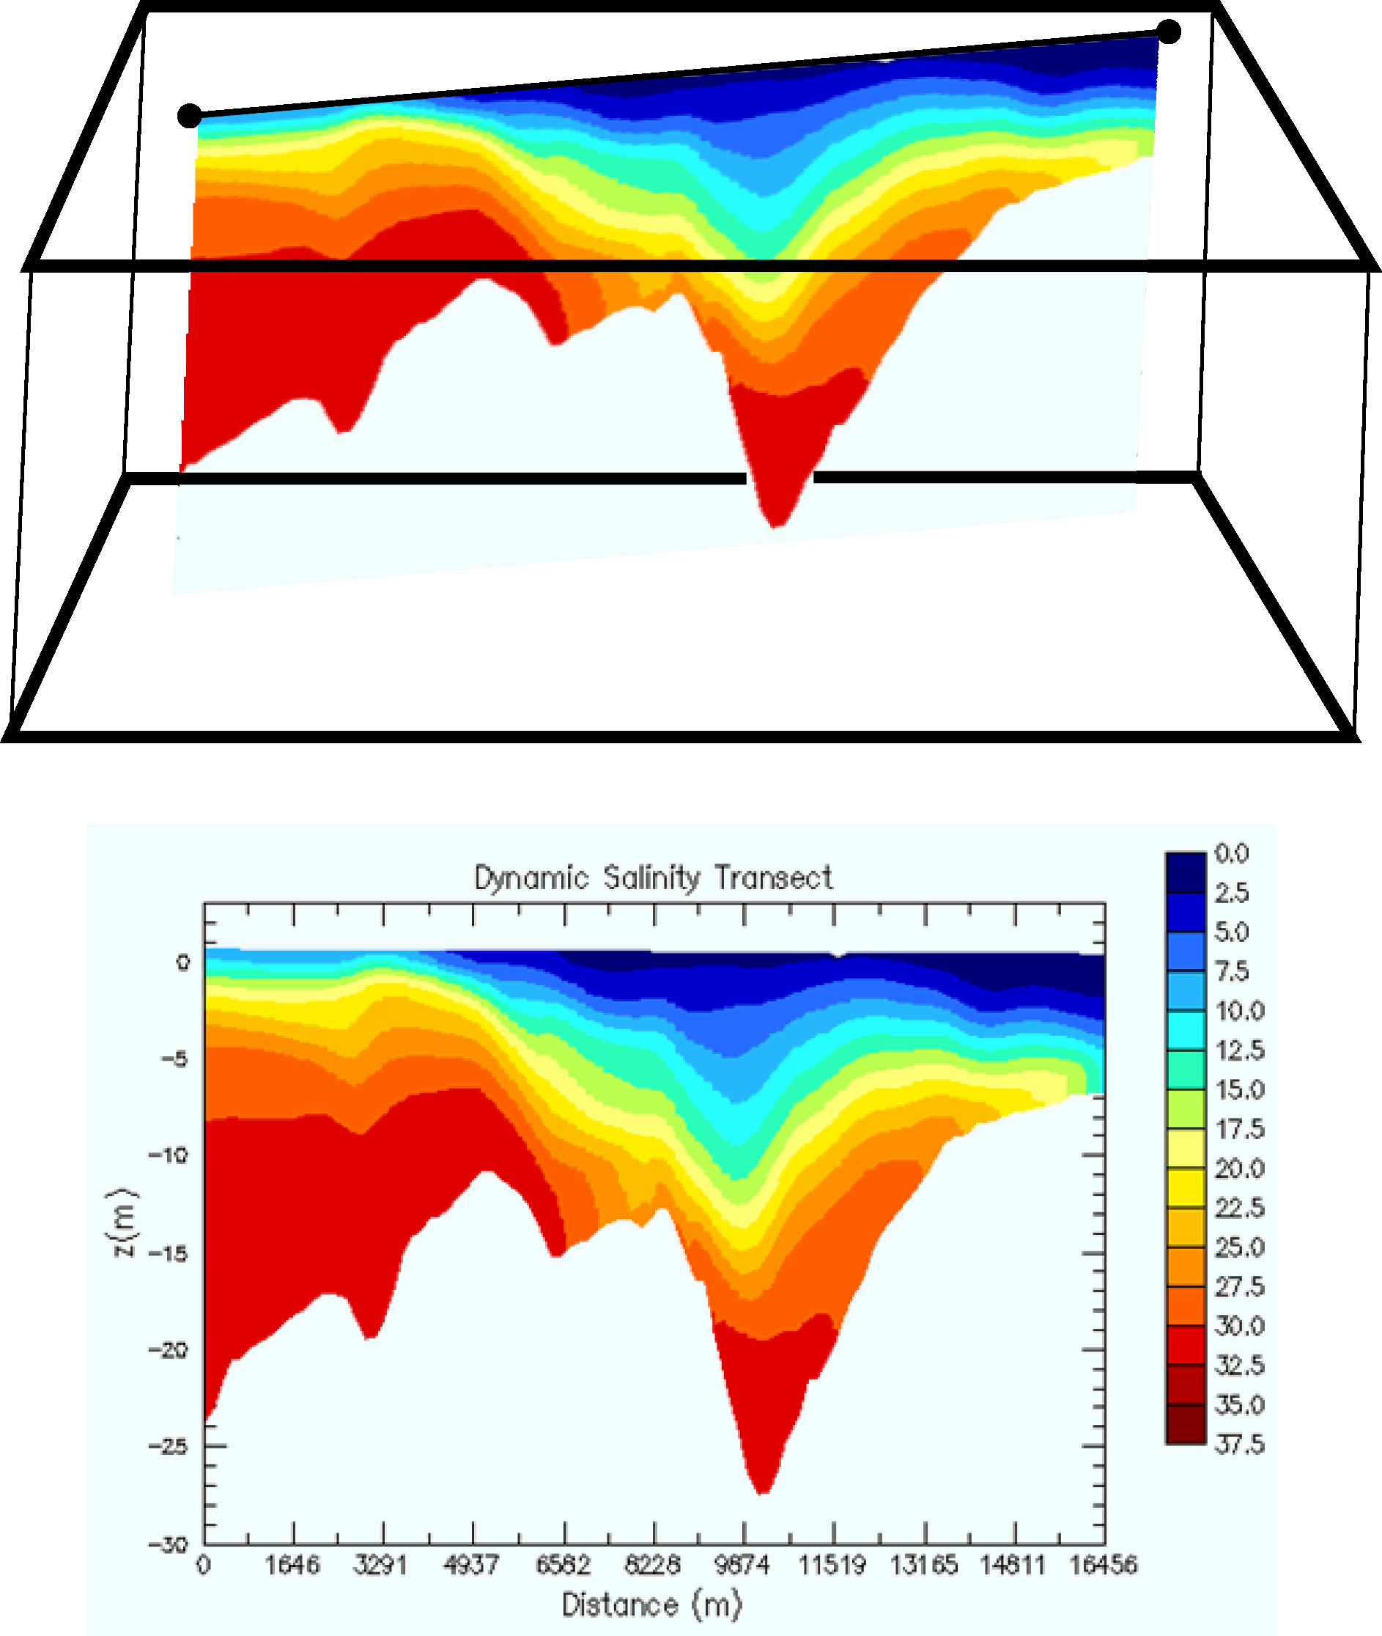
Figure 6. Stationary transect image generation.

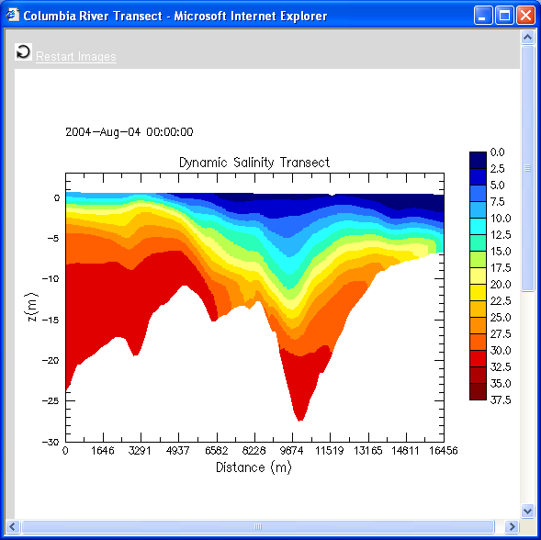
Figure 7. Example stationary transect output image. This is a salinity animation of forecast model output for 24 hours. The transect is defined via mouse clicks on the main map in the CORIE-Mapserver tool.

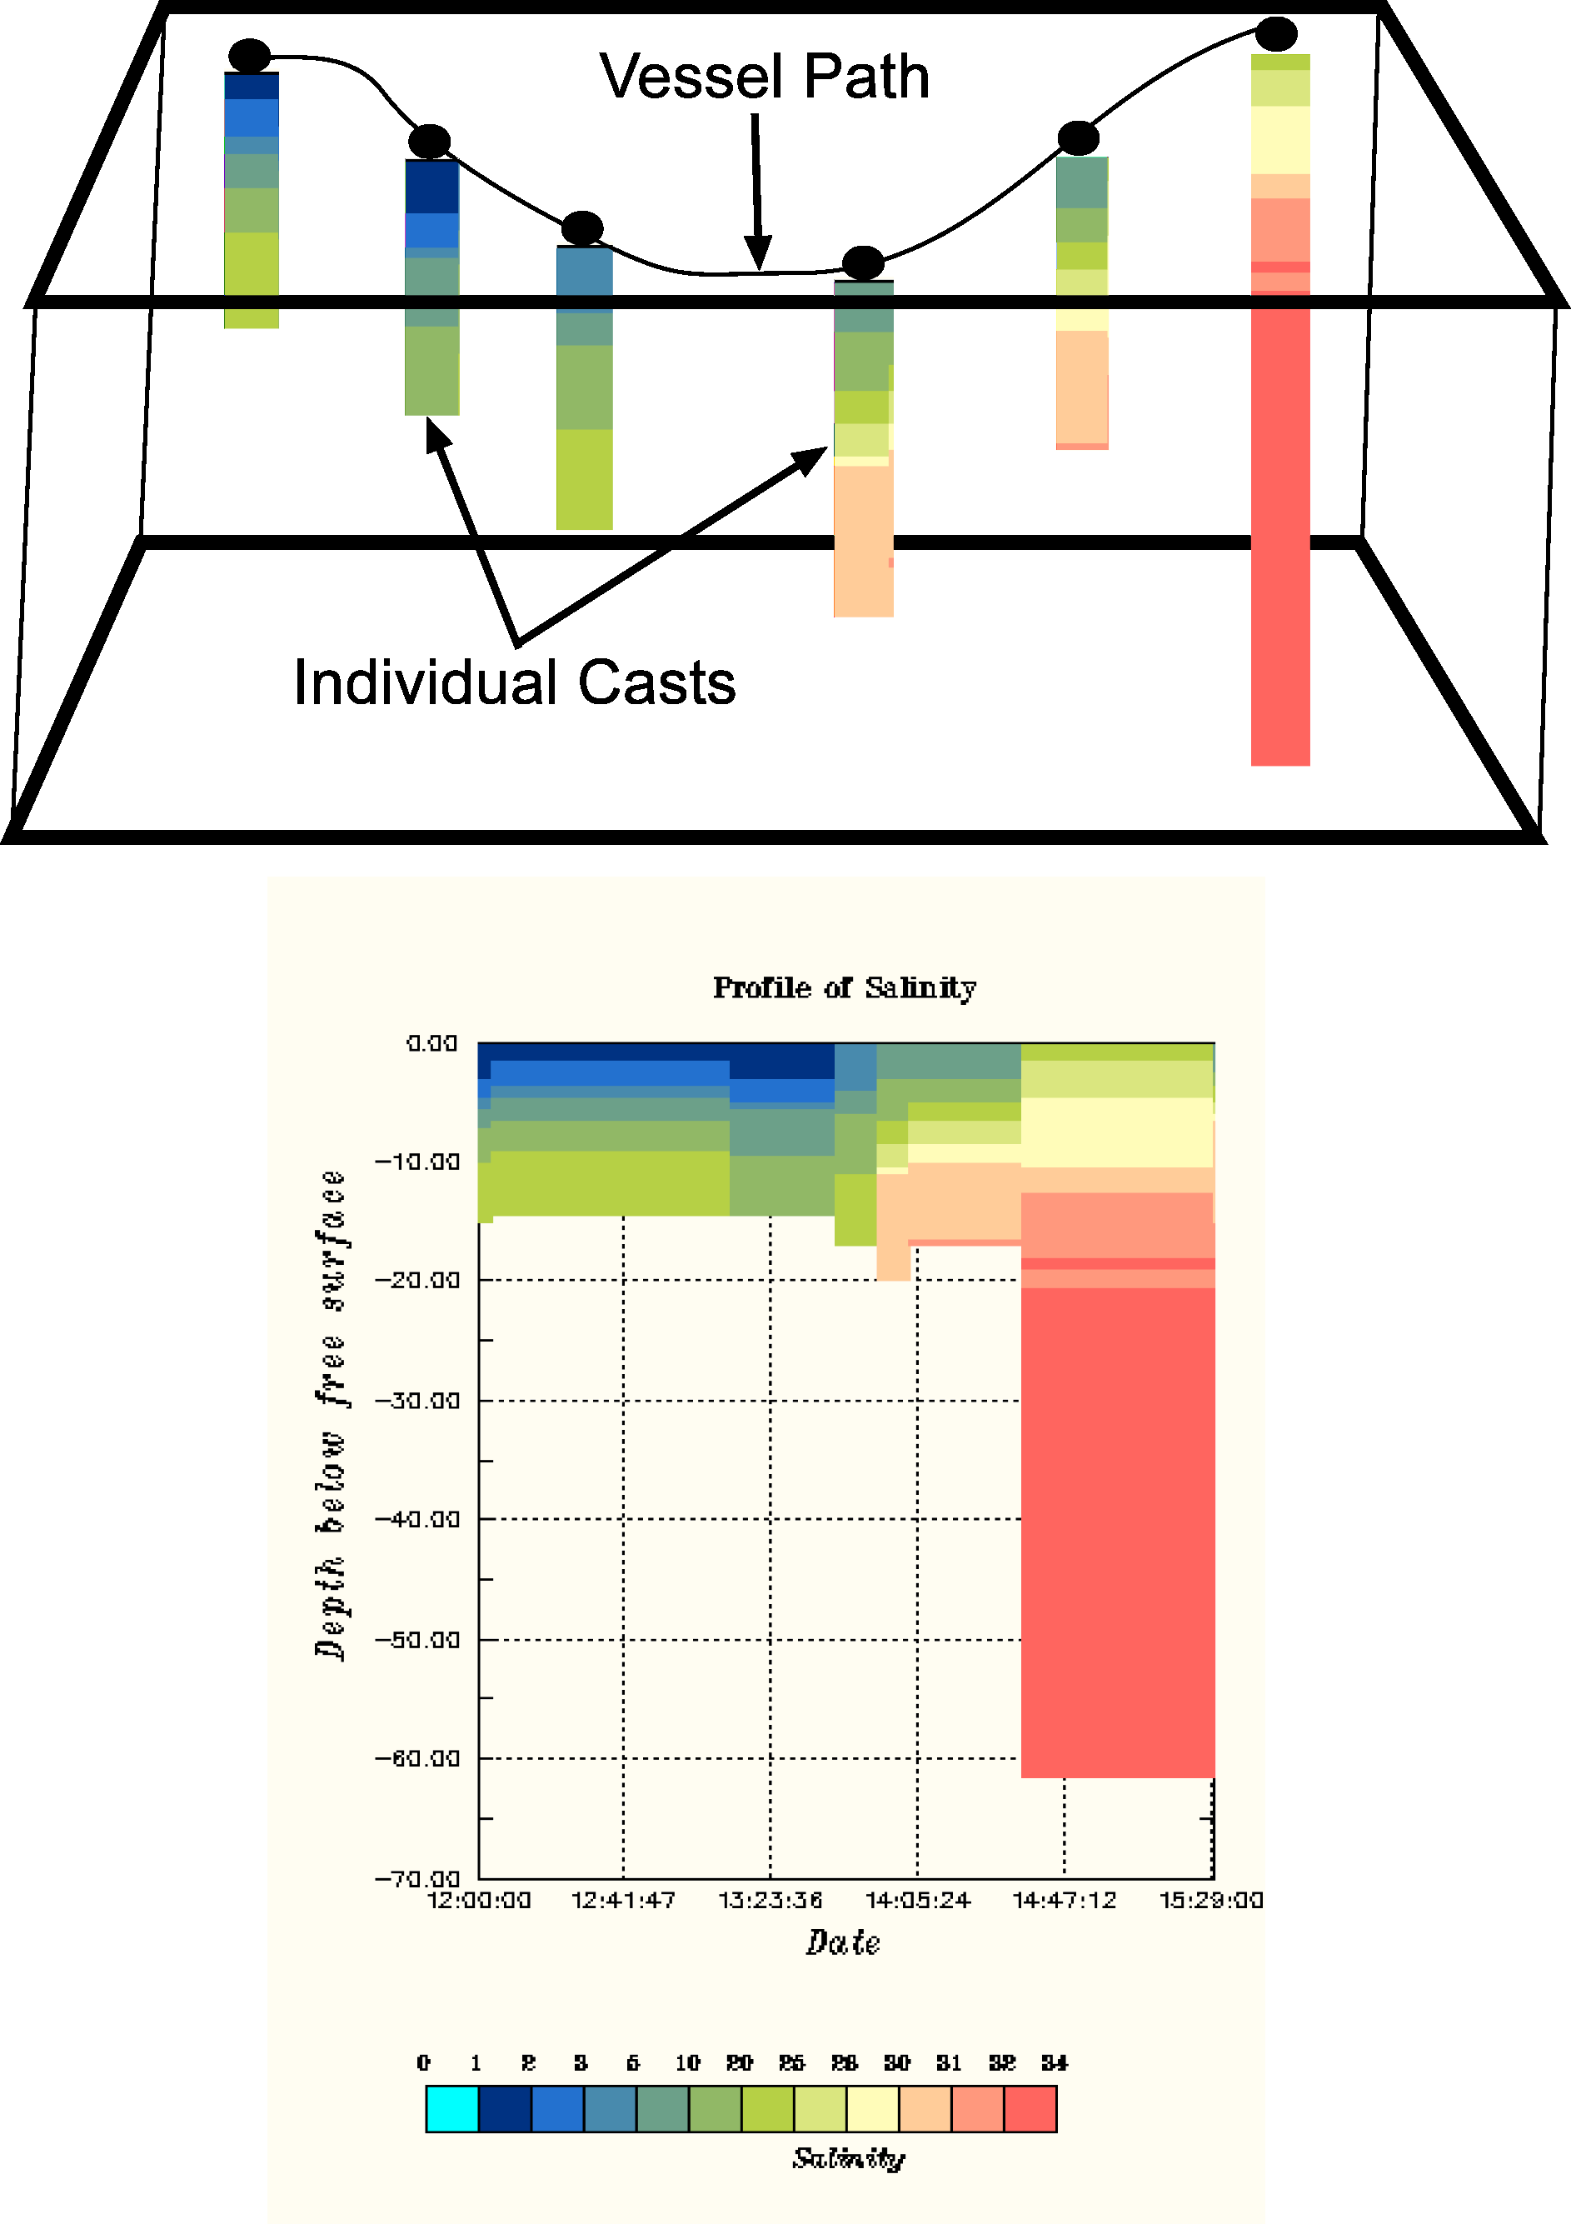
Figure 8. Vessel transects image generation.
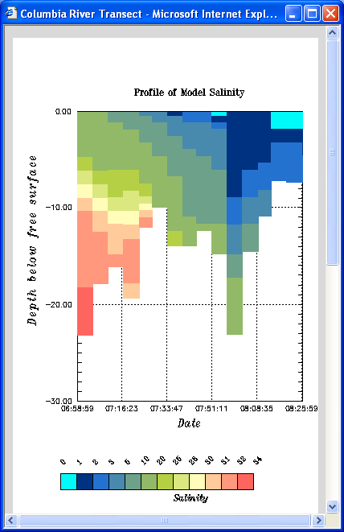
Figure 9. Example vessel transect output image. This is a graph of predicted model salinity, at the cast locations marked on the map, at the time the cast is to be taken.

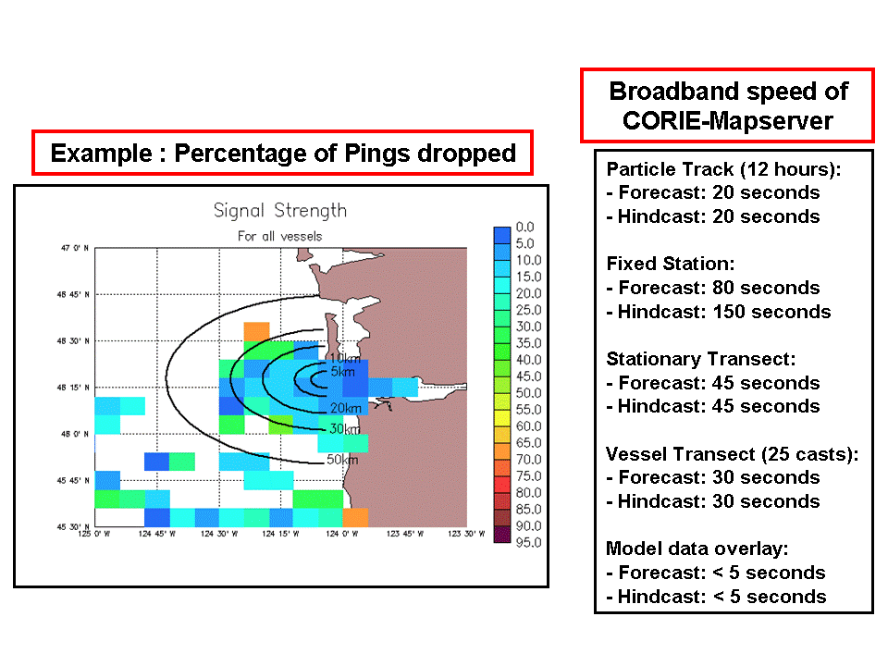
Figure 10. CORIE-Mapserver performance statistics. Example signal strength map based on pings dropped from network connections to roaming vessels in the Columbia River estuary and plume.

Although this is not an open-source product, it is based upon the open-source Linux kernel and is considered to be a stable “server grade” Linux distribution as compared to its near relative Redhat Fedora [Redhat White Paper, 2003].
ACE also consists of other tools not utilized by the CORIE-Mapserver project including G3 and GREdit. Please refer to the ACE online documentation for more information.
www.dmsolutions.ca
www.refractions.net

